Assignment :Exploring Linux cron jobs

Task 1:
The crontab command give the user the ability to schedule tasks to be run at a specific time or with a specific interval. If you want to move beyond using Linux from a graphical user interface, you will most likely want to schedule a task to run at a particular time or interval.

crontab [-u user] [-l | -r | -e] : Schedule a task to run at a particular time or interval

Task 2:
Here i used crontab -l and there is no crontab for the user and also for the root.
Task 3:
In this task i created hello.sh file which contains script to make a hello.txt file in that i wrote “hello world!”.
After creation of hello.sh using crontab -e command i put an entry of 1st cron job which will run hello.sh file in every minute. Pic 2.1 is the output of the above task
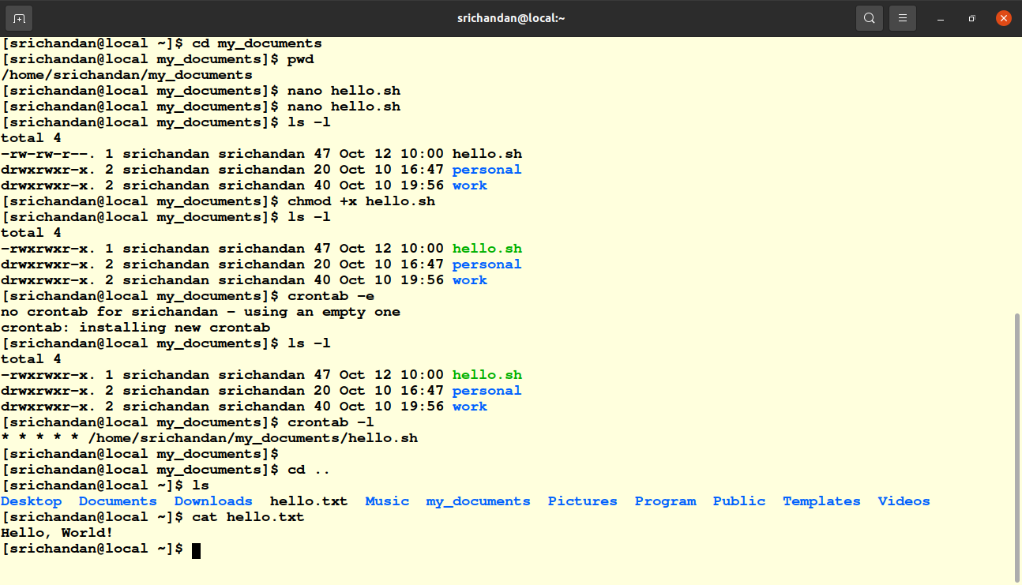
pic 2.1

Task 4:
Here i changed “ * * * * * /home/srichandan/my_documents/hello.sh” to
“ 0 * * * * /home/srichandan/my_documents/hello.sh” in cron table.

Task 5:
In this task i deleted new created cron job in task3

Task 6:
in this task i created a log_script.sh file in that i wrote a script which will run my new cron job at every 5 min. Bellow pic shows the output of this task.
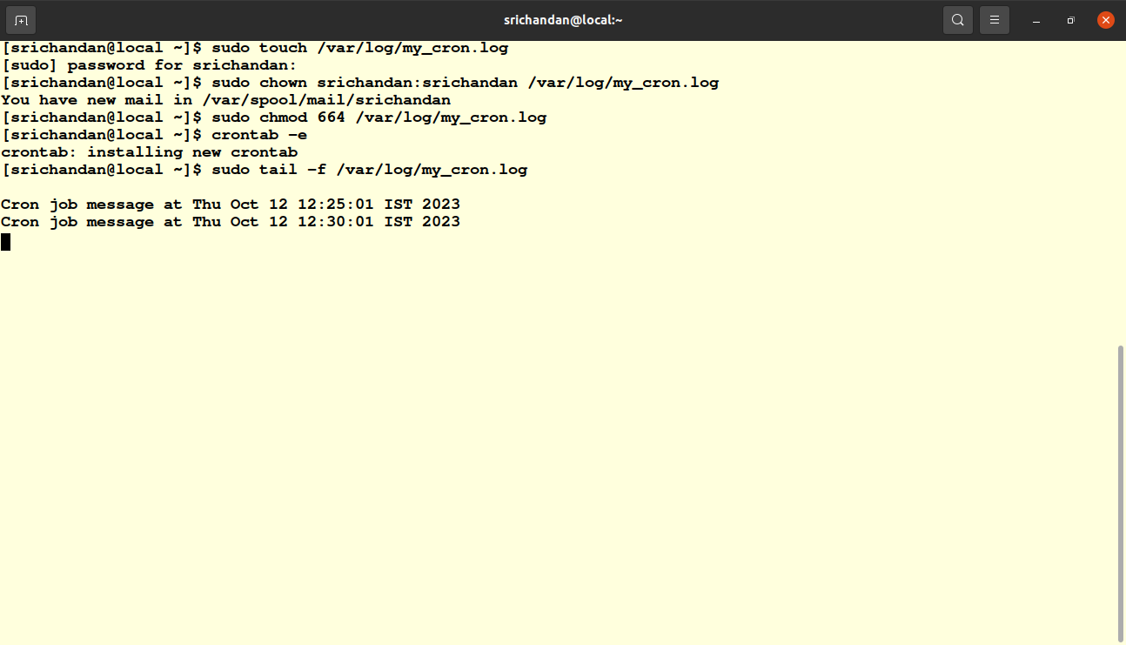
Pic 2.2

Task 7:
Automated website backups:-In this use case, i will create a Cron job to perform automated backups of a website. Automated backups are essential for data protection and disaster recovery. They help ensure that you have a recent copy of your website's files and databases that can be restored in case of data loss or website issues.
Cron Job Behavior:
- Create a Backup Directory: The Cron job starts by creating a new directory to store the backup files. This directory could be named with the current date and time to keep backups organized.
- Website Files Backup: It copies all website files (HTML, CSS, JavaScript, images, etc.) to the backup directory. This ensures that the latest version of the website's frontend is saved.
- Database Backup: If the website uses a database (e.g., MySQL), the Cron job performs a database dump to create a backup of the database. The database dump is saved in the backup directory.
- Compress and Archive: After backing up files and the database, the Cron job compresses the backup directory to save disk space. Common archive formats like tar or zip are used.
- Storage or Transfer: Depending on your setup, the Cron job can store the backup locally or transfer it to a remote server or cloud storage for added redundancy.

Cron Schedule: To run this Cron job at 2 AM every night, add the following line to your user's Crontab:- 0 2 * * * /home/srichandan/my_documents/backup_script.sh
Task 8:-
intentionall i made some syntax mistake in crontab which is in bellow pic 2.3
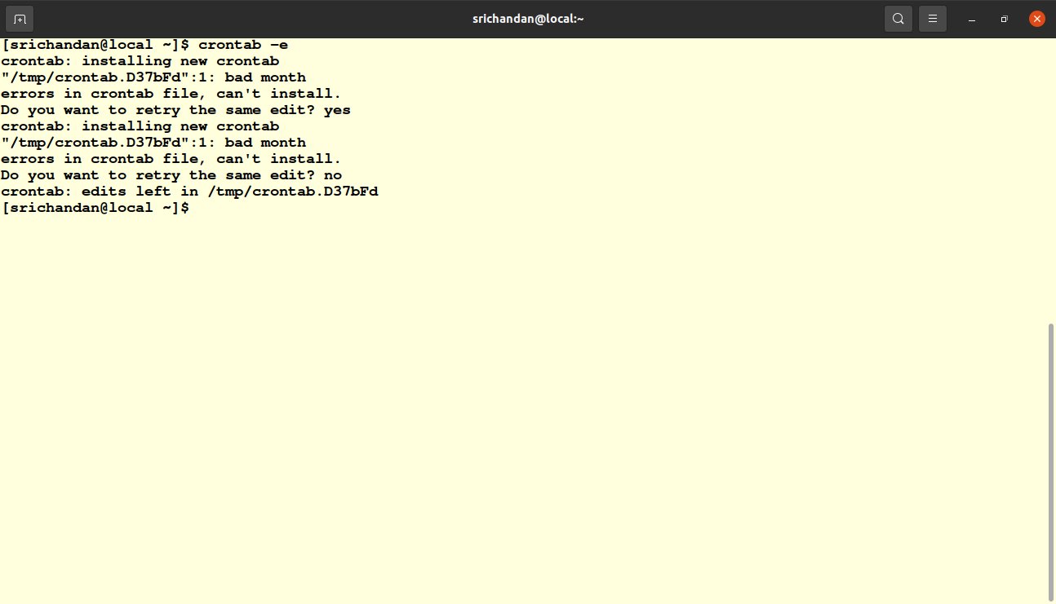
pic 2.3
Here its asking to rewrite the crontab if i say no then it automatically add the previous crontab script.
Task 9:-
here i cleared every crontab jobs using crontab -r commands and i cleared all my scripts which i made for crontab.

