Assignment Title: CPU Management in Linux

Task 1:
The top command in Linux is a widely used and powerful system monitoring tool. It provides real-time information about system performance, such as CPU usage, memory usage, running processes, and more. When you run the top command in a terminal, it displays a dynamic, continuously updating list of processes. The default view shows processes sorted by their CPU usage, with the most resource-intensive processes at the top. Bellow image-3.1 shows about the top command

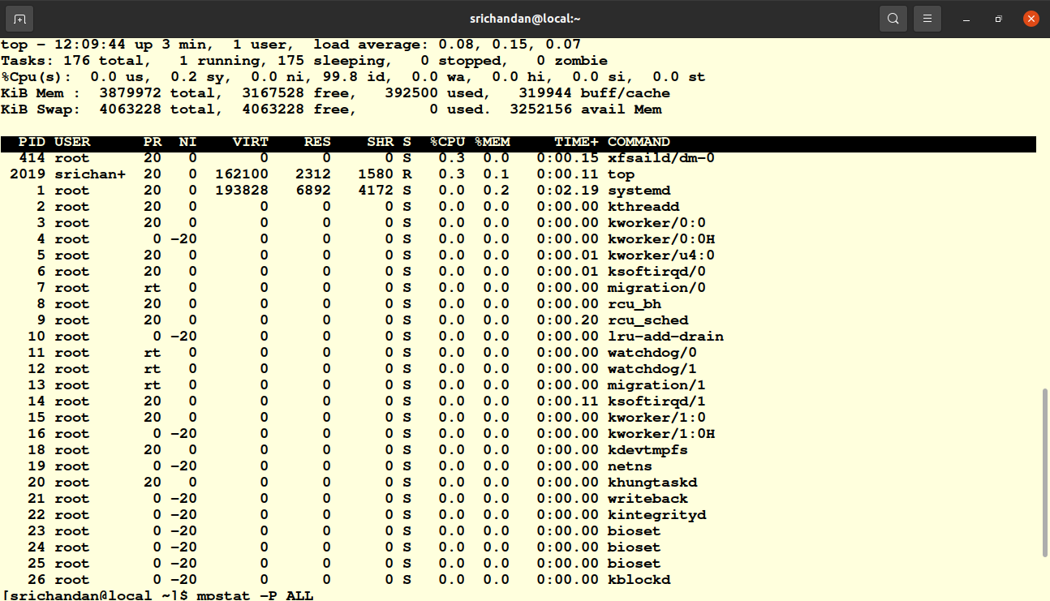
Pic-3.1

Htop:- htop is a text-based, interactive system monitoring utility in Linux that is similar to the traditional top command but provides a more user-friendly and feature-rich interface.

Mpstat -P ALL : The `mpstat -P ALL` command is used in Linux to display detailed processor (CPU) statistics, specifically per-processor statistics. It provides information about the CPU usage, performance, and other metrics for each available processor core on the system.

Here's what each part of the command does:

- `mpstat`: This is the command itself, which stands for "multiprocessor statistics." It's used for monitoring and reporting CPU usage and statistics.

- `-P ALL`: This option tells `mpstat` to display statistics for all available processors or CPU cores. The `-P` flag is followed by `ALL` to indicate that you want information for all processors. If you want to see statistics for a specific processor, you can replace `ALL` with the processor number (e.g., `mpstat -P 1` to get statistics for the first processor core).

When you run `mpstat -P ALL`, the command will typically display a table with columns of data that can include:

- CPU utilization percentages: These percentages show how much each processor core is being used by user processes, system processes, and other activities.

- Interrupts per second: This shows the rate of hardware interrupts handled by each core.

- Context switches per second: This indicates how often the core is switching between different processes.

- CPU-specific information: Additional details about each processor core's performance, such as idle time, utilization, and other statistics.

`mpstat` is a valuable tool for monitoring CPU performance on a multi-core system, as it provides a breakdown of CPU usage per core, helping you identify any performance bottlenecks or irregularities on the system.

Task 2:-
- In this task i used ‘ps aux’ command to list running processes and their pid.
- after that i choose a process firefox and noted its pid.
- Then i run “taskset -cp 0 <pid>” to set affinity manually in terminal
- I verified afinity with top command as well as ‘taskset -p <pid>’ commands.
- To automate this process i wrote a script named ‘set_cpu_affinity.sh’ file
- To run this file i use “./set_cpu_affinity.sh <pid> <cpu no>” command and output of the above is given below image 3.2.

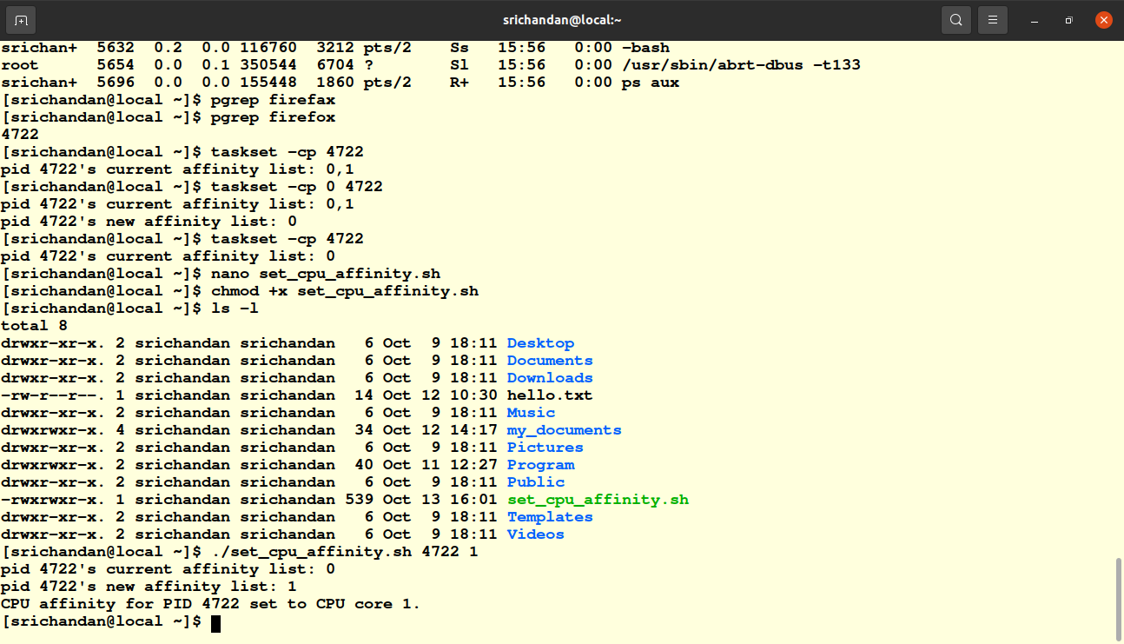
Pic 3.2

Task3 :
- In this task at first i run `cat /proc/cpuinfo` this command after this i get to know about Processor Model and Vendor,CPU core count,CPU clock speed, cache info, CPU Features.
- To increase cpu performance i used stress tool. This utility is used to stress all availble cpu. I used ‘stress –cpu 4’
- After this stress command i opened another terminal there i monitored my cpu utilization increases and it becomes 100%.
- I notice that the CPU load is spread across multiple cores, and as the load changes or tasks complete, the distribution of tasks may change as well. The kernel's load balancing mechanism aims to maximize system performance and ensure efficient utilization of CPU resources.
- I observe how the kernel may migrate processes between cores as needed to balance the load. This dynamic load balancing helps optimize the system’s overall performance.
Task 4:
- In this task i created a shell script file named cpu_monitor.sh .
- After that run that script using ‘./cpu_monitor.sh &’ and for output “ tail -f cpu_usage.log”.
- To kill the above script i used “pkill -f cpu_monitor.sh”.the output above script is given below image 3.3
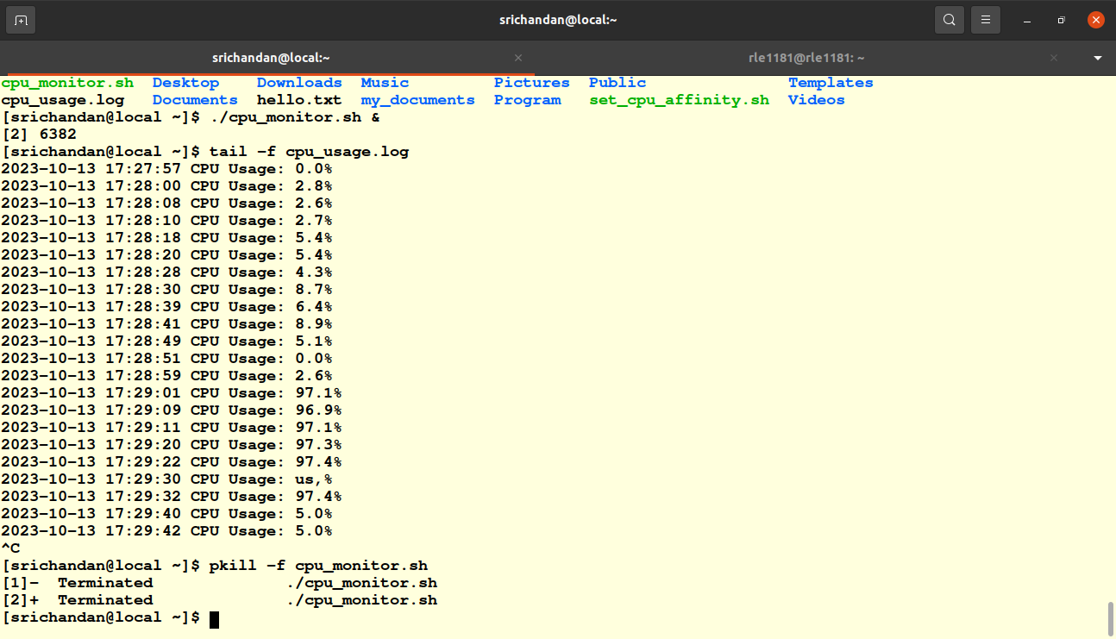
pic 3.3

