Assignment Title: Exploring Memory Management in Linux

Task 1:
In the terminal i run “free -m” command and my output is given below image 4.1.
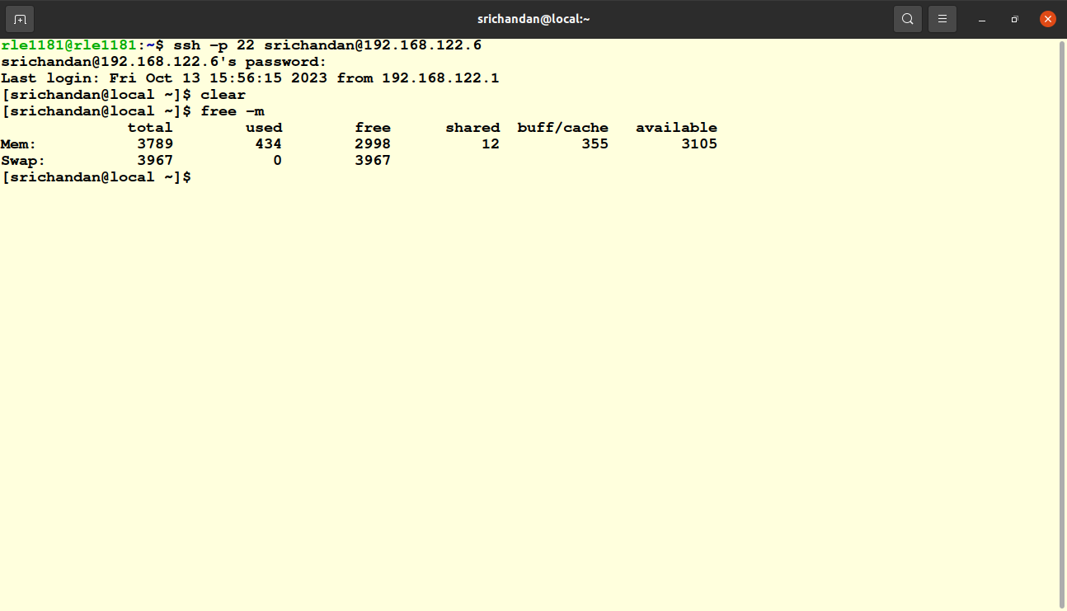
pic 4.1

The ‘free’ command will display several values, but the most relevant ones for memory usage are the “total”, “used”, “free” values.
In my VM the values are as follows:
- Total =3789 MB
- Used =434 MB
- Free=2998 MB
- Total : This represent the total physical RAM available in my virtual machine,measured in megabyte.
- Used: This value represents the amount of RAM currently in use by varius processes and by the OS.
- Free: This value indicates the amount of RAM that is currently not in use. This protion of RAM that is avilable for new processes or to meet increased demands.
Task 2:
in this task i run top command it displays adynamic list of processes and their resources usage .To sort the processes by memory usage i pressed “ Shift + M” key. This helped me to order the process from highhest to lowest memory usage.
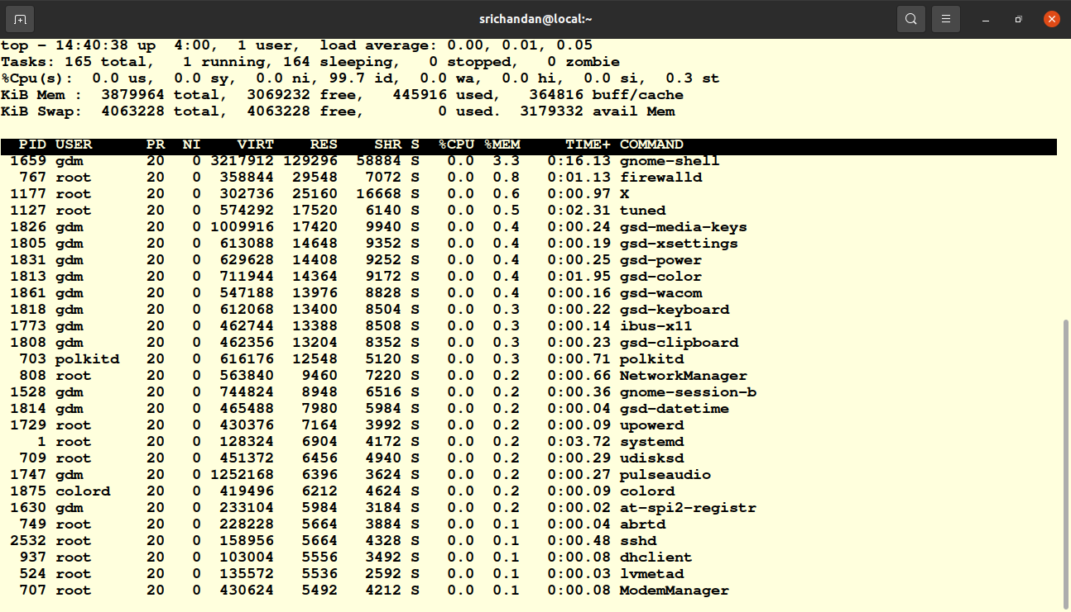
Pic 4.2

In the above above pic 4.2 i got highest memory usage processes. In that
- Gnome shell is the graphical shell or user interface of the GNOME desktop environment. It's the part of the desktop that users interact with, including the desktop background, application launcher, taskbar, system tray, and window management.

- Firewalld is a dynamic firewall management tool for Linux systems. It is used to configure and manage network filtering rules, making it easier for system administrators to manage firewall settings and improve system security. Firewalld is often found on Linux distributions that use the systemd init system, such as Fedora, CentOS, and RHEL.

- X server, which is responsible for managing and rendering graphical content on the display. The X server process can be started with root privileges because it requires low-level access to hardware and display devices.

- Tuned" is a system tuning service in Linux that helps optimize system performance, power consumption, and resource utilization. It is often used to enhance the performance and power efficiency of a Linux server or desktop system. This can be found on Red hat enterprises like centos, Fedora etc.

- "gsd-media-keys" is a part of the GNOME desktop environment in Linux. It is a component responsible for handling keybindings and shortcuts related to media control functions on your system. These media control functions typically include actions like adjusting volume, controlling media playback (play, pause, stop, skip, and rewind), and launching media-related applications.
Task 3:
“vmstat” is a command-line utility,that provides detailed information about various system performance statistics. It is a versatile tool for monitoring and diagnosing system performance. The name "vmstat" stands for "virtual memory statistics." It provides information related to various aspects of the system.\
In this task i installed vmstat using procps package as i am using centos vm and procps contains vmstat utility.
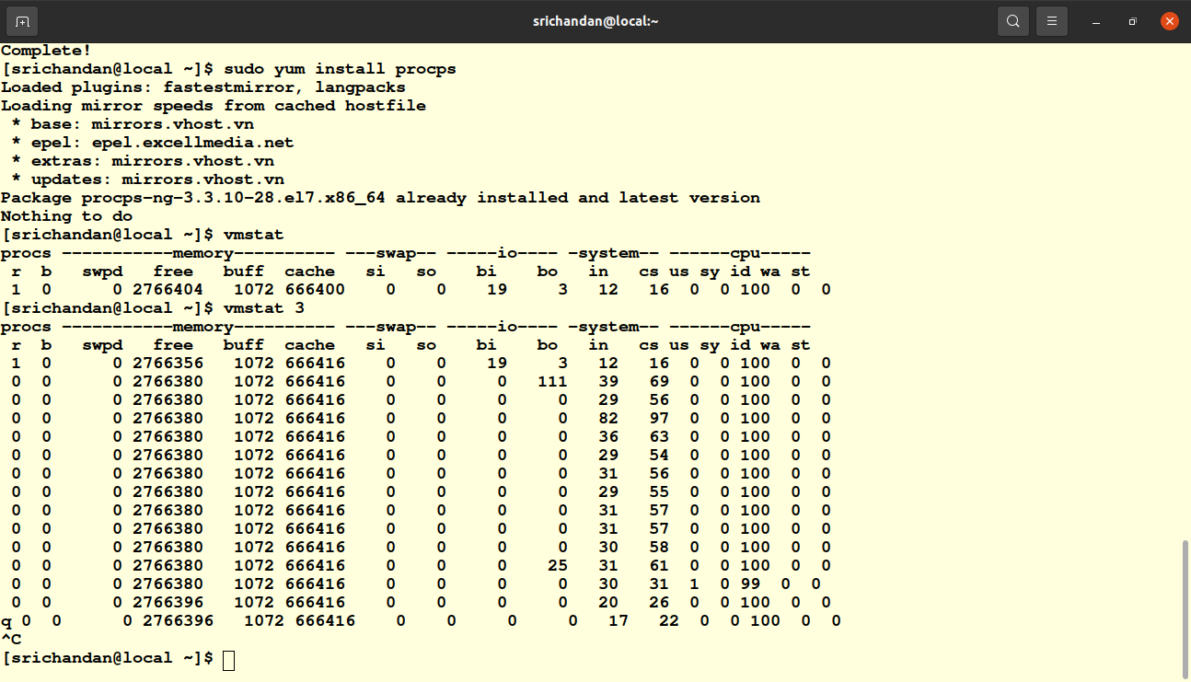
Pic 4.3
The above pic 4.3 is output of ‘vmstat’ consists of several columns, including:

- procs : This section provides information about processes. The columns in this section include:
  - r : The number of processes in the "run queue," meaning processes waiting to be executed.
  - b The number of processes in the "blocked" state, usually waiting for I/O.
- Memory : This section provides information about memory usage. The columns in this section include:
  - swpd : The amount of virtual memory (in KB) used

  - free : The amount of free memory (in KB) available for new processes.
  - Buff : Memory used as buffers (in KB). Buffers are used for disk I/O operations.
  - cache : Memory used as page cache (in KB). It stores recently accessed data for faster access
  - si : Amount of memory swapped in from disk (in KB)
  - so : Amount of memory swapped out to disk (in KB).
- Swap : This section provides information about swap space. The columns in this section include:
  - bi : Blocks received from a block device (in KB) for swap operations.
  - bo : Blocks sent to a block device (in KB) for swap operations.
- Io : This section provides information about input and output operations. The columns in this section include:
  - in : Number of interrupts per second.
  - Cs : Number of context switches per second.

- System: This section provides general system information. The columns in this section include:
  - sy: Number of system-related operations (system calls) per second.
  - Id: Percentage of time the CPU is idle.
  - Wa: Percentage of time the CPU is waiting for I/O.
- Cpu : This section provides CPU utilization information, which is not directly related to memory usage.
Task 4:
In this task i installed ‘valgrind’ and created a c file named ‘ memory_leak.c ’ . After compilation when i run ‘ valgrind –leak-check=full ./memory_leak ‘ command , it provided a detailed information about memory leak ,including the line number where the memory was allocated.
To fix the memory leak i added a free function to deallocate the memory properly. After re run of the valgrind command i ensured that the memory leak has been fixed.The below pic 4.4 is the details about this task.
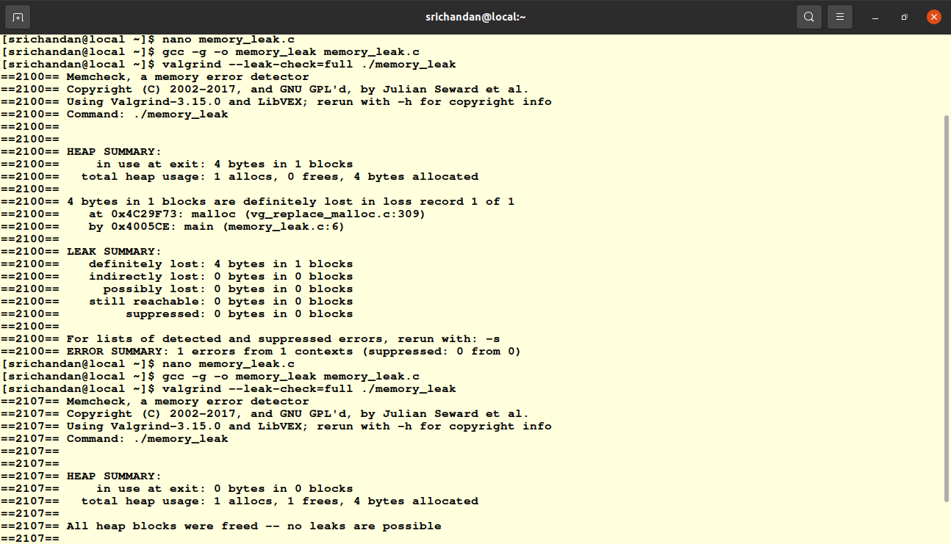
pic 4.4
Task 5:
Optimizing memory usage for a process often involves a balance between reducing memory consumption and maintaining the functionality of the application
I consider firefox web browser that can consume a significant amount of memory. There are some strategies which can optimize its memory usage:
- Close unnecesssary tabs and Extensions
- Use Lightweight Browser Extension.
- Limit the number of open tabs.
- Disable Autoplay for Videos
- Use memory-saving browser features
- Monitor resource usage
- Adjust memory allocation.
- Use built-in task manager
- update the browser
- check for memory leaks.
- Clear browser cache.
For this task i opened several firefox tabs after that the web browser increases its memory consumption.Below pic 4.5 is the expermintal output
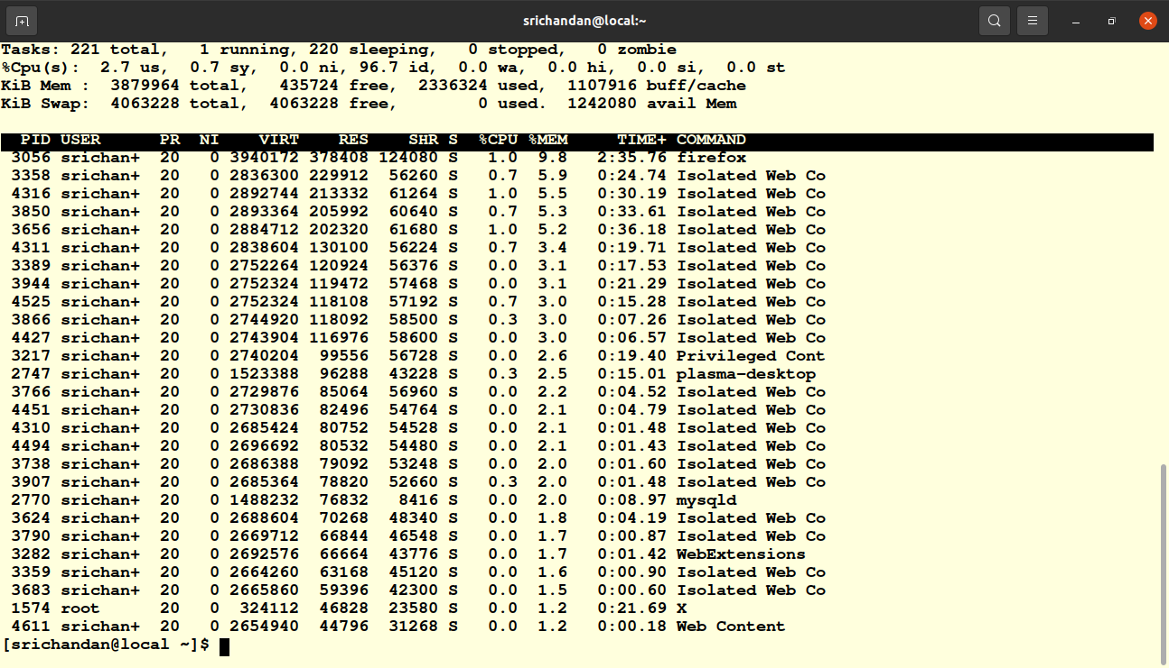
pic 4.5
after closing all the tabs it consumed less memory. This can be seen in below pic 4.6

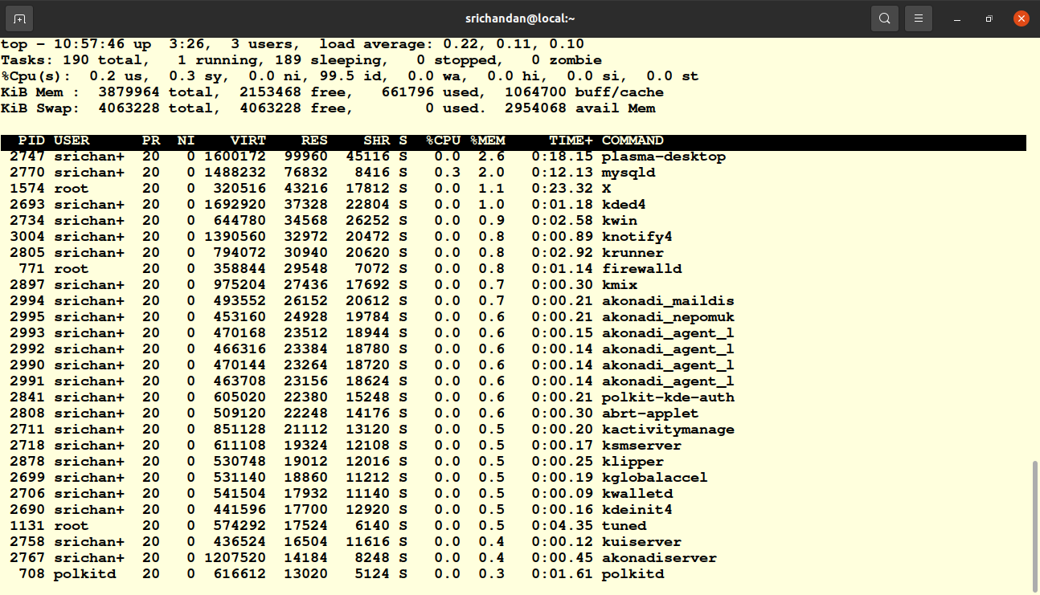
pic4.6

Task 6:
Memory management is a critical component of Linux that allocates and deallocates system memory, ensuring the efficient operation of applications and the stability of the system. It involves resource allocation, virtual memory, memory protection, caching, and kernel operations. Efficient memory management is crucial for system performance and responsiveness, as it optimizes resource utilization and prevents memory-related issues like leaks and exhaustion. Properly configured memory settings are vital for servers and workstations, and it's fundamental for the reliability and efficiency of the Linux operating system. In this assignments i did not faced much issues as it is already mentioned commands to excute for specfic problems.

