Exploring Linux Logging

Task 1:
Logging is an essential aspect of managing Linux systems, playing a pivotal role in system administration, security, and troubleshooting. It involves the recording of events and activities within the system, allowing administrators to monitor, analyze, and ensure the smooth operation of their Linux environments. In this report, we will discuss the importance of logging in Linux, its significance in system administration, security, and troubleshooting, and the various components involved in logging.

System Asministration
- Monitoring system health : Logging provides system administrators with the means to continuously monitor the health and performance of a Linux system. By regularly reviewing system logs, administrators can detect issues such as hardware failures, resource constraints, and application crashes. This proactive approach enables administrators to take corrective actions before these issues evolve into major problems, ensuring system reliability and minimizing downtime.
- Resource Optimization : Logs contain data on resource utilization, enabling administrators to optimize system resources efficiently. This information helps in identifying underutilized resources that can be reallocated to enhance performance, as well as overutilized resources that may require scaling or configuration adjustments.
Security
- Intrusion Detection : Security logs are vital for detecting and responding to security threats. They record suspicious activities, unauthorized access attempts, and other security-related events. By analyzing security logs, administrators can identify potential security breaches, assess their impact, and initiate countermeasures to protect the system's integrity
- Forensic Analysis : In the event of a security incident, logs are invaluable for forensic analysis. They provide a timeline of events leading up to the incident, helping administrators and security professionals investigate the root cause and understand the extent of the breach. This information is crucial for legal and regulatory compliance and post-incident recovery.
Troubleshooting
- Debugging Application :
Logs are indispensable for debugging applications. They capture error messages, stack traces, and other diagnostic information that aid in identifying and resolving software issues. System administrators and developers can use these logs to pinpoint the source of problems and implement fixes, thereby ensuring the smooth operation of software within the Linux environment
- Configuration Management : Logs also play a vital role in configuration management. Changes to system configurations are typically logged, allowing administrators to track modifications, identify misconfigurations, and roll back changes if necessary. This ensures system stability and reliability by preventing unintended or unauthorized alterations.
Task 2:
In linux there are several common logs files, each serving a specific purpose and storing different types of information. Some of the common log files and their functions are given below:
- /var/log/syslog :
  - Purpose : This is one of the most comprehensive log files in Linux and contains general system messages. It aggregates log messages from various system components and services, making it a valuable resource for system administrators to diagnose system-level issues.
  - Information Stored : Information related to system startup and shutdown, hardware and kernel events, device driver messages, system service messages, and other general system activities.
- /var/log/auth.log :
  - Purpose : This log file focuses on authentication-related events. It is essential for monitoring user authentication and tracking login attempts, providing insights into potential security breaches or unauthorized access.
  - Information stored : Records login attempts, including both successful and failed logins, as well as user authentication-related activities.
- /var/log/messages :
  - Purpose : Similar to ‘/var/log/syslog’ it captures system-wide messages and is often used for debugging and system analysis. However, its contents may vary slightly depending on the Linux distribution.
  - Information stored : General system messages, kernel events, hardware-related issues, and other system activities. This file may contain more detailed information about certain messages compared to.
- /var/log/kern.log :
  - Purpose : This log file focuses exclusively on kernel messages and is critical for diagnosing kernel-related issues. It provides detailed information about the kernel's operation.
  - Information Stored : Kernel-specific messages, including driver loading, hardware issues, and kernel error messages.
- /var/log/daemon.log :
  - Purpose : Daemon processes often write their log messages to this file. It contains information about various system services and daemons running on the system.
  - Informmation Stored : Log messages from daemon processes, which can help in diagnosing issues related to specific services and daemons.

- /var/log/boot.log :
  - Purpose : This log file records messages related to the system's boot process. It is valuable for troubleshooting boot-related issues and understanding the sequence of events during system startup.
  - Information stored : Messages related to the initialization of services, hardware detection, and other activities during the boot process.
- var/log/messages:
  - Purpose : This log file is specific to Red Hat-based distributions like CentOS and contains a wide range of system messages similar to ‘syslog’ on other distributions.
  - Information Stored : General system messages, kernel events, hardware-related issues, and other system activities.
- /var/log/security :
  - Purpose : This log file primarily focuses on security-related events, helping to track security breaches and unauthorized access attempts.
  - Information Stored : Security events, including successful and failed login attempts, password changes, and other security-related activities.
Task 3:
Configuration files like rsyslog.cof and logrotate.conf are crucial for configuring the Linux logging system and managing log files. They allow administrators to control the behavior of the logging system, specify log destinations, and implement log rotation policies. Here's an overview of how these files are used:
- etc/rsyslog.conf :
  - Purpose : rsyslog.conf is the main configuration file for the rsyslog daemon which popular logging system used in many Linux distributions. It defines how how log messages are processed and where they are forwarded.
  - Key Configuration Elements :
    - Log Rules : This file specifies log rules that determine how log messages are processed. Rules include selecting which log messages to process, the actions to take (e.g., store in a file, forward to a remote server), and the log file destination.
    - Log File Definitions : Administrators can define custom log files and their properties, such as the location, format, and rotation policies.
    - Log Destinations : Specify where log messages should be sent, whether it's local log files, remote log servers, or other destinations.
- etc/logrotate.conf :
  - Purpose : logrotate.conf and the configuration files in ‘/etc/logrotate.conf’ are used to configure log rotation policies for log files. Log rotation is essential to prevent log files from growing indefinitely and consuming excessive disk space.
  - Key configuration Elements :
    - Log File Paths : Specify the log files or directories that need log rotation. These are listed along with rotation directives.
    - Rotation Polices : Define how log files are rotated, including parameters such as rotation frequency (daily, weekly, monthly), maximum log file size, and the number of archived log files to retain.
    - Compression and Post-rotation Actions : Logrotate allows for compressing log files and executing custom scripts or commands before or after log rotation.
In summary, these configuration files are essential for setting up a well-structured and manageable logging system in a Linux environment. They allow administrators to control where log messages are written, how they are processed, and how log files are managed over time. This is crucial for ensuring system stability, performance, and security while efficiently utilizing storage resources.
Task 4:
- 1st of all i created a log file using “ sudo touch /var/log/myapp.log” command.
- Now i configure logrotate to manage my log file which is predent in ‘/etc/logrotate.conf’ and ‘/etc/logrotate.d’.
- I create a file named ‘myapp’ using ‘sudo nano /etc/logrotate.d/myapp’.
- Inside of above file i configured ‘rotate weekly’, ‘size 10M’ (it means it will rotate the log file when file reaches 10MB in size), and create a new log file with specific permissions and ownership.
- To test my log rotattion configuration without waiting for the scheduled rotation i used “sudo logrotate -d /etc/logrotate.d/myapp” command. This will show what logrotate do without actually making any changes.
- After i verified manually by running “ls varlog/myapp*” command.
The above experiment is shown in below pic 5.1
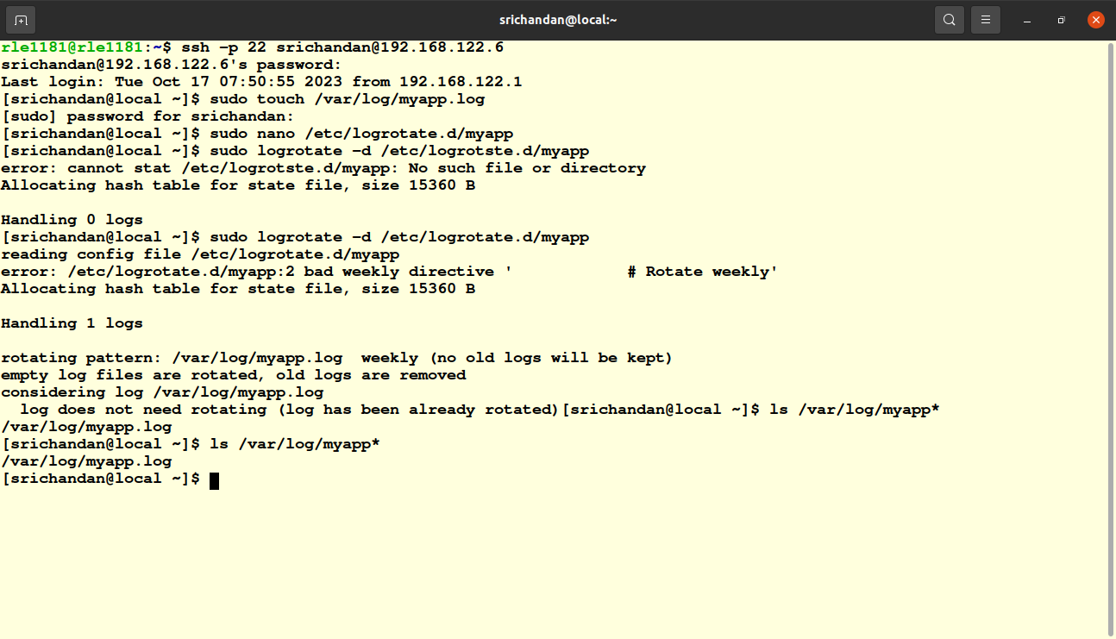
pic 5.1
Task 5 :
grep, awk commands to extract specific information from log files particularly focusing on finding failed login attempts in the ‘/var/log/secure file.
- Using grep:
To find failed login attempts in the ‘/var/log/secure’ file i use grep . ‘grep ‘Failed password’ /var/log/secure’ command will display lines containing the pharse failed passwod in the secure file which often indicates failed login attempts.
- Using awk:
awk is a versatile tool for processing log files, allowing you to extract specific fields or columns. To find failed login attempts with awk .
“awk ‘/Failed password/ {print $1,$2,$9}’ var/log/secure”
in this awk looks for lines containing ‘Failed password’ and prints the date and time and the user attempting to log in field 19.
Task 6 :
To monitor a log file in real time i used “tail” command with the -f follow option. This command continuously displays new log entries as they are written to the file.
For example to monitor secure log file i run “ sudo tail -f /var/log/secure” This comand will start displaying the last few lines of the log file and will continue to show new log entries as they are added in real-time.
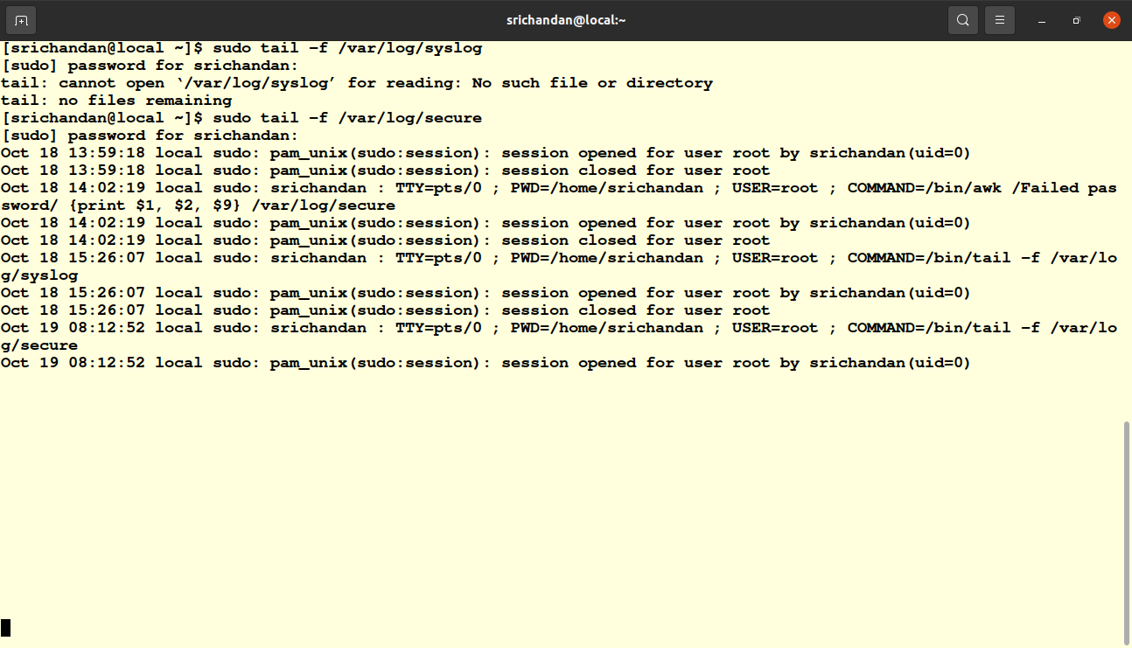
Pic 5.2
Task 7 :
Systemd Journal as a Logging Mechanism :
Systemd journal, also known as journald is a modern logging system used in many Linux distributions. It was developed as part of the systemd init system and offers several advantages over traditional syslog-based logging. Here's how systemd journal works and how it compares to traditional syslog-based logging.
How Systemd journal works:
- Centralized Logging : Systemd journal collects log messages from various sources, including system services, the kernel, and applications, and centralizes them in a structured binary format.
- Storage : Log data is stored in binary journal files under ‘/var/log/journal/’ . These files are indexed and compressed, which results in more efficient use of disk space compared to plain text log files.
- Structured Data : Log entries in the systemd journal are structured, making it easier to parse and filter. Each entry contains metadata, including the log message, the log source (e.g., the originating service or application), the timestamp, and the log level.
- Log rotation : Systemd journal manages log rotation and retention policies automatically. It ensures that older log entries are archived or deleted according to configured settings. This prevents log files from growing indefinitely and consuming excessive disk space.
- Indexed Queries : The ‘journalctl’ command provides a powerful interface for querying and filtering log data. You can search for log entries based on various criteria, including time range, log level, source, and specific log message content.
- Forwarding and Remote acess : Systemd journal supports log forwarding to remote syslog servers using the ‘ForwardToSyslog’ option .This enables centralized log management across a network.
Comarison to traditional Syslog-Based Logging:
- Structure vs unstructed data : Systemd journal stores log data in a structured binary format, making it easier to search, filter, and analyze log entries. Traditional syslog typically uses plain text log files, which can be less organized and require complex parsing.
- Efficient disk usage : Systemd journal uses indexed and compressed binary files, resulting in more efficient disk usage. Traditional syslog generates plain text log files, which can become large and unwieldy, consuming more disk space.
- Centralised Management : Systemd journal is integrated with the systemd ecosystem, offering centralized log management and configuration. Traditional syslog setups may require additional configuration and tools to achieve similar results.
- Remote logging : While both systemd journal and traditional syslog can forward logs to remote servers, systemd journal provides this feature by default, simplifying centralized log management.

Task 8 :
In this task i use a popular logging tool known as the ELK Stack, which consists of Elasticsearch, Logstash, and Kibana. ELK Stack is a powerful and versatile solution for log collection, storage, and visualization. Here's a brief overview of each component and the installation process:
- Elasticsearch : Elasticsearch is a distributed search and analytics engine. It's used for indexing and searching log data.
- Logstash : Logstash is a data processing pipeline that ingests data from various sources, transforms it, and then sends it to Elasticsearch.
- Kibana : Kibana is a web-based user interface for visualizing and exploring log data stored in Elasticsearch.
I installed and configure elk stash succeccfully.
Features and Capabilities :
- Centralized log collection: ELK Stack allows you to centralize log data from various sources, making it easier to manage and analyze logs from multiple servers or applications.
- Real-time data analysis : Logstash and Elasticsearch provide real-time log data processing and analysis, enabling you to detect issues and troubleshoot in near real-time.
- search and query : Elasticsearch's powerful search engine enables you to search, filter, and query log data efficiently. You can use Elasticsearch Query DSL to perform complex searches.
- Custom log parsing : Logstash allows you to define custom log parsing and transformation rules using Grok patterns, regular expressions, and filters.
- Data Enrichment : You can enrich log data by adding additional information, such as geolocation data or user context, during the processing stage with Logstash.
Configuring the ELK Stack provides a robust solution for log collection, analysis, and visualization. However, there are other log management and visualization tools available, such as Graylog, Fluentd, and Splunk, each with its own unique features and capabilities.

