Linux File Management

Task 1:

- In this task i started creating a new directory using “mkdir linux_file_management”.
- To change your working directory to "linux_file_management," i use cd command. “cd linux_file_management”
- inside the directory i created there text files: ‘file1.txt’, ‘file2.txt’, and ‘file3.txt’ using the touch command.
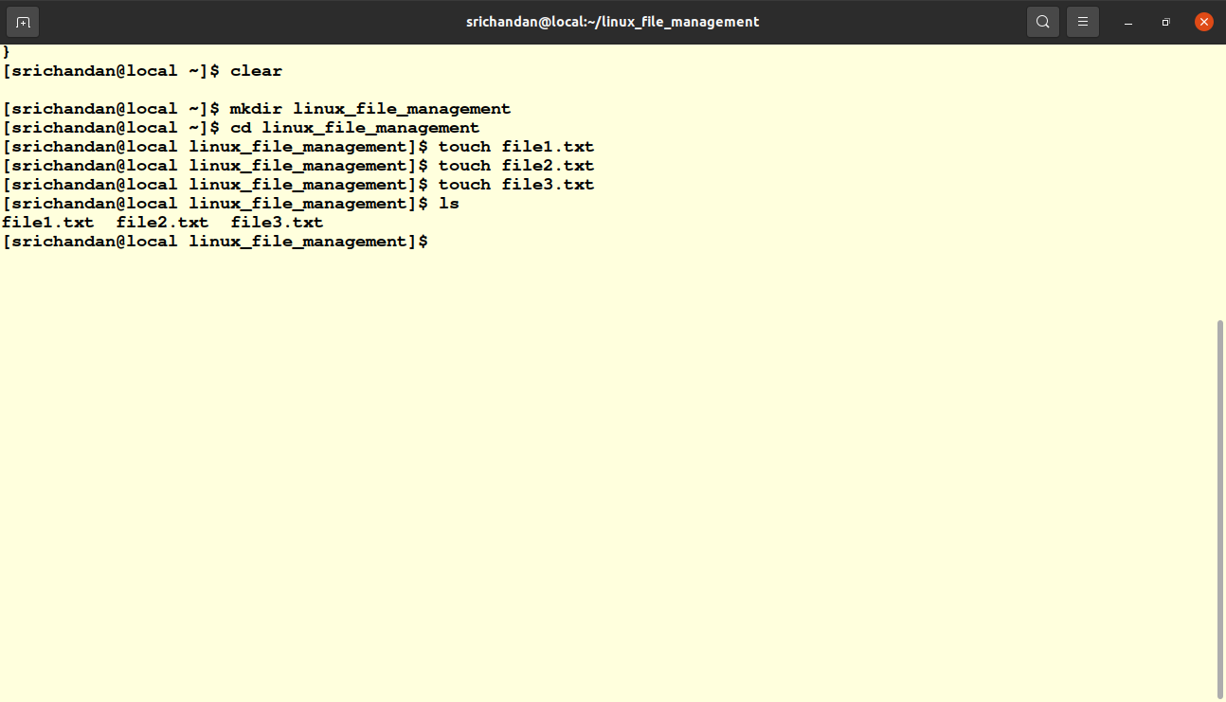
Pic6.1

Task 2 :
- In this task i used nano editor and the command is “ nano file1.txt”.
- After that i wrote a message and saved this file.
- Then i used cat command to display the content of file1.txt file
using “cat file1.txt” command
The image of the above task is given below pic 6.2
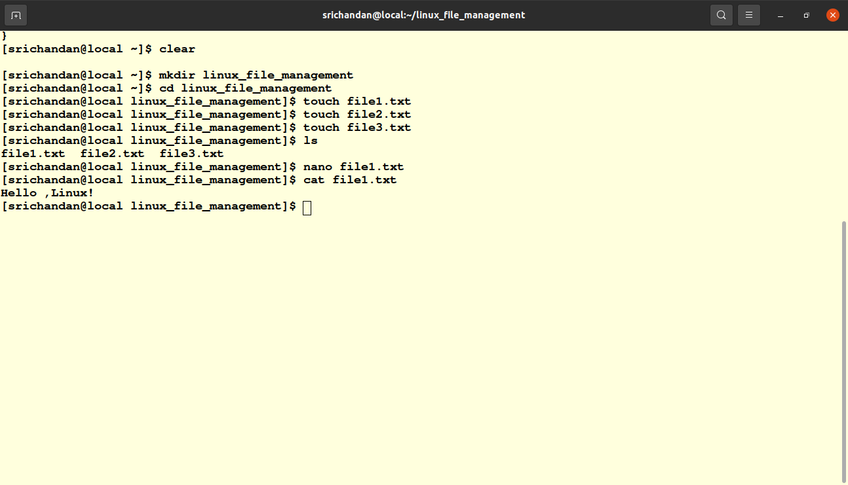
pic 6.2

Task 3 :
- Rename "file2.txt" to "newfile.txt" using the mv command.Command is “mv file2.txt newfile.txt”.
- To create a copy of "newfile.txt" called "file4.txt" using the cp command and the command is “ cp newfile.txt file4.txt”
output of above experiment is given below
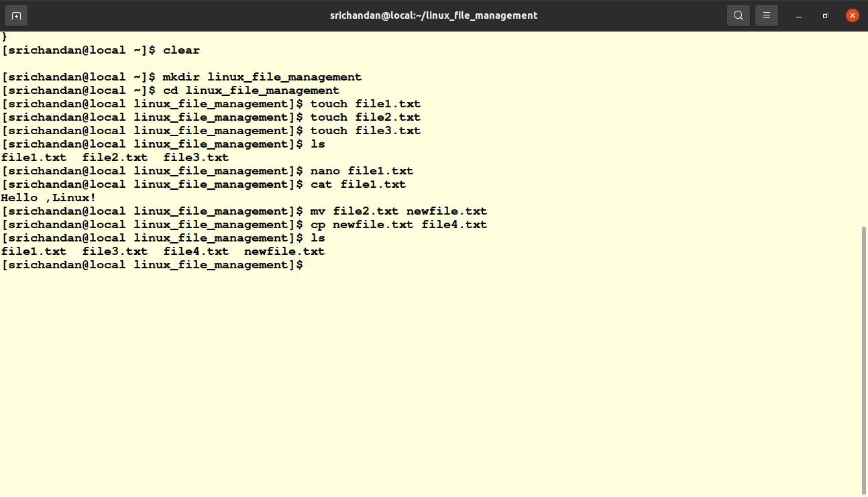
pic 6.3

Task 4 :
- To delete "file3.txt" using the rm command . The command is “rm file3.txt”
- Delete the entire "linux_file_management" directory and its contents using the rm command with the -r option. The command is “rm -r linux_file_management”.
The output above task is given below pic 6.4
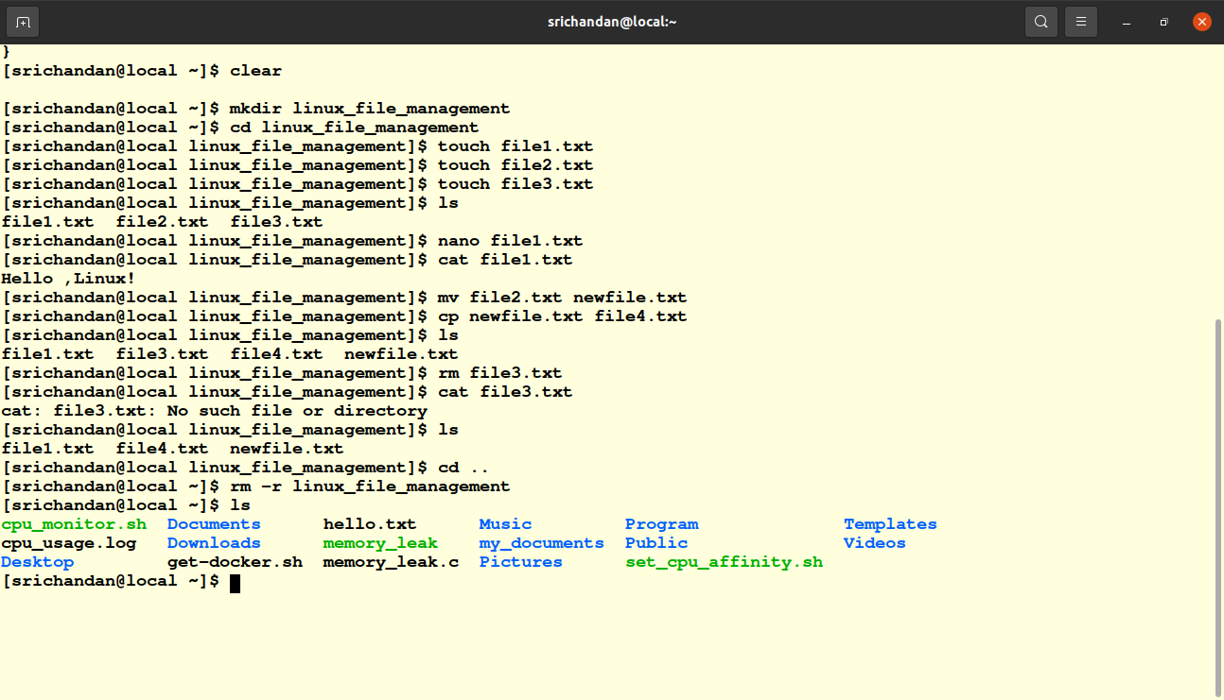
Pic-6.4

