Managing Linux Services

Task 1:
I created a centos virtual machine and installed nginx service.
Task 2:
- To list all services, i used the following command :“systemctl list-units --type=service”.
- To Start a service : “sudo systemctl start nginx”
- To stop a service : “sudo systemctl stop nginx”.
- To enable a service to start at boot : “ sudo systemctl enable nginx “
- To disable a service from starting at boot : “ sudo systemctl disable nginx”
- To check the status of a service : “systemctl status nginx”
below is the output of this task
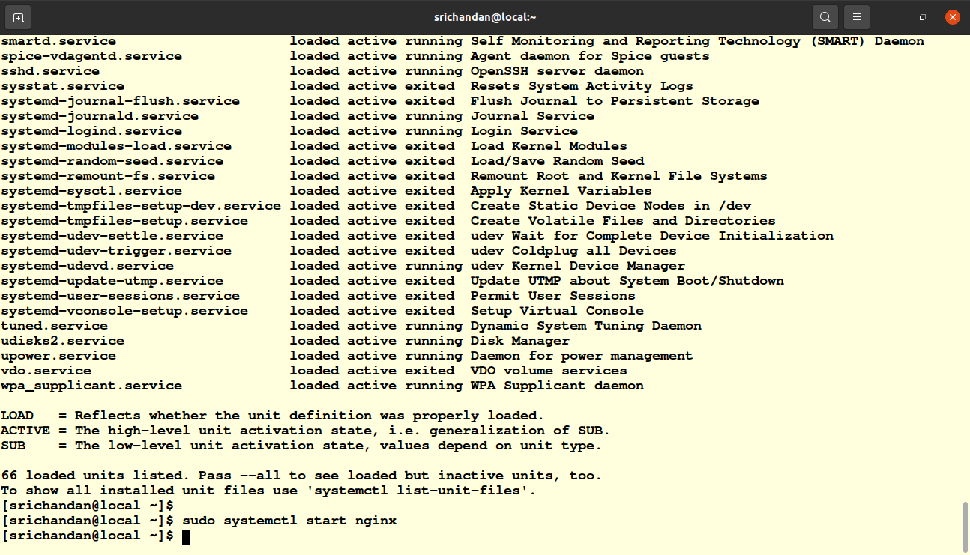
pic 7.1
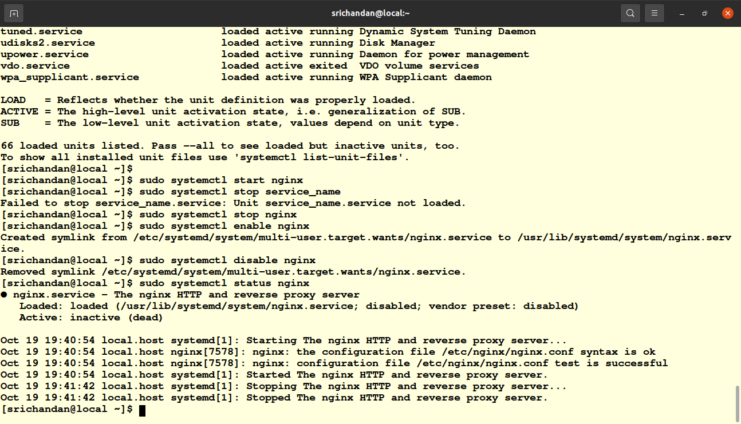
pic 7.2

Task 3 :
I want to modify the configuration of the "Nginx" web server, which is commonly found on Linux systems. In this example, i will change default port it listens on.
- To Explore the configuration Files :
  - Nginx's configuration files are typically located in the ‘/etc/nginx/’ directory .The main configuration file is usally named ‘nginx.conf’ and additional configuration files can be found in ‘/etc/nginx/conf.d/’ directory.
To explore main configuration file i used nano editor and the command is “sudo nano /etc/nginx/nginx.conf”
  - in the configuration file i changed the listen port before the default port is 80 and i changed it to 8080.
  - Before applying the changes, it's a good practice to test the configuration to ensure there are no syntax errors and the command is ‘sudo nginx -t’.
  - After that reload using “sudo systemctl reload nginx” command.
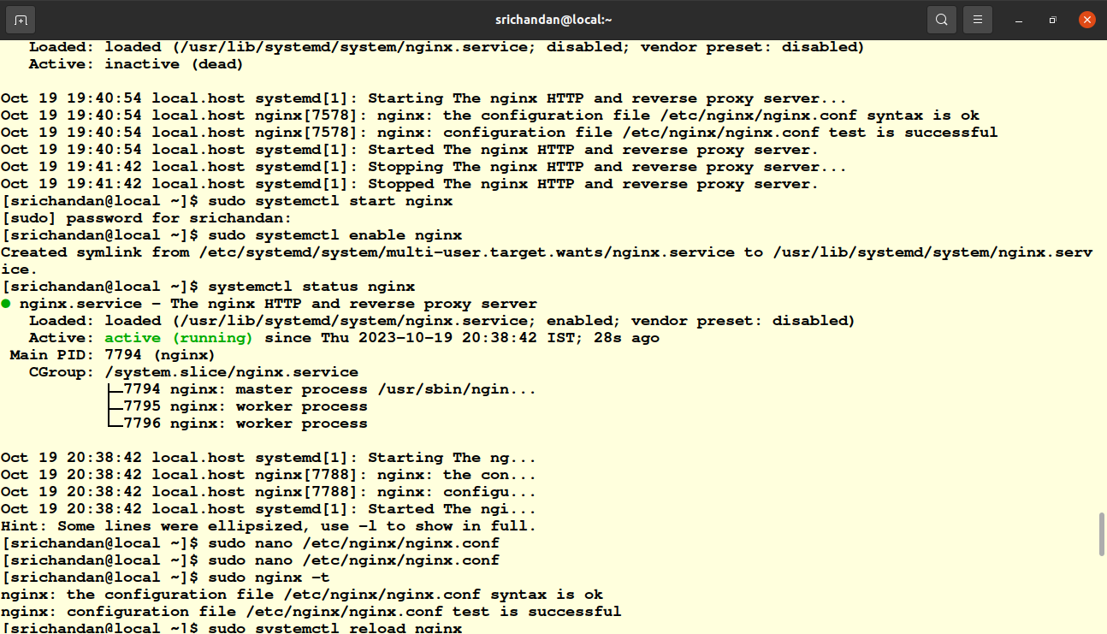
Pic 7.3

Task 4 :
Navigate to the ‘/etc/systemd/system/’ directory, where systemd service unit files are typically stored: “cd etcsystemd/system/”
- i created a new service unit file (my-service.service) using nano inside of the etc/systemd/system/ directory. And the command is “sudo nano my-service.service”
- Then i created a script file in usr/local/bin/ directory save that file and make it executable.
- After that reload the system manager using “sudo systemctl daemon-reload” command, and enable and start the service,then verify the service .
The output of above task is given below
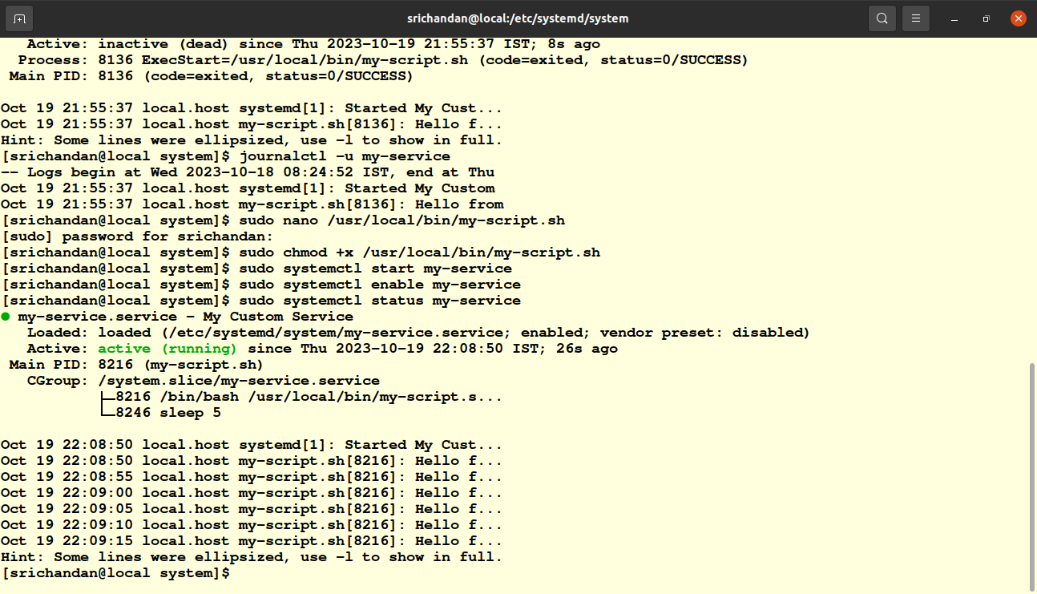
pic 7.4

