System Monitoring in Linux

Task 1:
In the terminal , i run “top” command.There are several things :
- Load Average : This is displayed at the top. It shows the system's load average over the last 1, 5, and 15 minutes. Load average represents the number of processes waiting for CPU time.
- CPU usage : Below the load average, CPU usage information. It includes the percentage of CPU utilization by the system, user processes, and other categories. This section shows which processes are using the most CPU.
- Memory Usage : This information about memory usage, including the total available memory, used memory, free memory, and buffers/cache.
- Tasks : The next section lists running processes. Here there are a list of processes with details such as the process ID (PID), user, CPU usage, memory usage, and more. We can sort these processes by different criteria using the keyboard shortcuts specified at the bottom.
- Command Options : at bottom we can find a list of command options.Here we can use k to kill a process and q to quite.

Below is the screenshot of the top command
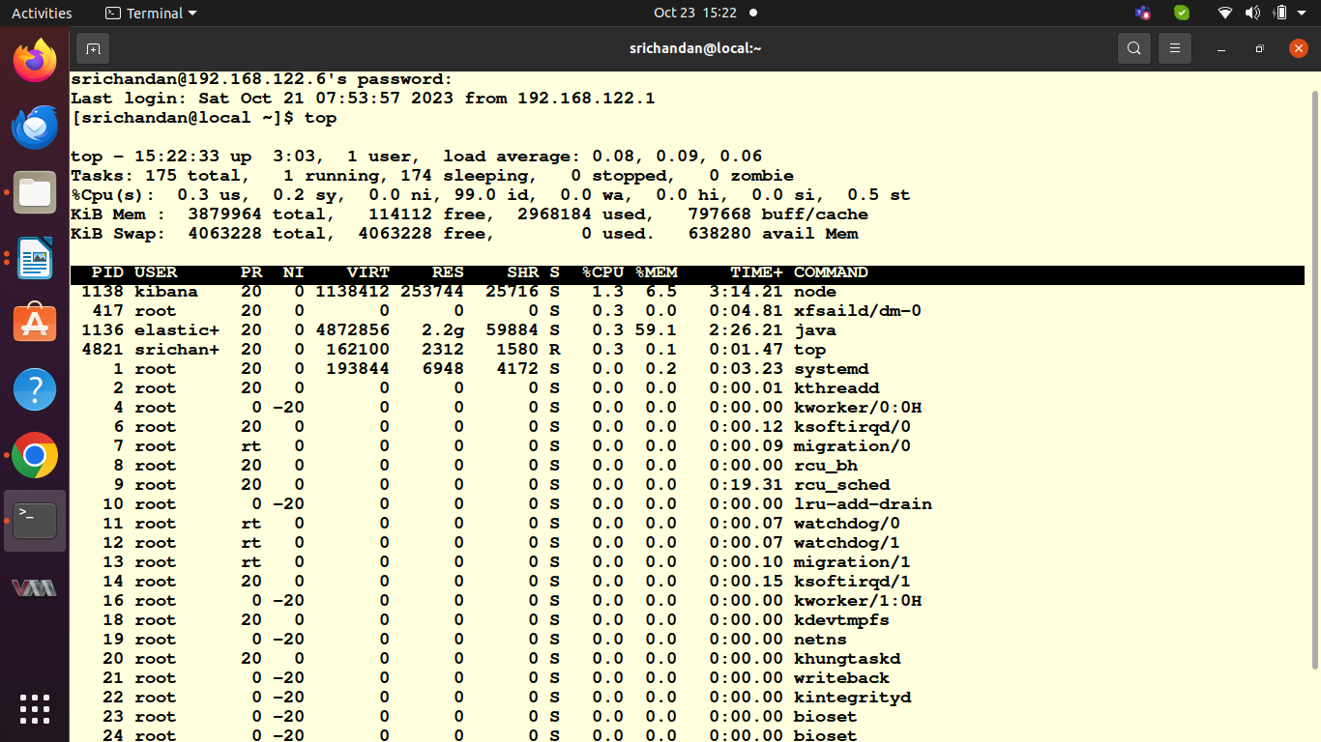
pic 8.1

Task 2:
I installed on my centos vm and i run using “htop” command.bellow is the screenshot of htop command.
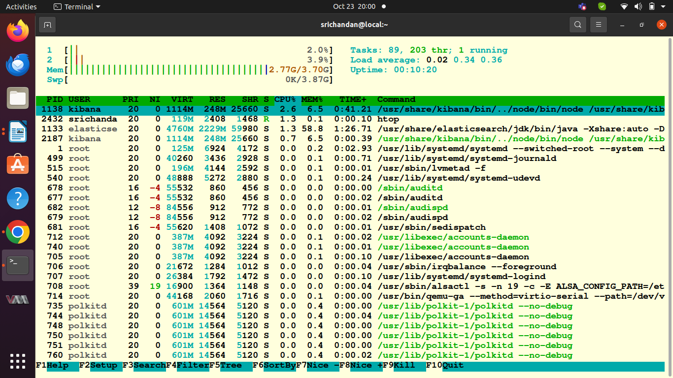
Pic 8.2

Key differences between “top” and “htop”
- User interface : htop provides a more visually appealing and interactive interface compared to the plain text output of top . Htop uses color-coding to make it easier to distinguish different types of processes and resource utilization.
- Interactive : htop allows you to interactively manage processes and system resources. You can use your keyboard to send signals, change process priorities, and even sort the process list based on various criteria without needing to remember specific key combinations.
- Tree View : htop displays processes in a tree view, making it easier to understand the hierarchy of processes. This can be particularly helpful for identifying pasent and child processes.
- Scrollable Process List : htop provides a scrollable list of processes, which means you can browse through all running processes, not just the ones that fit on a single screen. This is very useful in cases with many processes.
- Resource Meters : htop offers separate, dynamic meters for CPU, memory, and swap usage at the top of the screen, making it easy to monitor these resources at a glance.
- Customization : htop allows you to customize the columns and their order, so you can choose which information you want to see in the process list.
- Process Search : htop provides a search feature, which makes it easy to find specific processes.
- F4 shortcut :Presseing F4 in htop lets you filter processes interactively based on user, process name, or other criteria.
In summary htop is a more user-friendly and feature rich alternative basic top command.

Task 3:
- Using df to Display disk space usage :
Here i used command “df -h “. This command to display information about disk space usage on your system. The ‘ -h’ option is used to display sizes in human-readable format (e.g., GB, MB).
The output listed all mounted filesystems along with information on the total size, used space, available space, and utilization percentage for each. We can see how much space is available on each disk partition. The below image is the output of df command.
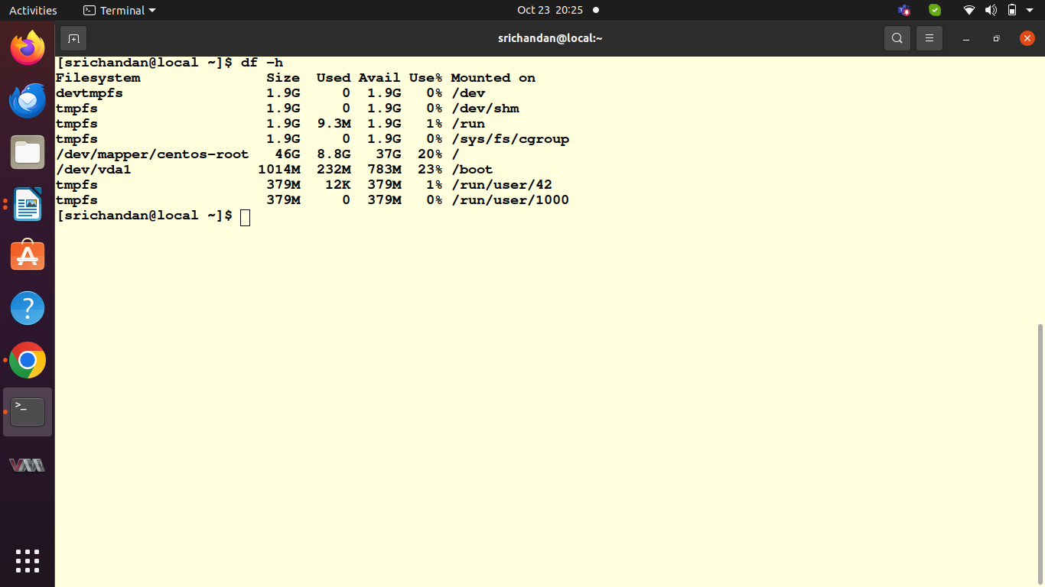
pic8.3
- Using du to calculate Directory size :
To calculate the size of a specific directory, navigate to the directory in terminal, and run the du command . For example i used du command in my /var/log directory using “du -sh /var/log”
‘-s’ : Summarizes the total size of the specified directory.
‘-h’ : Displays the size in a human-readable format.
Below is the screenshot of above command.
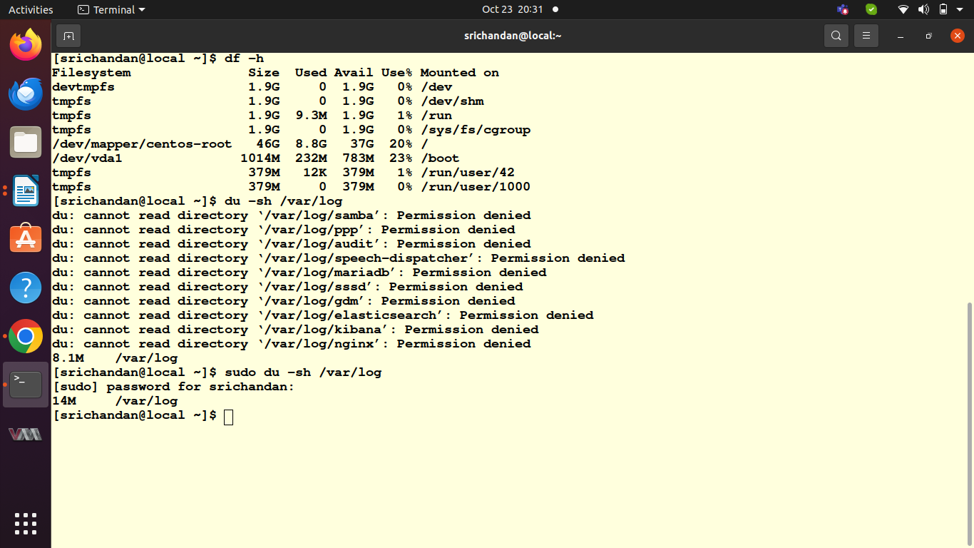
Pic 8.4
- Finding Largest Directories :
  - To find and report on the largest directories consuming disk space on system, i used the ‘du’ command with the ‘sort’ and ‘head’ commands to list the top directories in your home directory, we can use
“du-h –max-depth=1 $HOME | sort -rh | head -n 10”
-h : Displays sizes in a human-readable format.
--max-depth=1 : Limits the depth of the directory tree to 1 level (only immediate subdirectories).
Sort -rh : Sorts the output in reverse numerical order (largest first).
Head -n 10 : displays the top 10 results.
This command will list the largest directories in your home directory.

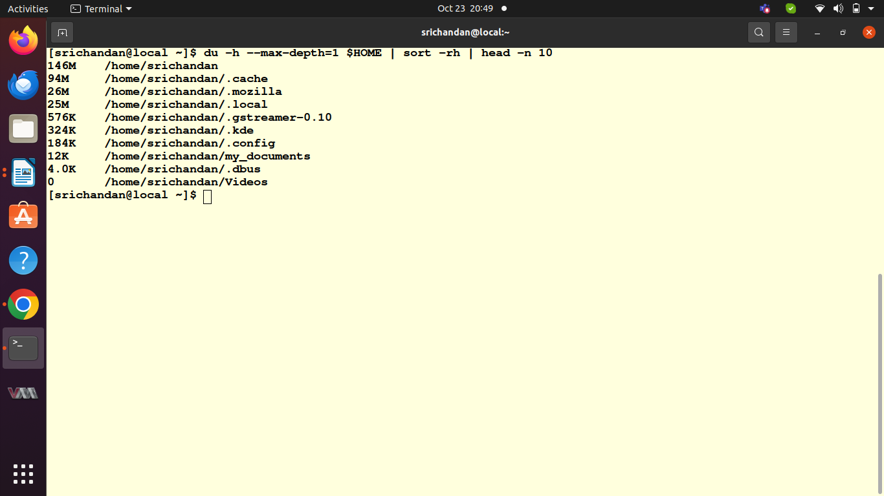
Pic 8.5
Task 4 :
To install iftop “sudo yum install iftop “ command used
When we run iftop we see a real-time display of network activity.
Some of the observations were given below :
- Networking Interface : iftop will ask to select the network interface to monitor.
- Display : i saw a list of network connections in real-time. It displays information about the source and destination IP addresses, the data transfer rates (in both directions), and the total data transfer over time. These connections are sorted by the amount of data transferred.
- User interface : iftop provides a color-coded interface where you can easily distinguish incoming and outgoing traffic. It uses color to highlight the most active connections.
- Sort and fltering : we can press specific keys (e.g., 's' to sort by a different column or 'n' to apply a display filter) to customize the view and focus on specific network connections.
Below is the screenshot of above
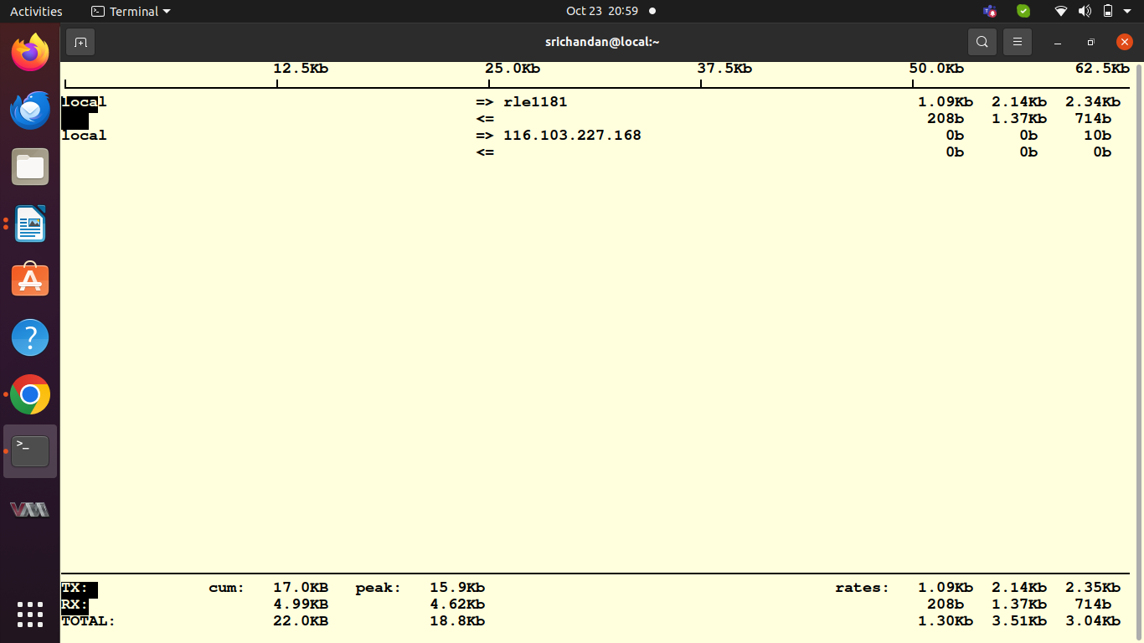
pic 8.6
Task 5 :
run the below command to obtain information about the kernel version and system architecture :
“unsme -a’
The output will include details such as the kernel version and system architecture.
Use the lsb_release -a command to gather information about Linux distribution:
“lsb_release -a ” this command provides details about the distribution name, release number, description, and code name.
I run the hostnamectl command o obtain comprehensive system information, including the hostname, operating system, kernel, and more:
hostnamectl command provides a detailed overview of your system, including the hostname, operating system, kernel, architecture, and more.
Below is the output of above task
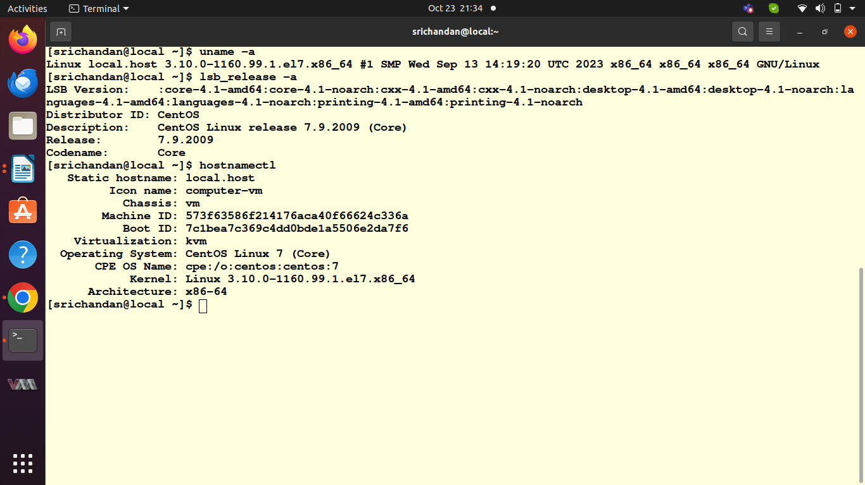
pic 8.7

