Exploring Secure Shell

Task 1 :
SSH, which stands for Secure Shell, is a network protocol that provides a secure and encrypted means of connecting to and managing remote computers over an insecure network. It was designed to address the vulnerabilities of earlier remote access protocols like Telnet, which transmitted data, including login credentials, in plain text. SSH offers a robust and trustworthy way to access and control systems, making it a cornerstone of computer security.

Key points :
- Encryption :
SSH encrypts all data transmitted between the client and server. This encryption prevents eavesdropping, ensuring that sensitive information, such as passwords and data, remains confidential.
- Authentication :
SSH uses various authentication methods, including passwords, public-key cryptography, and multi-factor authentication, to verify the identity of users attempting to access a remote system. This strengthens security by reducing the risk of unauthorized access.
- Data integrity :
It also ensures data integrity, meaning that data sent via SSH is protected from tampering or alteration during transit.
- Port forwarding :
SSH allows for secure tunneling and port forwarding, enabling users to securely access network services that would otherwise be vulnerable to external attacks.
- Remote Administration :
SSH is commonly used for remote system administration. System administrators can securely manage servers and network equipment from any location, reducing the need for physical access.
- File Transfer :
SSH can be used for secure file transfers with utilities like SFTP (SSH File Transfer Protocol) or SCP (Secure Copy Protocol). These tools provide a secure alternative to FTP and RCP.

Real world Scenarios where SSH is used :

- Server Management : System administrators use SSH to remotely manage servers and network devices. They can perform tasks such as software updates, configuration changes, and troubleshooting without being physically present at the data center or server location.
- Secure File Transfer : SSH is employed for secure file transfers between computers, often with the help of SFTP or SCP. This is especially critical in business environments where sensitive data needs to be transferred between locations securely, such as financial transactions or healthcare records.

Task 2 :
Key components of an SSH system :
- Client :The SSH client is a software application or command-line tool installed on a user's local computer. It initiates the connection to a remote server using SSH. The client is responsible for establishing a secure communication .
- Server : The SSH server, installed on the remote system, listens for incoming SSH connections. It is responsible for authenticating clients and providing access to the server's resources. The server securely manages and executes the commands or requests from the SSH client.
- SSH Protocol : The SSH protocol is the set of rules and conventions that govern how the client and server communicate securely. It defines the encryption algorithms, authentication methods, and data exchange procedures used during the SSH session. The protocol ensures the confidentiality, integrity, and authenticity of data transferred between the client and server.
- User Authentication : Authentication is a fundamental part of SSH. It verifies the identity of the user or client connecting to the server. Common authentication methods in SSH include passwords, public-key authentication, and multi-factor authentication. Proper authentication is crucial to prevent unauthorized access.
Roles of SSH in Authentication and their advantages :
SSH keys are cryptographic key pairs consisting of a public key and a private key. Here's how they work and their advantages over password-based authentication:
- Authentication role : When a user sets up SSH keys, they generate a pair of keys - a public key and a private key. The public key is placed on the remote server, while the private key remains on the client. During authentication, the client proves its identity by presenting the private key, and the server verifies it using the corresponding public key.
- Advantages Over Passwords:
  - Enhanced Security : SSH keys provide a higher level of security compared to password-based authentication. Since the private key is never transmitted over the network, it is highly resistant to interception by attackers.
  - Resistance to Brute-force attacks : Passwords can be vulnerable to brute-force attacks, where attackers try multiple combinations until they guess the correct password. SSH keys, with their complexity and length, make such attacks virtually impossible.
  - Elimination of Password Management : SSH keys eliminate the need for users to remember complex passwords. This reduces the risk of weak passwords or password reuse, which is common in password-based systems.
  - Ease of Automation : SSH keys are essential for automated tasks, as they allow for passwordless logins. This is especially valuable in scripting and batch processing, where user interaction is not possible.
  - Two-factor Authentication : SSH keys can be combined with other authentication factors to create a multi-factor authentication (MFA) setup. This adds an additional layer of security by requiring both something the user knows (the private key) and something the user has (e.g., a password or a smartcard).
Taske 3:
I am using OpenSSH on my Linux system.
I installed using “ sudo apt install Openssh” command. We can check ssh installed or not using “ssh -V” command. I provided a screenshot of above task
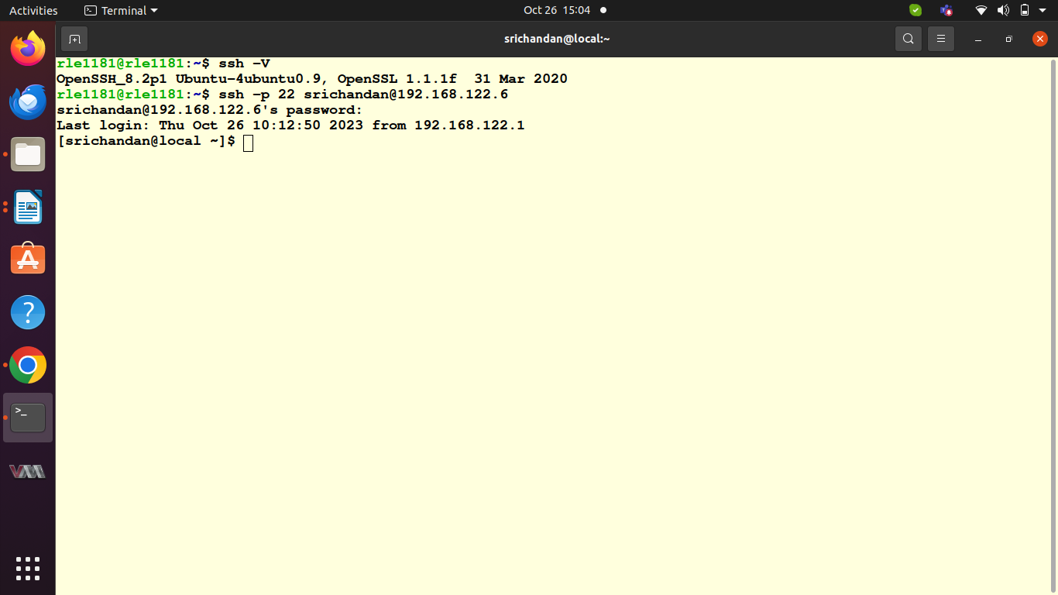
pic 9.1
In the pic 9.1 it is visible that i suucessfully connected with a remote server.

Task 4 :
In this task i created a file named “hello.txt” and i transfer it between my local and remote server. The screenshot of above task is given below.
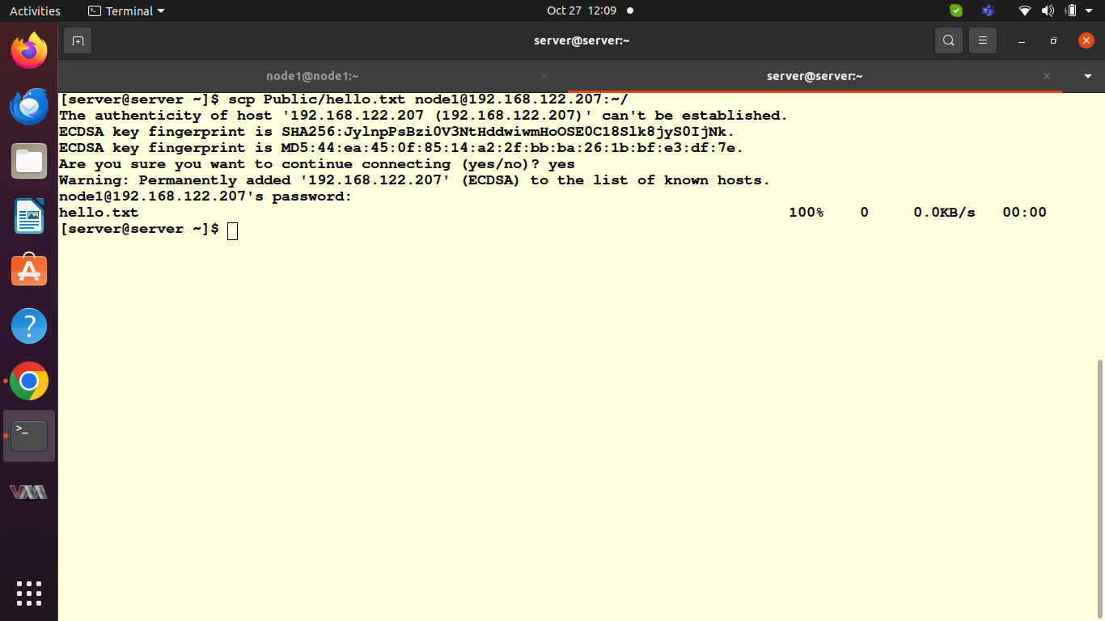
Pic 9.2
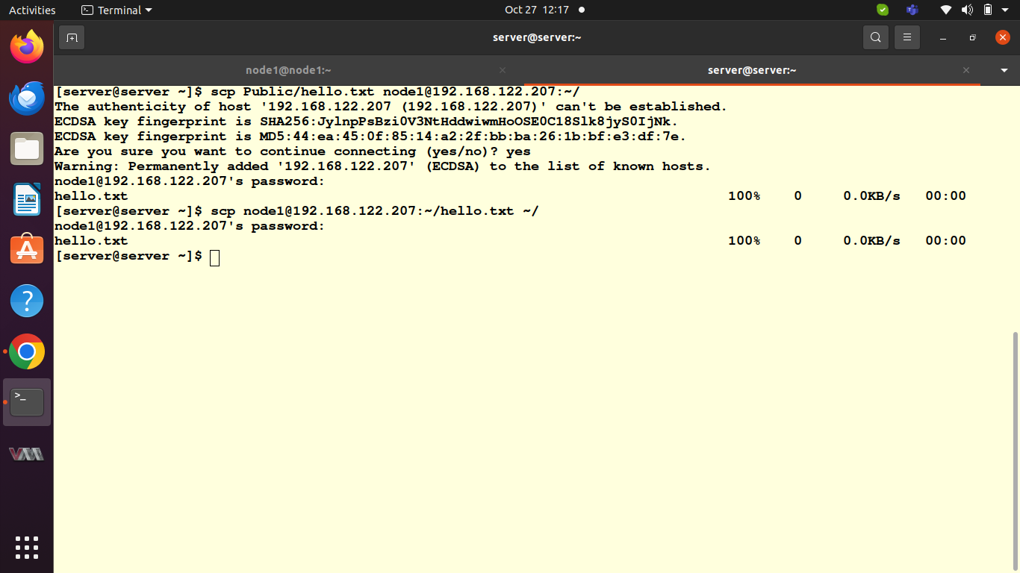
pic 9.3

Task 5 :
To generate an SSH key pair on my local i used “ssh-keygen” command, which is a standard tool for generating SSH keys.The command is “ssh-keygen -t rsa -b 2048 -C "srichandan.hota@relevancelab.com" -f ~/.ssh/srichandan_key”.

Purpose of SSH Key Pairs and They Enhance Security:
SSH key pairs serve the following purposes and enhance security:
- Authentication :SSH key pairs are used for authenticating users and servers. The private key is kept secret on your local machine, while the public key is stored on the remote server. This means that even if someone gains access to your public key, they cannot authenticate without the private key.
- Eliminating Passwords: With SSH keys, you can perform passwordless logins, enhancing security by removing the risk of weak or compromised passwords. Instead, the private key is used for authentication.
- Stronger Security : SSH keys provide a high level of security due to their complexity and the use of asymmetric cryptography. They are resistant to brute-force attacks and unauthorized access.
- Identity Verification : SSH keys provide strong proof of identity for the user, making it difficult for attackers to impersonate users or servers.
Storing Public key:
i stored public key in a file with .pub extension in `/.ssh directory,and the command is “cat ~/.ssh/srichandan_key.pub” .
Task 6:
I created the SSH cpnfig file using a text editor and the command is “nano ~/.ssh/config”
Add the following lines to the “~/.ssh/config” file to specify your SSH key for the remote server. Replace my_key_name, “user_name” and “remote_server” with the appropriate values:
save the config file.
Now we can use using ssh remote_server using key-based authentication.
Below is the screenshot of above task
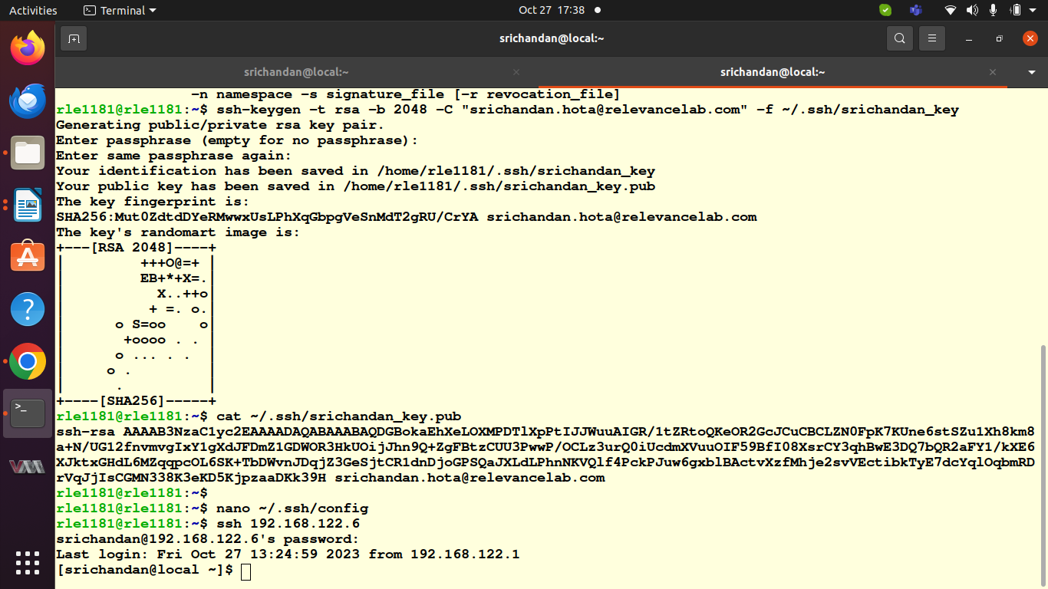
pic 9.4

Task 7:
SSH Security Best Practices :
- Disable root Login : Disabling root login via SSH is crucial for security. The root account has unrestricted access to the entire system, making it an attractive target for attackers. If root login is allowed, attackers can repeatedly attempt to gain access to the root account, increasing the risk of a successful attack.
- Use Strong Passpharases or Passpharases-protected keys :
Strong passphrases or passphrase-protected SSH keys add an extra layer of security. If an attacker somehow gains access to your private key, they would still need the passphrase to use it. This makes it significantly harder for unauthorized users to misuse your keys.
- Implement Multi-factor Authentication: MFA adds an extra layer of security by requiring at least two forms of authentication for SSH access. Even if an attacker obtains your SSH key or password, they would still need the secondary factor, such as a one-time code from a mobile app, to gain access.

