AI/Tech Project Lifecycle Documentation
Flow Cast AI: Intelligent Inventory Forecaster

Project Type: AI/ML Web Application
Domain: Retail, Inventory Management, Supply Chain Analytics
Primary ML Capability: Demand Forecasting and Inventory
Optimization Target Users: Retail managers, inventory planners, procurement teams, operations analysts, and small-to-medium distributors
1. Phase One — Business Understanding and Problem Definition
1.1 Business Problem
Retailers frequently experience two competing inventory problems:
· Stockouts: Products are unavailable when customers want them.
· Overstock: Too much inventory is purchased for products with insufficient demand.
Lost sales, bad customer experience, and lower customer loyalty can all be the outcome of stock-outs. Overstock means higher storage costs, lower working capital, and possibly markdowns or wasted merchandise.
Traditional inventory management techniques rely on static reorder points or simple past averages. These methods may not be responsive to:
· Seasonal demand
· Product promotions
· Holidays
· Sudden demand spikes
· Regional differences
· Price changes
· Product lifecycle changes
· Changing customer behavior
Flow Cast AI uses intelligent inventory recommendations and machine-learning-based demand forecasting to solve this issue.
1.2 Business Objective
The primary objective is to provide inventory decision-makers with accurate product-demand forecasts that allow them to make better purchasing and stocking decisions.
The application should answer questions such as the following:
· How many units of a product are likely to sell next week?
· What products are at risk of going out of stock?
· Which products are currently overstocked?
· How much inventory should be reordered?
· Which products are experiencing unusual demand?
· Why is demand expected to increase or decrease?
1.3 Example Business Scenario
A retailer currently has:
Product: Wireless Headphones
Current Inventory: 260 units
Average Daily Sales: 11 units
Supplier Lead Time: 10 days
Expected Demand: Next 30 Days: 420 units
Flow Cast AI predicts:
· Stockout probability: 87%
· Expected stockout date: 12 days
· Recommended reorder quantity: 240 units
· Demand trend: Increasing
· Primary demand driver: Upcoming promotion
The user can immediately convert this forecast into a purchasing decision
1.4 Project Scope
The initial MVP supports:
· CSV sales-data upload
· Product-level demand forecasting
· 7-day, 14-day, and 30-day forecasts
· Inventory health dashboard
· Stockout-risk calculation
· Overstock detection
· Reorder recommendations
· Forecast visualization
· Product-level analytics
· Model confidence indicators
· Forecast explanation
· Basic anomaly detection
· Downloadable forecast reports
Future Scope:
POS integrations, Automated purchase orders, Multiple warehouse support, AI inventory assistant, advanced scenario simulation
Scalability
Initial target:
· 1,000–50,000 SKUs
· Millions of historical sales records
Security
HTTPS, Authentication, Authorization
1.5 Business Success Metrics
Primary KPIs include:
Forecast Accuracy
MAPE < 20% where appropriate.
Stockout Reduction
20% reduction in stockout events.
Excess Inventory Reduction
10–15% reduction in unnecessary inventory.
Inventory Turnover
Measure improvements in inventory utilization.
Working Capital
Estimate money released through inventory optimization.

2. Phase Two — Data Understanding and Data Collection
2.1 Data Requirements
The forecasting model requires historical sales transactions aggregated by product and time.

Core Dataset
Field | Description
date | Transaction or aggregation date
product_id | Unique SKU identifier
product_name | Product description
category | Product category
units_sold | Number of units sold
price | Selling price
inventory_level | Available inventory
promotion | Promotion indicator
store_id | Store identifier

2.3 Example Raw Dataset
Date | Product | Category | Units Sold | Price | Inventory | Promotion
2026-01-01 | SKU001 | Electronics | 18 | 99.99 | 420 | 0
2026-01-02 | SKU001 | Electronics | 21 | 99.99 | 399 | 0
2026-01-03 | SKU001 | Electronics | 32 | 89.99 | 367 | 1
2026-01-04 | SKU001 | Electronics | 38 | 89.99 | 329 | 1
2.4 Exploratory Data Analysis
Before ML modeling, the team should understand the behavior and quality of the dataset. The dataset is validated and modified in various aspects.
3. Design & Prototype
3.1 Data Cleaning Pipeline
The preprocessing pipeline will:
1. Parse timestamps.
2. Remove invalid records.
3. Resolve duplicate observations.
4. Handle missing values.
5. Normalize product identifiers.
6. Generate continuous time series.
7. Correct invalid inventory values.
8. Detect outliers.
9. Generate features.
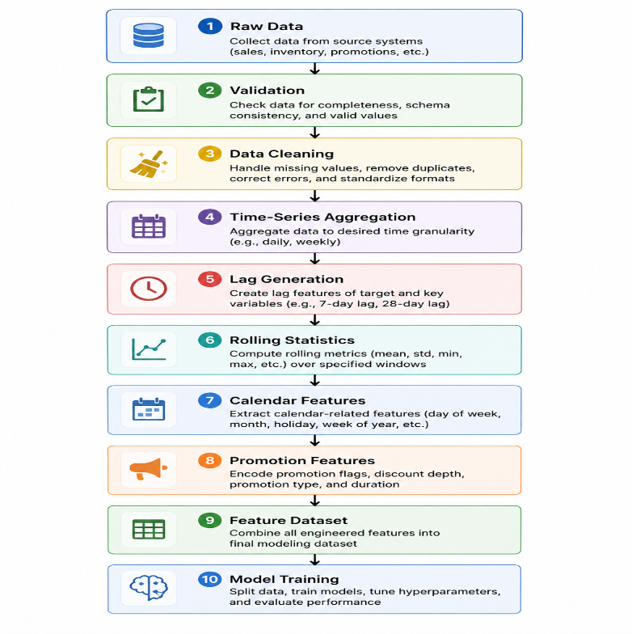
3.2 Modeling Strategy
Multiple forecasting methods should be evaluated.
The first version should include:
Baseline Model
Historical average.
Example:
Prediction = average sales during previous 7 days
This provides a reference point.
A sophisticated model is useful only if it performs better than a simple baseline.

3.3 Recommended MVP Model
Recommended architecture:
LightGBM or XGBoost Global Forecasting Model
Instead of training one model for each SKU, the application can train one model using data across many products.
Features include:
product_id
category
store
lag_1
lag_7
lag_14
lag_28
rolling_mean_7
rolling_mean_30
price
discount
promotion
day_of_week
month
holiday
Target: Next_day_units_sold
3.4 System Architecture
Recommended architecture
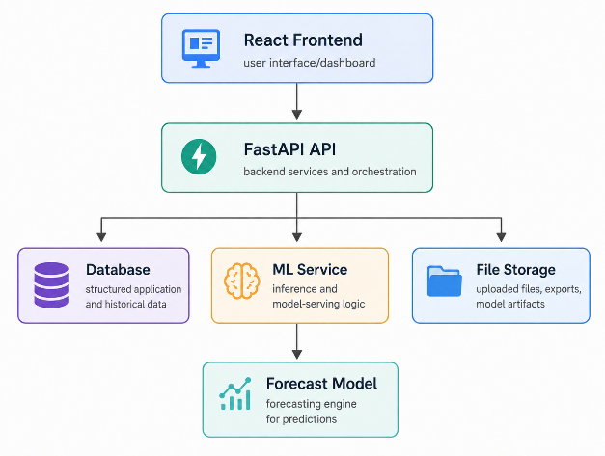

3.5 Recommended Technology Stack
Frontend
React or Next.js(Chosen React as it’s light weight application)
Libraries: Tailwind CSS, Recharts, Axios
Backend
Python FastAPI
Reasons:
· Native Python ML integration
· High performance
· Automatic API documentation
Database
PostgreSQL
Store: Users, Products, Inventory, Sales, Forecasts, Alerts, Model metadata
ML Stack
Python
Libraries: pandas, numpy, scikit-learn, lightgbm, xgboost, statsmodels, shap, mlflow
User workflow:

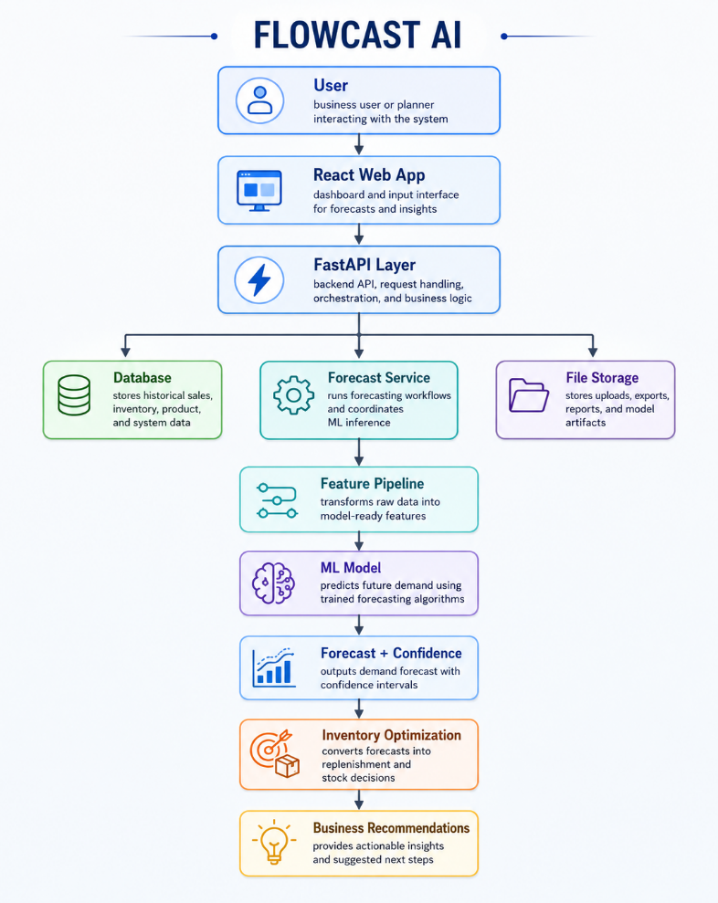
3.6 API Design
API could be around the forecast product API, inventory risks API, and product analytics API.
Visualizations/UI Screens:
· Demand trend
· Forecast vs actual
· Stockout-risk distribution
· Inventory by category
· Top-demand products

4. Phase Five—Model Evaluation, System Testing and Validation
4.1 Offline Model Evaluation
Compare candidate models against baseline forecasting.
Example evaluation:
Model | MAE | RMSE | WAPE
7-Day Average | 13.2 | 21.4 | 24.8%
Prophet | 11.7 | 18.9 | 20.5%
XGBoost | 8.9 | 14.6 | 15.2%
LightGBM | 8.6 | 14.1 | 14.8%
Best candidate: LightGBM
4.2 Time-Series Cross-Validation
Use rolling validation.
Example:
Train Jan–Jun → Test July
Train Jan–Jul → Test August
Train Jan–Aug → Test September
This more accurately simulates production forecasting.
4.3 Segment-Level Evaluation
Overall accuracy can hide poor performance.
Example:
Electronics WAPE: 12%
Clothing WAPE: 17%
Seasonal WAPE: 23%
4.4 Business-Level Evaluation
ML accuracy alone is insufficient.
Test whether forecasts improve stock availability, stockout rate, inventory carrying cost, and lost sales.
Unit Testing, Integration Testing on all features and Apis , error handling and authentication

5. Deployment
5.1 ML-Ops Pipeline
Production lifecycle:
New Data
↓
Data Validation
↓
Feature Pipeline
↓
Model Training
↓
Model Evaluation
↓
Model Registry
↓
Deployment
↓
Monitoring
↓
Retraining
5.2 CI/CD
Developer commits code
↓
GitHub
↓
Automated tests
↓
Docker build
↓
Security checks
↓
Staging deployment
↓
Integration tests
↓
Production deployment
5.3 Cloud Deployment
Suitable platforms include AWS, Azure, and Google Cloud.
5.4 Alerting
Trigger alerts when stockout probability > 80%, forecast error > defined threshold, or data pipeline fails
5.5 Retraining Strategy
Possible schedule:
Daily: Update forecasts.
Weekly: Update features
Monthly: Retrain model
Quarterly: Full model evaluation
High-volume retailers may require more frequent retraining.
Phase 6 - User Feedback & Iteration
6.1 Proposed MVP Roadmap
Sprint 1—Foundation of project, front-end and back-end, and ML models
Sprint 2 — Data Pipeline
Sprint 3 — Baseline Forecasting
Sprint 4 — ML Forecasting
Sprint 5 — Inventory Intelligence
Sprint 6—Dashboard and initial testing
Sprint 7 — Explainability and overall testing and signoff
Sprint 8 — Production deployment
Afterwards, the same life cycle could be utilized for other new features and components based on demand and signed requirements for a year or so.
Flow Cast AI will be considered successful when the system can:
1. Accept historical retail sales and inventory data.
2. Automatically validate and prepare the data.
3. Forecast future SKU-level demand.
4. Consistently outperform basic forecasting baselines.
5. Estimate stockout and overstock risks.
6. Generate actionable reorder recommendations.
Final Product Vision
Flow Cast AI generates a forecasting dashboard into an AI-powered inventory decision platform with visual analysis and operating mechanisms.

Executive summary
Flow Cast AI: Intelligent Inventory Forecaster is an AI/ML-powered web application that helps businesses make smarter inventory planning decisions by forecasting future product demand. The app does not simply rely on historical averages or manual estimates. It uses historical sales and inventory data to identify demand patterns and generate forecasts for the periods ahead. Flow Cast AI’s primary goal is to help businesses keep the right amounts of stock while also reducing the danger of both too much and too little inventory.
The program gives customers a single point of entry to view inventory information, past sales trends, and insights into projected future demand. Flow Cast AI turns raw business data into predictions and visual insights that are relevant, allowing inventory managers and decision-makers to easily discover products that may need restocking, products that could be overstocked, and products that are experiencing shifts in demand.
The forecasting model learns the trends and relations in this data and predicts the future product demand. Improved demand forecasts can also help suppliers with planning and boost customer satisfaction since popular products are more likely to be in stock when customers want them. At the same time, businesses can avoid tying up capital in things that will not sell rapidly.
Overall, Flow Cast AI is a model for how machine learning might be applied in a real-world web application to tackle a typical supply-chain problem.
List of AI prompts used:
- Generate 3 different AI/ML web application use cases for me to choose from. Make them diverse and interesting. For each option, provide: 1. Company Name 2. Industry/Sector 3. The Problem (2-3 sentences) 4. The AI/ML Solution (1-2 sentences) 5. Why this would be valuable Include at least one RAG-based application in the options. Make them realistic but innovative, something a small team could actually build.
- I'm building Option 2, Flow Cast AI—Intelligent Inventory Forecaster. Generate comprehensive documentation for all 6 phases of the AI/Tech Project Lifecycle
How AI accelerated the documentation process:
AI has greatly accelerated the documentation process for the Flow Cast AI project by assisting in the transformation of high-level project ideas into a well-organized and detailed lifecycle document in a considerably shorter timeframe. AI helped to structure the project in separate phases rather than writing each section from scratch. This gave us more time to review assumptions, refine technical decisions, and ensure the proposed solution remained realistic and aligned to the business problem.

References:
https://chatgpt.com/( prompts to data reports, grammar and refining, diagrams and flowcharts)
https://aws.amazon.com/what-is/sdlc/

