**WEB TECHNOLOGIES**

**LAB RECORD**

**LAB CODE: 20ITL401**



**DEPARTMENT OF INFORMATION TECHNOLOGY**

**Bapatla Engineering College :: Bapatla (Autonomous)**

**(Affiliated to Acharya Nagarjuna University) BAPATLA – 522101, A.P**

BAPATLA ENGINEERING COLLEGE DEPARTMENT OF INFORMATION TECHNOLOGY WEB-TECHNOLOGY



**CERTIFICATE**

This is to certify that the experiments recorded in this book is the bonafide work

of _ _ _ _ _ _ _ _ _ _ _ _ _ _ _ _ _ _ bearing Regd. No. _ _ _ _ _ _ _ _ _ _ _ _

a student of **2/4 IT-** B.Tech ( Information Technology) carried out in the subject

**Web Technology** Lab in the Bapatla Engineering College, Bapatla during the year of experiments recorded are____.

Prof **N. Sivaram Prasad**

LECTURER-IN-CHARGE HEAD OF THE DEPARTMENT

**INDEX**

|  |  |  |  |
| --- | --- | --- | --- |
| S.no | Topic | Page.no | Date |
| 1. | Develop a html program to demonstrate:  a) Formatting tags  b) Different types of lists  c)Timetable | 5-8  9-10  11-15 |  |
| 2. | Develop a html program to demonstrate:  a) Internal LINK, External Link, Image Link  b) Frames using ID  c)Image map | 16-18  19-21  22-23 |  |
| 3. | Develop a html program to demonstrate:   1. Student Registration Form   b) label, Text Area, legend, option, optgroup | 24-26  27-28 |  |
| 4. | Develop a program to demonstrate:   1. Internal, Inline, External Style Sheets in css 2. Query selectors | 29-36  37-38 |  |
| 5. | Develop a java script program to demonstrate:  a) Mouse-events  b) Form-events  c)Popups | 39-42  43-45  46-48 |  |
| 6. | Develop a java script program to demonstrate the following objects:  a) String  b) Math  c)Date | 49-50  51-52  53-54 |  |
| 7. | Develop a java script program to demonstrate the following Browser objects:  a) Window  b) Document | 55-56  57-58 |  |
| 8. | A) Develop a java script program to demonstrate the following Dom operations:   1. Create Element 2. Remove Element 3. Duplicate Element 4. Insert the Element Before   B) Develop a java script program to demonstrate basic calculator operations | 59-61  62-64 |  |
|  | Write a program to demonstrate :   1. Internal dtd 2. External dtd | 65-66  67-68 |  |
| 10. | Develop an XML file to store the student data and validate using XSD | 71-63 |  |

**Experiment:** 1 a) **Date:**

**Aim:** Demonstrate all the basic tags in HTML 5 for Formatting tags

1. **Physical tags**

**Source code:**

<!DOCTYPE html>

<html>

<head>

<title>formating tags</title>

</head>

<body>

<h1>Physical tags</h1>

<p>BEC Bapatla Engineering college</p>

<i>BEC Bapatla Engineering college</i><br>

<b>BEC Bapatla Engineering college</b><br>

<u>BEC Bapatla Engineering college</u><br>

<big>BEC Bapatla Engineering college</big><br>

<small>BEC Bapatla Engineering college<small><br>

BEC <sup> Bapatla Engineering college</sup><br>

BEC <sub> Bapatla Engineering college</sub><br>

</body>

</html>

**Output:**

1. **Logical tags**

**Source code:**

<!DOCTYPE html>

<html>

<head>

<title>logical tags</title>

</head>

<body>

<p><abbr title="Hyper Text Markup language">

HTML</abbr></P>

<p><dfn title="geeks"> GeeksforGeeks is a Computer Science

</dfn>portal for geeks.</P>

<p><em>Physical and Logical tags are used in HTML for

</em>better visibility and understanding of the text by

the user on the web page</p>

<p><mark>Branches </mark>of BEC are CS,IT,EE</p>

<p>Branches of BEC are CS,IT,EE,EC,EI,CH,ME,

<ins>DS,CS</ins></p>

<p>Branches of BEC are CS,IT,EE,EC,EI,CH,ME,<del>

CH,ME</del></p>

<p><strong>We are delighted to inform you that you are

</strong>going to be part of GfG journey.</p>

<p><q>We are delighted to inform you that you are </q>going

to be part of GfG journey.</q></p>

<p>In classical physics <blockquote>and general chemistry,

<blockquote> matter is any substance that has mass

and takes up space by having volume.</p>

<p> GeeksforGeeks<kbd> -This is a</kbd>Keyboard

input</p>

<p> It contains well written,well thought and well explained

<bdo dir="rtl"> computer </bdo> science and

programming articles, and quizzes.</p>

<p><code>#include stdio.h printf("hello world"></code></p>

<p><samp>hello world</samp></p>

</body>

</html>

**Output:**

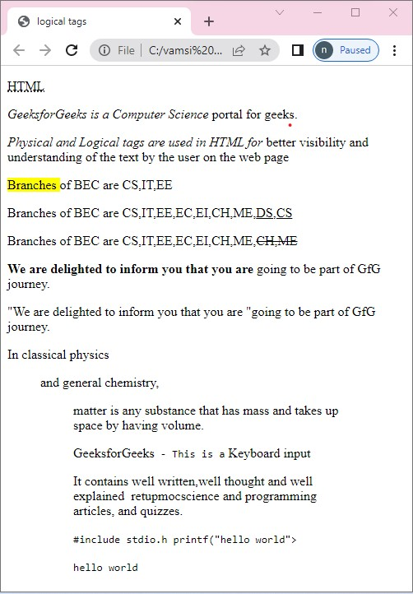

**Experiment:** 1 b) **Date:**

**Aim:** DemonstrateRepresenting type of list in HTML 5

**Source code:**

<!DOCTYPE html>

<html>

<body>

<h1>ordered list</h1>

<ol>

<li>apple</li>

<li>banana</li>

<li>mango</li>

</ol>

<h2>fruits list</h2>

<ul>

<li>apple</li>

<li>banana</li>

<li>mango</li>

</ul>

<dl>

<dt>BEC</dt>

<dd>Bapatla Enginnering College</dd>

</dt>

</body>

</html>

**Output:**

**Experiment:** 1 c) **Date:**

**Aim:** Demonstratetime table creation of list in HTML 5

**Source code:**

<!DOCTYPE html>

<html>

<head>

<title>Time Table</title>

</head>

<body>

<div style="width:2%;float:left" align="right">

<img src="bec.png" width="90" height="90">

</div>

<div style="width:98%;float:center">

<p align="center"><b>Bapatla Engineering College </span>

</b> <br> (Autonomus) <br>

Department of Information Technology <br>

. <span style="color:brown"> <i>Class Time Table for the <span style="background-color:yellow"><u> A.Y2021-22,IV Semester </u> </span> </i> </span> </p>

</div>

<hr>

<div style="float:left">

<table>

<td colspan="2"><i>w.e.f:</i>28-03-2022</td>

<td><pre> </pre></td>

<td colspan="2"><i>Class:</i>2 II B.Tech,IT</td>

<td><pre> </pre></td>

<td colspan="2"><i>Section:</i>2A</td>

<td><pre> </pre></td>

<td colspan="2"><i>Room No:</i>2RPLH-03</td>

</table>

<table border="2">

<tr style="background-color:orange">

<th>Time <br>Day</th>

<th>7:30-<br>8:20</th>

<th>8:20-<br>9:10</th>

<th>9:10-<br>10:00</th>

<th rowspan="7">B<br>R<br>E<br>A<br>K</th>

<th>10:30-<br>11:20</th>

<th>11:20-<br>12:10</th>

<th>12:10-<br>01:00</th>

</tr>

<tr align="center">

<th style="background-color:orange">Mon</th>

<td>PHEV</td>

<td>DAA</td>

<td><small>PYTHON<br>

PROGRAMMING</small></td>

<td>WT</td>

<td>p&s </td>

<td>DBMS</td>

</tr>

<tr align="center">

<th style="background-color:orange">Tues</th>

<td colspan="3">WT/RDBMS LAB</td>

<td>DBMS</td>

<td><small>PYTHON<br>

PROGRAMMING</small></td>

<td>WT</td>

</tr>

<tr align="center">

<th style="background-color:orange">Wed</th>

<td>p&s</td>

<td>DAA</td>

<td>WT</td>

<td colspan="3">RDBMS/Python Prog.lab </td>

</tr>

<tr align="center">

<th style="background-color:orange">Thus</th>

<td>PHEV</td>

<td><small>PYTHON<br>

PROGRAMMING</small></td>

<td>DBMS</td>

<td>p&s </td>

<td>WT</td>

<td>DAA</td>

</tr>

<tr align="center">

<th style="background-color:orange">Fri</th>

<td colspan="3">Python Prog./WT Lab</td>

<td>PHEV</td>

<td>DAA</td>

<td>DBMS</td>

</tr>

<tr align="center">

<th style="background-color:orange">Sat</th>

<td>DAA</td>

<td>DBMS</td>

<td>p&s </td>

<td>PHEV</td>

<td>WT</td>

<td style="background-color:green">Mentoring</td>

</tr>

</table>

</div>

<div style="width:80%;float:right">

<table>

<th style="background-color:blue;color:white">Section

Coordinator: Mr.K.Suresh Kumar,Asst.Professor</th>

</table>

</div>

<div style="float:left">

<table>

<tr style="background-color:orange" align="left">

<th>Sub.Code</th>

<th>Sub.Name</th>

<th>Faculty.Name</th>

<th>Sub.Code</th>

<th>Sub.Name</th>

<th>Faculty.Name</th>

</tr>

<tr align="left">

<th>20IT401/MA03</th>

<td>P&S </td>

<td>Mr.I.Pothuraju </td>

<th>20ITL401</th>

<td>WT Lab</td>

<td>Mr.Sk.Mabasha</td>

</tr>

<tr align="left">

<th>20IT402</th>

<td>WT</td>

<td>Mr.Sk.Mabasha</td>

<th>20ITL402</th>

<td>RDBMS Lab</td>

<td>Mr.P.Ravi Kumar</td>

</tr>

<tr align="left">

<th>20IT403</th>

<td>DBMS</td>

<td>Mr.P.Ravi Kumar</td>

<th>20ITL403 /</th>

<td>Python</td>

<td>Mr.K.Suresh Kumar</td>

</tr>

<tr align="left">

<th>20IT404</th>

<td>DAA</td>

<td>Prof.N.Sivarama Prasad</td>

<th>SO02</th>

<td>Prog.Lab</td>

</tr>

<tr align="left">

<th>MC02</th>

<td>PEHV</td>

<td>Dr.K.Srinivasa Rao</td>

</tr>

</div>

</table>

<hr>

<div style="width:100;float:left">

</body>

</html>

**Output:**

**Experiment:** 2 a) **Date:**

**Aim:** Demonstrateinternal link, external link, image as link type of list in HTML 5 **Source code:**

<!DOCTYPE html>

<html>

<head>

<title>links</title>

</head>

<body>

<h1>Internal link</h1>

<a href="bec.html">click here</a>

<h1>External link</h1>

<a href="http://www.becbapatla.ac.in/">click here</a>

<h1>image link</h1>

<a href="bec.html"><img src="bec.jpg" height="200"

width="200"></a>

</body>

</html>

**Output:**

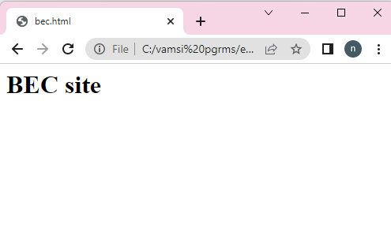

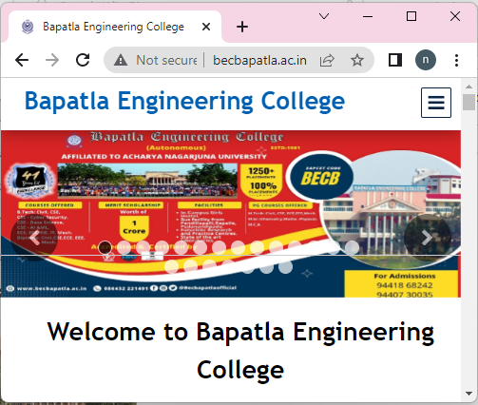

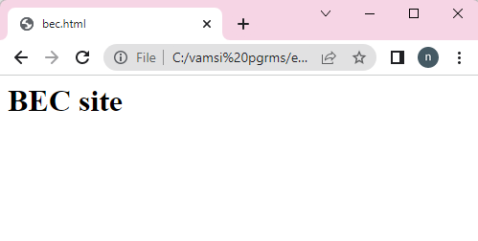

**Experiment:** 1 b) **Date:**

**Aim:** Demonstrateid using frames in HTML 5

**Source code:**

<!DOCTYPE html>

<html>

<head>

<title>Gmail</title>

</head>

<frameset rows="30%,40%,30%">

<frame src="header.html" name="header"/>

<frameset cols="40%,60%">

<frame src="nav.html" name="aside"/>

<frame src="" name="section"/>

</frameset>

<frame src="footer.html" name="footer"/>

</frameset>

</html>

**Header.html**

<!DOCTYPE html>

<html>

<head>

<title>head</title>

</head>

<body>

<h2>GMAIL</h2>

</body>

</html>

**Nav.html**

<!DOCTYPE html>

<html>

<head>

<title>NAVIGATION</title>

</head>

<body>

<nav>

<a href="Inbox.html" target="section">inbox</a><br>

<a href="sent.html" target="section">sent</a><br>

</nav>

</body>

</html>

**Inbox.html**

<!DOCTYPE html>

<html>

<head>

<title>Inbox</title>

</head>

<body>

<h2>Inbox</h2>

</body>

</html>

**Sent.html**

<!DOCTYPE html>

<html>

<head>

<title>sent</title>

</head>

<body>

<h2>sent</h2>

</body>

</html>

**Footer.html**

<!DOCTYPE html>

<html>

<head>

<title>footer</title>

</head>

<body>

<h2>footer</h2>

</body>

</html>

**Output:**

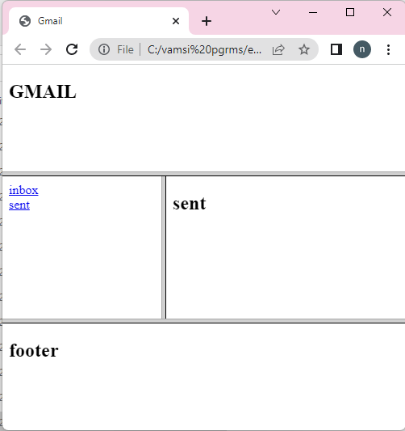

**Experiment:** 1 c) **Date:**

**Aim:** Demonstrateimage map in HTML 5

**Source code:**

<!DOCTYPE html>

<html>

<head>

<title>Image Map</title>

</head>

<body>

<img src="indiamap.jpg" width="500" height="500" alt="india map"

usemap="#india">

<map name="india">

<area shape="circle" coords="200,400,50" href="https://ap.nic.in/">

<area shape="rect" coords="150,440,200,490"

href="https://www.tnstc.in/home.html">

</map>

</body>

</html>

**Output:**

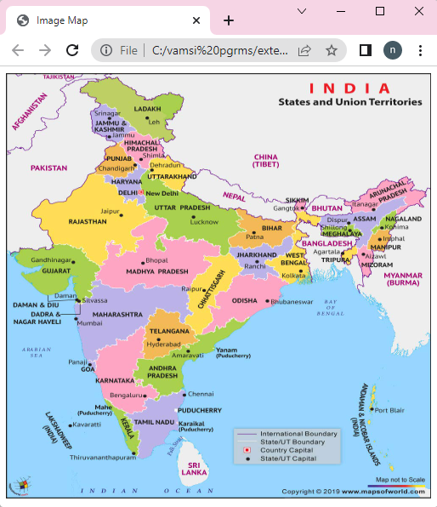



**Experiment:** 3 a **Date:**

**Aim:** ahtml document to create regrstration form using all input fields

**Source code:**

<!DOCTYPE html>

<html>

<head>

<title> forms </title>

</head>

<body >

<div style="background-color:aqua">

<h1 align="center">Register Here</h1>

<form action="header.html">

<label>Name:</label>

<input type="text" name="name"></input></br><br>

<label>Father Name:</label>

<input type="text" name="Fame"></input></br><br>

<label> Mother Name:</label>

<input type="text" name="Mname"></input></br><br>

<label>Phone No:</label>

<input type="text" name="phnno"

maxlength="10"></input></br><br>

<label>Dob:</label>

<input type="date" name="dob"></input></br><br>

<label>Blood Group:</label>

<select>

<option > select</option></br>

<option > O</option></br>

<option > O+</option></br>

<option > A</option></br>

<option > A+</option></br>

</select><br><br>

<label>Gmail</label>

<input type="email" name="gmail"></input></br><br>

<label>Gender:</label>

<input type="radio" name="gen">Male</input>

<input type="radio" name="gen">female</input>

<input type="radio"

name="gen">Others</input><br><br>

<label>Like of Interest:</label>

<input type="checkbox" name="course"> C</input>

<input type="checkbox" name="course"> C++</input>

<input type="checkbox" name="course"> java</input>

<input type="checkbox" name="course">

Python</input><br><br>

<input type="submit" value="submit" >

<input type="reset" value="reset">

</div>

</form>

</body>

</html>

**Output:**

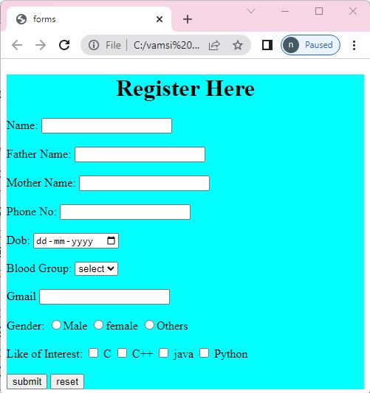

**Experiment**: 3 b **Date:**

**Aim:** a html document to demonstrate to create a form to demonstrate label, textarea, legend, option group, select

**Source code:**

<!DOCTYPE html>

<html>

<head>

<title>FORMs all</title>

</head>

<body>

<form>

<h1>registration form</h1>

<label>address</label>

<input type="text" name="address"></input> <br><br>

<label>Blood group:</label>

<select>

<option>select</option>

<option>A+</option>

<option>B+</option>

<option>AB+</option>

<option>A-</option>

<option>B-</option>

<option>AB-</option>

</select><br>

<label>textarea</label>

<textarea rows="3" cols="100"> </textarea>

<legend style="background-color:blue;color:white">student details</legend>

<optgroup label="Engineering colleges">

<option>BEC</option>

<option>GEC</option>

<option>LBRCE</option>

</optgroup>

</form>

</body>

</html>

**Output:**

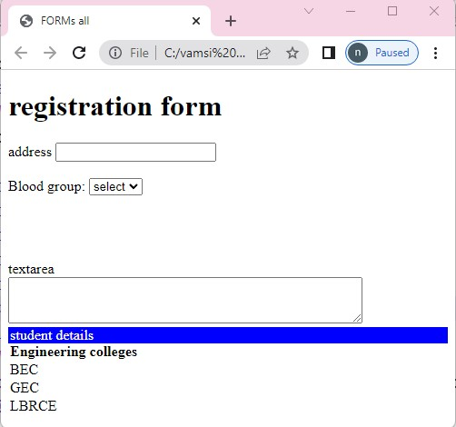

**Experiment:** 4 a) **Date:**

**Aim:** Demonstrateinline, internal, external sheets in CSS

1. **Inline sheet**

**Source code:**

<!DOCTYPE html>

<html>

<head>

<title>Inline style sheet</title>

</head>

<body style="color:red;background-color:pink;font-family:sans-serif">

<h1>Inline style sheet</h1>

<h1 style="font-size:18px">The font size of this heading is

18px</h1>

<p style="font-size=12px">The font size of this heading is

12px</p>

<h1 style="color:#ff0000;background-color:#ffff00;font-

family:Ariel;font-size:18px">

This is inline style sheet

</h1>

</body>

</html>

**Output:**

1. **Internal style**

**Source code:**

<!DOCTYPE html>

<html>

<head>

<title>Internal style sheet</title>

<style>

*{

margin:0;

}

body{

background-color:pink;

font-family:sans-serif;

}

h1{

font-size:18px;

color:red;

}

p{

font-size=12px;

color:green;

}

</style>

</head>

<body>

<h1>Internal style sheet</h1>

<h2>The font size of this heading is 18px<h2>

<p>The font size of this heading is 12px<p>

</body>

</html>

**Output:**

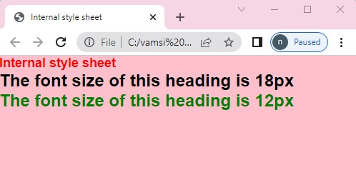

1. **External sheet**

**Link :**

**Source code:**

<!DOCTYPE html>

<html>

<head>

<title>External style sheet-import</title>

<style type="text/css">

@import url("externalstylesheet.css");

</style>

</head>

<body>

<h1>External style sheet-import</h1>

<h1>The font size of this heading is 18px</h1>

<p>The font size of this heading is 12px</p>

</body>

</html>

**externalstylesheet.css**

*{

margin:0;

}

body

{

color:#000000;

background-color:#00ff00;

font-family:sans-serif;

}

h1

{

font-size:18px;

}

p

{

font-size:12px;

}

**Output:**

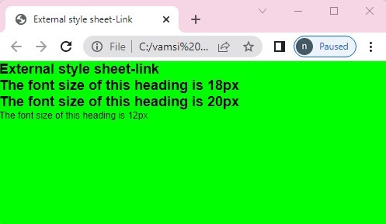

**Import:**

<!DOCTYPE html>

<html>

<head>

<title>External style sheet-import</title>

@import url("externalstylesheetcss.css");

</head>

<body>

<h1>External style sheet-import</h1>

<h1>The font size of this heading is 18px</h1>

<p>The font size of this heading is 12px</p>

</body>

</html>

**externalstylesheet.css**

*{

margin:0;

}

body

{

color:#000000;

background-color:#00ff00;

font-family:sans-serif;

}

h1

{

font-size:18px;

}

p

{

font-size:12px;

}

**Output:**

**Experiment:** 4 b)  **Date:**

**Aim:** Demonstrate Query selector in CSS

**Source code:**

<!DOCTYPE html>

<html>

<head>

<title>query selector</title>

<script type="text/javascript">

function changecss()

{

document.querySelector("p").style.background="red";

}

function changecssall()

{

list=document.querySelectorAll("p");

for(var i=0;i<list.length;i++)

{

list[i].style.background="blue";

}

}

</script>

</head>

<body>

<p>my paragraph 1</p>

<p>my paragraph 2</p>

<p>my paragraph 3</p>

<p>my paragraph 4</p>

<button onclick="changecss()">selector</button>

<button onclick="changecssall()">selector all</button>

</body>

</html>

**Output:**

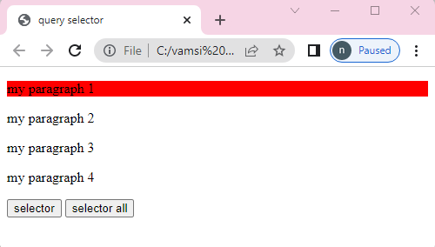

**Experiment:** 5 a **Date:**

**Aim:** a java script to demonstrate mouse event

**Source code:**

<!DOCTYPE html>

<html>

<head>

<title>mouse events</title>

<style>

div{

border:2px;

}

</style>

<script>

function msg()

{

document.getElementById("button").style.backgroundColor="red";

}

function dbmsg()

{

document.getElementById("dbclick").style.backgroundColor="cyan";

}

function mousedown()

{

document.getElementById("down").style.backgroundColor="yellow";

}

function imgover()

{

document.getElementById("img").style.height="300px";

document.getElementById("img").style.width="300px";

}

function imgout()

{

document.getElementById("img").style.height="100px";

document.getElementById("img").style.width="100px";

}

function imgmove()

{

document.getElementById("img").style.height="100px";

document.getElementById("img").style.width="100px";

document.getElementById("img").style.backgroundColor="cyan";

}

function up()

{

document.getElementById("up").style.backgroundColor="red";

document.getElementById("up").innerHTML="mouseup";

}

</script>

</head>

<body>

<button id="button" onclick="msg()">click here</button><br>

<button id="dbclick" ondblclick="dbmsg()">double click here</button><br>

<button id="down" onmousedown="mousedown()">click

here</button><br>

<button id="up" onmouseup="up()">mouseup</button><br><br>

<img id="img"src="bec.jpg" onmouseover="imgover()"

onmouseout="imgout()">

</body>

</html>

**Output:**

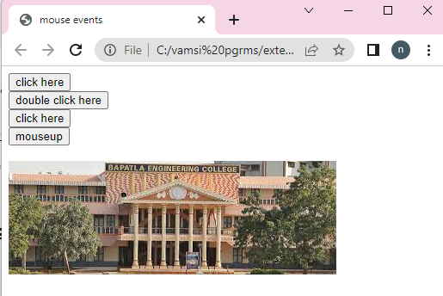

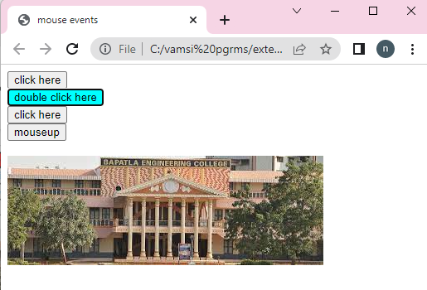

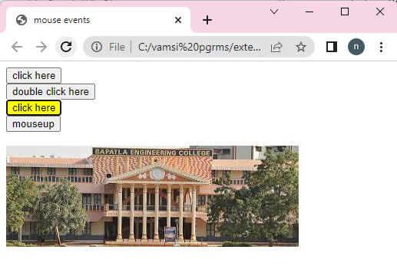

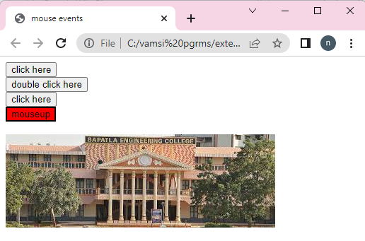

**Experiment:** 5 b) **Date:**

**Aim:** a java script to demonstrate popup boxes

**Source code:**

<!DOCTYPE html>

<html>

<head>

<title>popup windows</title>

<script type="text/javascript">

var v;

function alertmsg()

{

alert("please enter mandatory fields");

}

function confirmmsg()

{

v=confirm("do you want proceed? ");

}

function promptmsg()

{

v=prompt("enter your otp:");

document.write("your otp: "+v);

}

</script>

</head>

<body>

<br><br><br><br><br><br>

<h1>popup windows</h1>

<input type="submit" value="alert message" onclick="alertmsg()">

<input type="submit" value="confirm message"

onclick="confirmmsg()">

<input type="submit" value="prompt message"

onclick="promptmsg()">

</body>

</html>

**Output:**

**Experiment:** 5 c) **Date:**

**Aim:** a java script to demonstrate form event

**Source code:**

<!DOCTYPE html>

<html>

<head>

<title>form events</title>

<script type="text/javascript">

function inpfocus()

{

document.getElementById("uname").style.background="gray";

}

function inpblur()

{

document.getElementById("uname").style.background="skyblue";

}

function inpselect()

{

alert("you are selecting the text");

}

function inpsearch()

{

prompt("you are searching for something");

}

function inpchange()

{

alert("do you want to change the text?");

}

function inpinvalid()

{

document.getElementById("msg").innerHTML="you can't submit

the form";

}

function inpsubmit()

{

alert("you are submiting the form");

}

function inpreset()

{

confirm("you are reseting the content");

}

</script>

</head>

<body>

<h1>form Events</h1>

<form onsubmit="inpsubmit()" onreset="inpreset()">

enter your name:

<input id="uname" type="text" onfocus="inpfocus()" onblur="inpblur()" oninvalid=" inpinvalid()" required onselect="inpselect()" onchange="inpchange()"><br>

<p id="msg"></p>

<input type="submit" value="submit">

<input type="reset" value="reset">

</form>

</body>

</html>

**Output:**

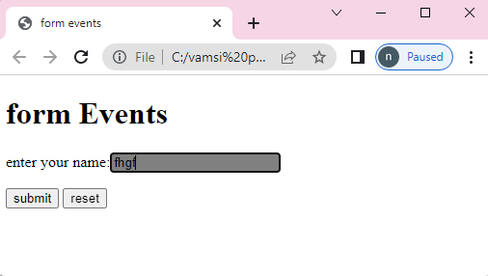

**Experiment:** 6 a) **Date:**

**Aim:** a java script to demonstrate string object

**Source code:**

<!DOCTYPE html>

<html>

<head>

<title> String Object</title>

</head>

<body>

<script type="text/javascript">

document.write("<h2> methods in String Objects </h2>");

var str = "welcome to html5";

var str1 = "welcome to js";

document.write("Length of str:" + str.length);

document.write("<br>Character at 5 position:" + str.charAt(5));

document.write("<br>Concat str & str1:" + str.concat(str1));

document.write("<br>Index of 'm' in str:" + str.indexOf('m'));

document.write("<br> last Index of 'm' in str:" +

str.lastIndexOf('m'));

document.write("<br>Replace html5 to HTML5 in str:" +

str.replace("html5", "HTML5"));

document.write("<br>slice the test from 0-7 in str:" +

str.slice(0, 7));

document.write("<br>split the str based on space:" +

str.split(""));

document.write("<br>Upper case of str text:" +

str.toUpperCase());

document.write("<br>lower case of str text:" +

str.toLowerCase());

document.write("<h2> Wrapper methods in String Objects

</h2>");

document.write("small text:" + str.small());

document.write("<br>Big text:" + str.big());

document.write("<br>Bold text:" + str.bold());

document.write("<br>Font color:" + str.fontcolor("blue"));

document.write("<br>Font size:" + str.fontsize("15px"));

document.write("<br>Italic text:" + str.italics());

document.write("<br>strike-out text:" + str.strike());

document.write("<br>subscript:" + str.sub());

document.write("<br>supscript:" + str.sup());

document.write("<br>Text Blink:" + str.blink());

</script>

</body>

</html>

**Output:**

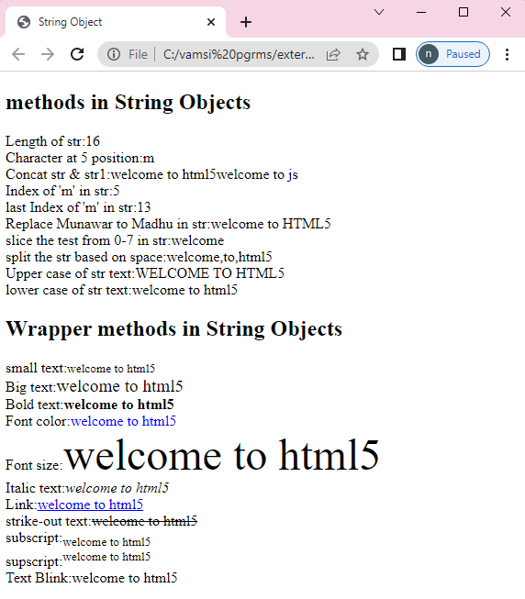

**Experiment:** 6 b) **Date:**

**Aim:** a java script to demonstrate math event

**Source code:**

<!DOCTYPE html>

<html>

<head>

<title> Math Object</title>

</head>

<body>

<script type="text/javascript">

document.write("<h2>Math object properties</h2>");

document.write("Euler's number E:" + Math.E);

document.write("<br>natural logarithmic of 2:" + Math.LN2);

document.write("<br>base-2 logarithmic of E:" +

Math.LOG2E);

document.write("<br>Number value of PI:" + Math.PI);

document.write("<br> Square root of 2:" + Math.SQRT2);

document.write("<h2>Math object methods</h2>");

document.write("absolute value of pi:" + Math.abs(Math.PI));

document.write("<br>natural logarithm of 2:" + Math.log(2));

document.write("<br>max value among (2,6,4,8,3):" +

Math.max(2,6,4,8,3));

document.write("<br>min value among (2,6,4,8,3):" +

Math.min(2,6,4,8,3));

document.write("<br>the value of 2 to the power of 5:" +

Math.pow(2, 5));

document.write("<br>random number :" + Math.random());

document.write("<br>square root of 49:" + Math.sqrt(49));

</script>

</body>

</html>

**Output:**

**Experiment:** 6 c) **Date:**

**Aim:** a java script to demonstrate date event

**Source code:**

<!DOCTYPE htm|>

<html>

<head>

<title> Date objects</title>

</head>

<body>

<script type="text/javascript">

var d1= new Date();

var d2=new Date(2000000);

var d3=new Date("july 08,2022");

var d4=new Date(2022,00,01);

var d5=new Date(2022,00,01,10,45,30);

document.write("<h2>Date object creation</h2>");

document.write("Empty Date object creation:"+d1);

document.write("<br>Date object with milliseconds:"+d2);

document.write("<br>Date object with string:"+d3);

document.write("<br>Date object with specified date:"+d4);

document.write(" br> Date object with specified date & time:"+d5);

document.write("<h2>Date object methods</h2>");

document.write("Current Date:"+Date(d1.valueOf()));

document.write("<br>Day:"+d1.getDay());

document.write("<br>Date:"+d1.getDate());

document.write("<br>Month."+d1.getMonth());

document.write("<br>Year:"+d1.getFullYear());

document.write("<br>Hourse:"+d1.getHours());

document.write("<br>Minutes:"+d1.getMinutes());

document.write("<br>Seconds:"+d1.getSeconds());

document.write("<br>Milliseconds:"+d1.getMilliseconds());

document.write("<br>Time:"+Date(d1.getTime()));

document.write("<br>difference between UTC time and

local time, in minutes:"+d1.getTimezoneOffset());

document.write("<br>Setting the Date:"+d1.setDate(10));

document.write("<br>getting the Date:"+d1.getDate());

</script>

</body>

</html>

**Output:**

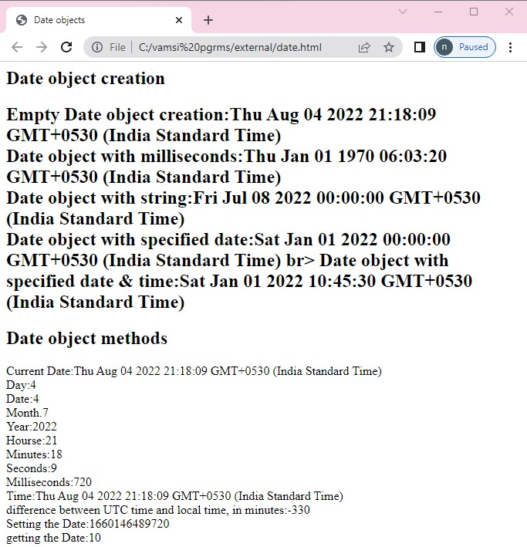

**Experiment:** 7 a) **Date:**

**Aim:** a java script to demonstrate window object

**Source code:**

<!DOCTYPE html>

<html>

<head>

<title>Window object</title>

</head>

<body>

<h2>Frames</h2>

<iframe src="stringobject.html" width="200" height="200"></iframe>

<iframe src="mouse.html" width="200" height="200"></iframe>

<iframe src="gmail.html" width="200" height="200"></iframe> <h2>window object methods</h2>

<button id="but1" onclick="win=window.open()">Open

Window</button>

<button id="but1" onclick="win.close()">close Window</button>

<button id="but1" onclick="window.alert('Alert Message')">

Alert</button>

<button id="but1" onclick="window.prompt('prompt Message)">

Prompt</button>

<button id="but1" onclick="window.confirm('confirm message')">

confirm</button>

<button id="but1" onclick="win.moveBy(100,100)">Move by

Window 100,100 pixel</button>

<h2>window object properties</h2>

<script type="text/javascript">

document.write("Number of Frames:" + window.length);

document.write("<br>height of the windows content

area(viewport)including scrollbars:" + window.innerHeight);

document.write("<br>width of the windows content

area(viewport)including scrollbars:" + window.innerWidth);

document.write("<br>height of the browser window,including

toolbars/scrollbars:" + window.outerHeight);

document.write("<br>width of the browser window,including toolbars/scrollbars:" + window.outerWidtht);

</script>

</body>

</html>

**Output:**

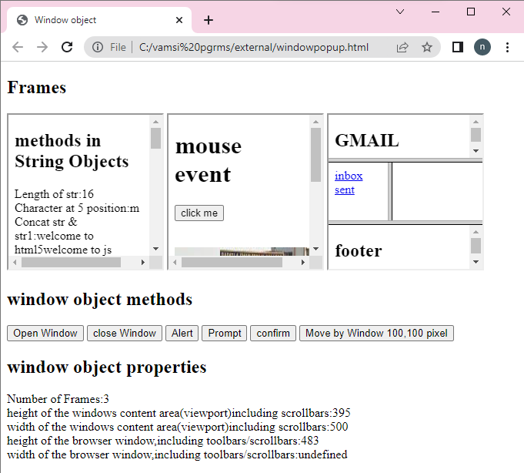

**Experiment:** 7 b) **Date:**

**Aim:** a java script to demonstrate document object

**Source code:**

<!DOCTYPE HTML>

<html>

<head>

<title>Document Object</title>

</head>

<body>

<h2>Images</h2>

Image 1:<img id="imgl" src="beclogo.png" width="100"

height="100">

Image 2:<img id="img2" src="ferrari.jpg" width="100" height="100">

<h2>Links</h2>

<a id="link1" href="mouseevent.html">Pagel</a>

<a id="link2" href="formevents.html">Page2</a>

<h2>Docuemnt object methods</h2>

<button onclick="open_doc()">Open Docuemnt</button>

<script type="text/javascript">

document.write("<h2>Document object collection</h2>");

document.write("Number of images:" +

document.images.length );

document.write("<br>Number of links:" +

document.links.length);

document.write("<h2>Document object properties</h2>");

document.write("Title of docuemnt:" + document.title);

document.write("<br>URL of docuemnt:" + document.URL);

document.write("<br> state of docuemnt:" + document.readyState);

document.write("<br>last modified of docuemnt:" +

document.lastModified);

function open_doc() {

var mywindow = window.open();

mywindow.document.open();

mywindow.document.write("<h1>Welcome to

document </h1>");

mywindow.document.close();

}

</script>

</body>

</html>

**Output:**

**Experiment:** 8 a) **Date:**

**Aim:** a java script to to create, delete, duplicate and insert a node using dom interface

**Source code:**

<!DOCTYPE html>

<html>

<head>

<title>Node interface</title>

<script type="text/javascript">

function create_node() {

var img = document.createElement("a");

img.setAttribute("id", "li");

img.setAttribute("href", "bec.jpg");

img.setAttribute("width", "100");

img.setAttribute("height", "100");

text = document.createTextNode("image");

img.appendChild(text);

document.body.appendChild(img);

}

function delete_node() {

child = document.getElementById("li");

document.body.removeChild(child);

}

function clone_node() {

img = document.getElementById("li");

c = img.cloneNode(true);

document.body.appendChild(c);

}

function insert_node() {

img = document.getElementById("ll");

para = document.createElement("p");

para.setAttribute("id", "p1");

text = document.createTextNode("my paragraph");

para.appendChild(text);

document.body.insertBefore(para, img);

}

</script>

</head>

<body>

<div id="d">

<h2>Node interface methods</h2>

<button onclick="create_node()">create image</button>

<button onclick="delete_node()">remove image</button>

<button onclick="clone_node()">clone image</button>

<button onclick="insert_node()">insert paragraph</button>

</div>

</body>

</html>

**Output:**

**Experiment:** 8 b) **Date:**

**Aim:** a java script to demonstrate calculator program

**Source code:**

<!DOCTYPE HTML>

<html>

<head>

<title>calculator</title>

<script type="text/javascript">

function dis(val) {

document.getElementById("result").value += val

}

function solve() {

var x = document.getElementById("result").value

var y = eval(x)

document.getElementById("result").value = y

}

function clr() {

document.getElementById("result").value = ""

}

</script>

</head>

<body>

<table>

<tr>

<td colspan="3"><input type="text" id="result"></td>

<td><input type="button" value="c" onclick="clr()" /> </td>

</tr>

<tr>

<td><input type="button" value="1" onclick="dis('1')" /> </td>

<td><input type="button" value="2" onclick="dis('2')" /> </td>

<td><input type="button" value="3" onclick="dis('3')" /> </td>

<td><input type="button" value="/" onclick="dis('/')" /> </td>

</tr>

<tr>

<td><input type="button" value="4" onclick="dis('4')" /> </td>

<td><input type="button" value="5" onclick="dis('5')" /> </td>

<td><input type="button" value="6" onclick="dis('6')" /> </td>

<td><input type="button" value="-" onclick="dis('-')" /> </td>

</tr>

<tr>

<td><input type="button" value="7" onclick="dis('7')" /> </td>

<td><input type="button" value="8" onclick="dis('8')" /> </td>

<td><input type="button" value="9" onclick="dis('9')" /> </td>

<td><input type="button" value="+" onclick="dis('+')" /> </td>

</tr>

<tr>

<td><input type="button" value="." onclick="dis('.')" /> </td>

<td><input type="button" value="0" onclick="dis('0')" /> </td>

<td><input type="button" value="=" onclick="solve()" /> </td>

<td><input type="button" value="*" onclick="dis('*')" /> </td>

</tr>

</table>

</body>

</html>

**Output:**

**Experiment:** 9) **Date:**

**Aim:** Write a EXPERIMENT to demonstrate Internal DTD

**Source code:**

<?xml version="1.0" encoding="UTF-8"?>

<!DOCTYPE student[

<!ELEMENT student (name,regd,address)>

<!ELEMENT name (#PCDATA)>

<!ELEMENT regd EMPTY>

<!ATTLIST regd id CDATA "401">

<!ELEMENT address (dno,street,city)>

<!ELEMENT dno (#PCDATA)>

<!ELEMENT street (#PCDATA)>

<!ELEMENT city (#PCDATA)>

]>

<student>

<name>Chaitanya</name>

<regd id="401"/>

<address>

<dno>10-214</dno>

<street>old bus stop</street>

<city>Guntur</city>

</address>

</student>

**Output:**

**EXPERIMENT-**9 b) **DATE:**

**Aim:** Design a webpage to demonstrate the external DTD.

**Source code:**

**XML fie:**

<?xml version="1.0" encoding="UTF-8"?>

<!DOCTYPE student SYSTEM "stu.dtd">

<student>

<name>Chaitanya</name>

<regd id="401"/>

<address>

<dno>10-214</dno>

<street>old bus stop</street>

<city>Guntur</city>

</address>

</student>

**DTD file:**

<!ELEMENT student (name,regd,address)>

<!ELEMENT name (#PCDATA)>

<!ELEMENT regd EMPTY>

<!ATTLIST regd id CDATA "420">

<!ELEMENT address (dno,street,city)>

<!ELEMENT dno (#PCDATA)>

<!ELEMENT street (#PCDATA)>

<!ELEMENT city (#PCDATA)>

**Output:**

**Experiment:** 10) **Date:**

**Aim: :**Develop a XML file to store the student dataand validate using XSD

**Source code:**

<Employee>

<name> chaitanya</name>

<salary> 70000 </salary>

<disignation> Manager </disignation>

<address>

<dno> 5-554 </dno>

<street> old bus stand</street>

<city> vijayawada</city>

</address>

</Employee>

Xsd code:

<xs:schema xmlns:xs="http://www.w3.org/2001/XMLSchema">

<xs:element name="Employee">

<xs:complexType>

<xs:sequence>

<xs:element name="name" type="xs:string" />

<xs:element name="salary" type="xs:integer" />

<xs:element name="disignation" type="xs:string" />

<xs:element name="address">

<xs:complexType>

<xs:sequence>

<xs:element name="dno" type="xs:string" />

<xs:element name="street" type="xs:string" />

<xs:element name="city" type="xs:string" />

</xs:sequence>

</xs:complexType>

</xs:element>

</xs:sequence>

</xs:complexType>

</xs:element>

</xs:schema>

**Output:**

