# BANNARI AMMAN INSTITUTE OF TECHNOLOGY

**An Autonomous Institution Affiliated to Anna University - Chennai, Accredited by NAAC with A+ Grade**

**Sathyamangalam - 638401 Erode District, Tamil Nadu, India**

**Student Name:** SRI SIVARAM A

# Seat No: 263

**Project ID: 23**

**Project title:** Approval of On Duty for the students

**Components - Tech Stack Used:**

| **Components** | **Tech Stack** |
| --- | --- |
| Backend | Html, CSS, JavaScript |
| Frontend | Python, Django |
| Database | MySQL, PostgreSql |

**Implementation Timeline:**

| **Project Phases** | **Deadline** | **Status** |
| --- | --- | --- |
| Planning and Requirement Gathering | 02/05/2024 | Under review |
| Design and Prototyping |  | Not started |
| DB Designing and implementation |  | Not started |
| Backend Development |  | In progress |
| Integration and Testing |  | Not started |
| Deployment |  | Not started |

**Project Phases in Detail:**

## Planning and Requirement Gathering:

**Overview:** The Student On-duty Approval Portal aims to streamline the process of approving on-duty requests for students. The system will ensure that the necessary criteria are met before granting permission for students to be on duty.

## Key Activities:

* + Understanding user roles and permissions.
  + Defining the OD submission form structure.
  + Mapping out the approval workflow.

## Deliverables:

* + Requirement documentation.
  + Project plan.

## Design and Prototyping:

**Overview:** Focuses on creating the design prototypes for the portal, including the user interface for students and faculty.

## Key Activities:

* + Developing wireframes for the login page, dashboards, and submission forms.
  + Finalizing the design for user interactions and notification systems.

## Deliverables:

* + Approved design prototypes.

## DB Designing and Implementation:

**Overview:** Designing the database structure to support the application requirements.

## Key Activities:

* + Implementing PostgreSQL as the database solution.
  + Structuring tables for user data, OD requests, and faculty approvals.
  + Ensuring data integrity and privacy.

## Deliverables:

* + Database schema design documentation.
  + Database implementation.

## Backend Development:

**Overview:** Development of the application logic and server-side functionalities using Django.

## Key Activities:

* + Implementing login authentication.
  + Developing the submission forms and approval workflows.
  + Integrating the notification system for parents' approval.

## Deliverables:

* + Backend services with all core features implemented.

## Integration and Testing:

**Overview:** Combining the frontend and backend components and testing for functionality, security, and performance.

## Key Activities:

* + Testing the approval workflow.
  + Ensuring the security of user data.
  + Performing usability testing with sample users.

## Deliverables:

* + Tested and bug-free application.

## Deployment:

**Overview:** Deployment involves deploying the system to production environments, making it accessible to users. This phase ensures a smooth transition from development to live operation.

## Key Activities:

* + Setting up the server environment.
  + Deploying the Django application.
  + Monitoring for issues post-launch.

## Deliverables:

* + Deployed application in the production environment.
  + Monitoring and logging configurations.
  + Deployment documentation.

**Problem Statement:**

Build a portal/app for approving the On-duty for our students. The condition to approve on-duty 1. Both academic and placement FA should be above 50% 2. Mentor has to provide permission after receiving acknowledgement from parent. 3 The special lab incharge should approve the permission after verify event details.

**Project Flow:**

## Purpose:

The purpose of this project is to develop a Student On-duty Approval Portal that streamlines the process of managing on-duty (OD) requests from students. The portal is designed to automate the approval process, ensure transparency, and enhance efficiency for students, faculty, and parents. By digitizing the OD request and approval workflow, the system aims to reduce administrative overhead, minimize errors, and ensure timely communication between all parties involved.

## Scope:

**User Authentication:**

* + Implement a secure authentication system for students, faculty, and parents using their institutional email accounts.

**Student Dashboard:**

* + Allow students to submit OD requests by filling out a standardized form that includes details like event type, dates, and faculty involved.
  + Enable students to track the status of their OD requests in real-time, receiving updates on approval stages (e.g., faculty approval, FA percentage checks, parental approval).

**Faculty Dashboard:**

* + Develop a dashboard for faculty members where they can review, approve, or reject OD requests based on criteria such as attendance percentage and academic performance.

**Parental Approval:**

* + Implement a notification system that sends an approval link to parents via SMS or email once faculty approval is granted.
  + Ensure that the system allows parents to view the details of the OD request and provide their approval or rejection with a single click.

**Approval Workflow:**

* + Design a multi-step approval workflow that ensures all necessary checks are completed before an OD request is granted.
  + Incorporate an automatic verification system for attendance percentage, flagging requests that do not meet the minimum required percentage for faculty review.
  + Integrate notifications at each stage of the approval process, ensuring that students, faculty, and parents are informed of the request's status and any required actions.

## Business Context:

Managing on-duty requests is a common yet time-consuming process in educational institutions, often involving multiple stakeholders and manual approvals. The Student On-duty Approval Portal addresses these challenges by automating the OD request and approval workflow, reducing the administrative burden on faculty and ensuring that all requests are processed efficiently.

## Considerations:

* + **Security:** Prioritize the security of student and faculty data by implementing robust authentication measures and encrypting data both at rest and in transit.
  + **Scalability:** Design the system to accommodate an increasing number of users and OD requests over time, ensuring that performance remains consistent as the user base grows.
  + **User Experience:** Focus on creating an intuitive and user-friendly interface for all users, ensuring that students, faculty, and parents can easily navigate the portal and complete their tasks.
  + **Regulatory Compliance:** Ensure that the system complies with relevant educational data protection regulations, such as GDPR or FERPA, to protect student privacy and confidentiality.

## Dependencies:

* + **Technology Stack:** The project depends on technologies such as HTML, CSS, JavaScript for frontend development, Python and Django for backend development, SQL for database management, and machine learning libraries for skill analysis and ranking.
  + **Data Availability:** The accuracy and availability of student data are crucial for ensuring that the OD approval process is fair and reliable.Work closely with institutional IT teams to ensure that all necessary data is collected, validated, and made available for use within the portal.
  + **Stakeholder Involvement:** Continuous collaboration and feedback from stakeholders, including students, faculty, parents, and administrators, are essential for defining requirements, validating system functionality, and ensuring user adoption.

**User Personas**

Students: Submit on-duty requests and track approval status.

Faculty: Review and approve requests based on institutional guidelines.

Parents: Provide final approval through an SMS or email link.

**User Stories:**

* + Student Story: As a student, I want to submit my on-duty request easily and track its status, so I know when it's approved.
  + Faculty Story: As a faculty member, I want to review student requests quickly and efficiently, so I can approve or reject them based on the criteria.
  + Parent Story: As a parent, I want to receive a notification for approval, so I can confirm my child’s participation in events.

**Functional Requirements:**

## User Authentication: Secure login for students, faculty, and parents.

## OD Submission Form: Allows students to submit detailed on-duty requests, including event type, duration, and faculty information.

## Approval Workflow: Multi-step process involving FA percentage checks, faculty approval, and parent validation.

## Notification System: Sends approval links to parents via SMS or email.

## Dashboard: Interface for users to submit, review, and track requests.

**FLOW CHART:**

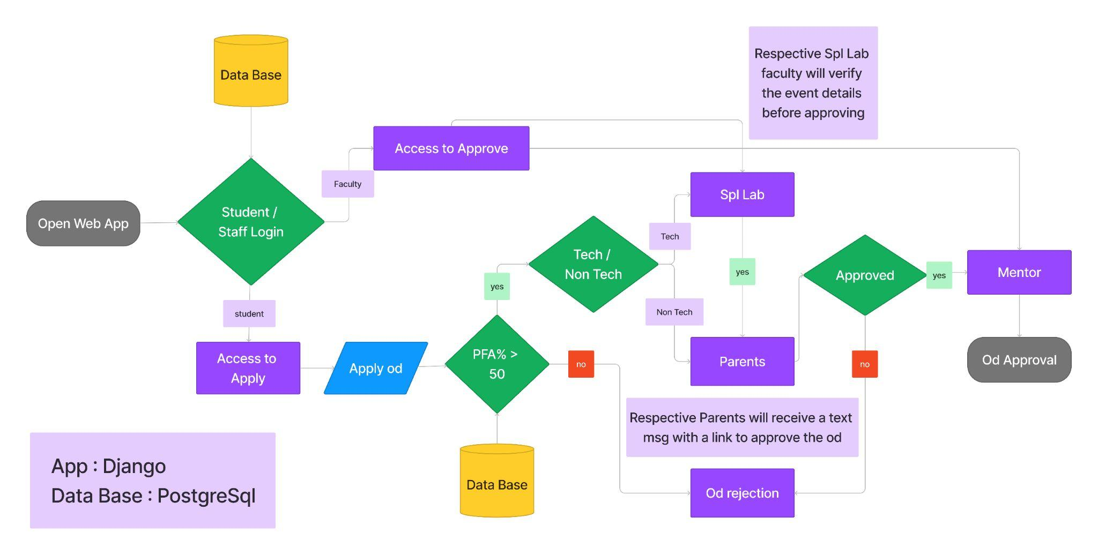

**Conclusion:**

## The Student On-duty Approval Portal/App project aims to enhance the efficiency and transparency of the on-duty approval process for students. By gathering detailed requirements and planning the development process, we ensure that the final product meets the needs of all stakeholders while adhering to security and privacy standards.