Laptop Request Catalog Item

- Open service now.
- And log in to the service now using your given ID and password
- Once it's over
- Then, open Naan Muthalvan home page in the browser
- Here, log in and move to the guided project

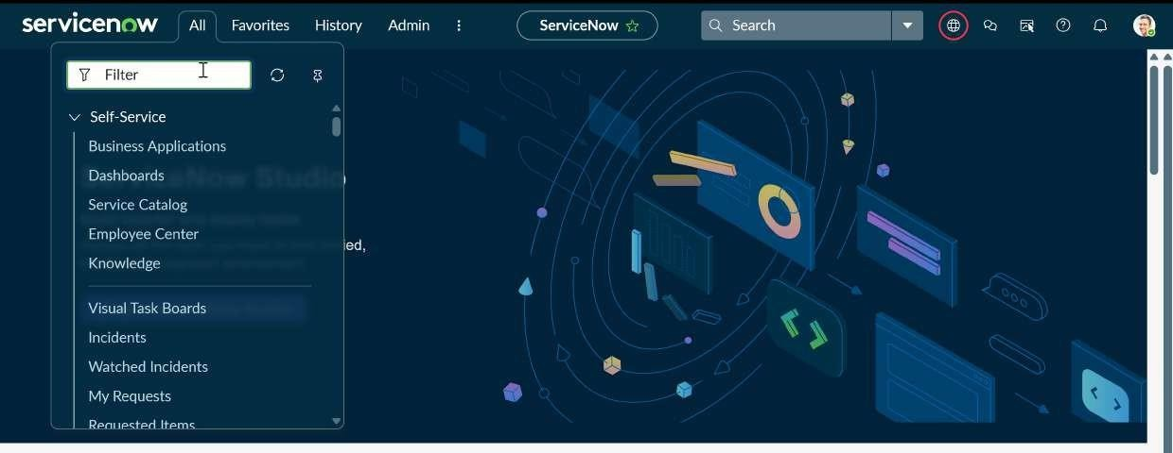

STEP 1: Create Local Update set

- Now in service now, at the top left corner, you can see All
- Click on All >> search for update sets
- Select local update sets under system update sets

- Click on new
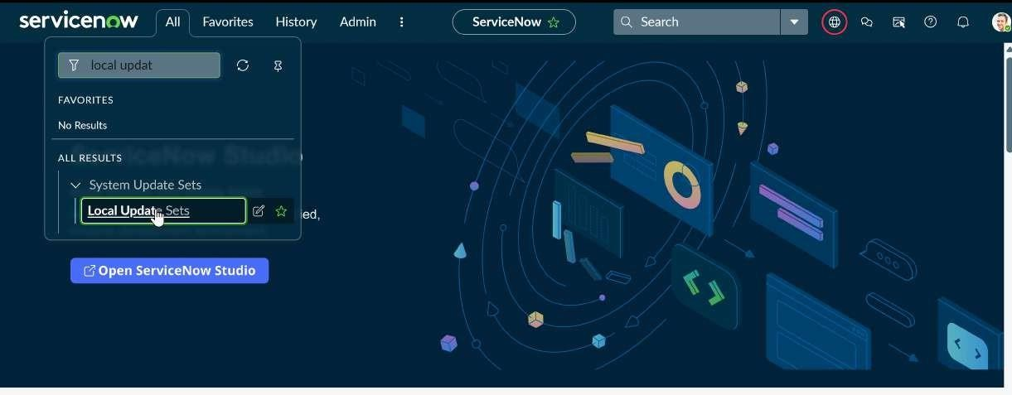
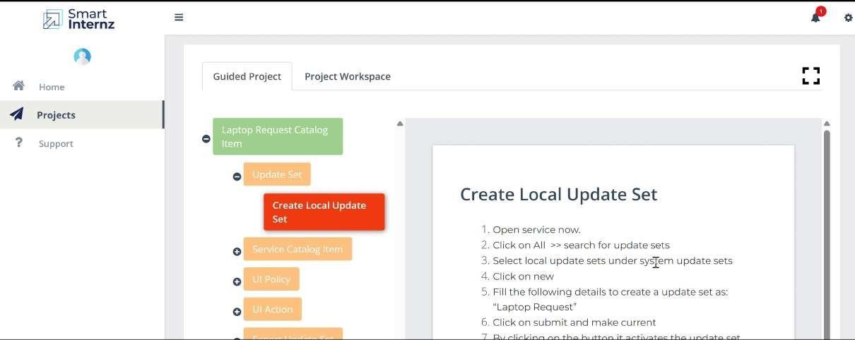
- Fill the following details to create a update set as: “Laptop Request”

- Click on submit to make the current changes.

7. By clicking the button, it activates the update set.

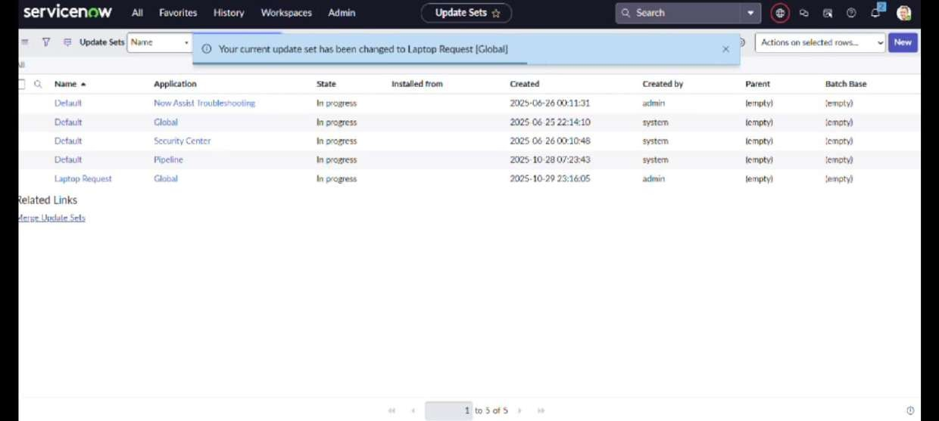

STEP 2: Create Service Catalog Item

1. Open service now.
2. Click on All >> service catalog
- Select maintain items under catalog definitions
- Click on New.

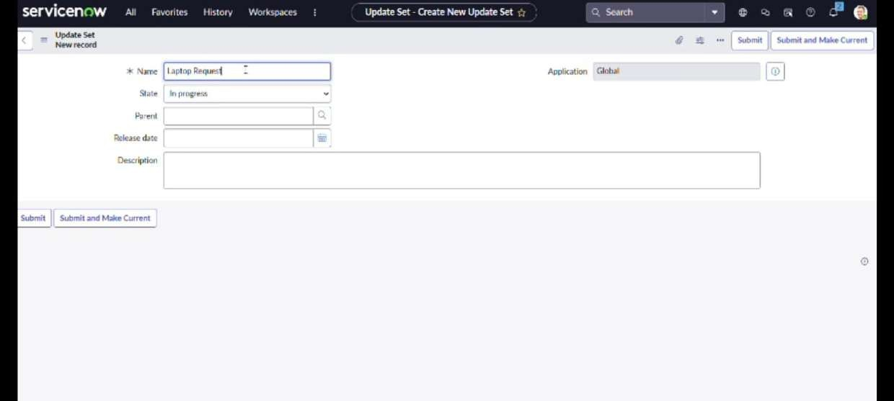

- Fill the following details to create a new catalog item Name: Laptop Request
Catalog: service Catalog Category: Hardware
Short Description: Use this item to request a new laptop
6. Click on ‘SAVE’

STEP 3: Add variables

- After saving the catalog item form scroll down and click on variable(related list)

2. Click on new and enter the details as below

Variable 1:Laptop Model Type: Single line text Name: laptop_model Order:100

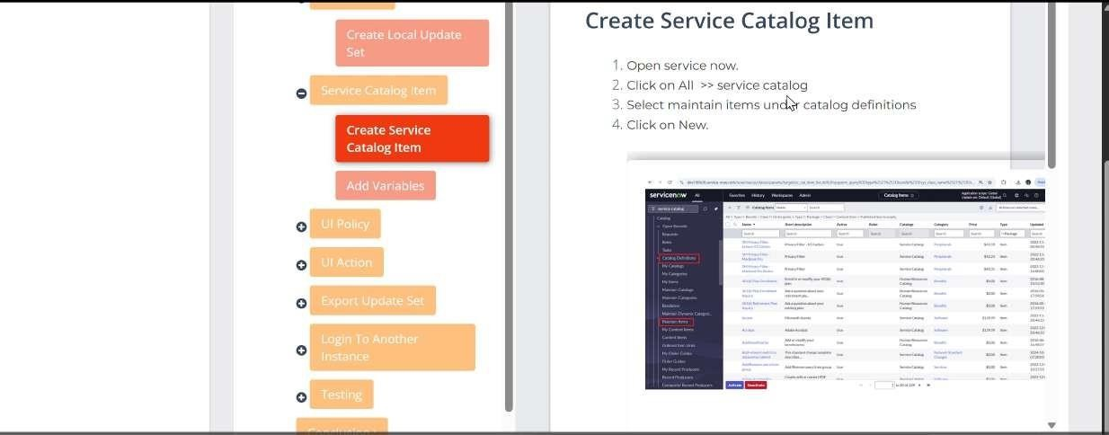

  - Click on submit
  - Again click on new and add Remaining variables in the above process

Do this same process for

2a. Variable 2:Justification

2b. Variable 3:Additional Accessories
2c. Variable 4: Accessories Details

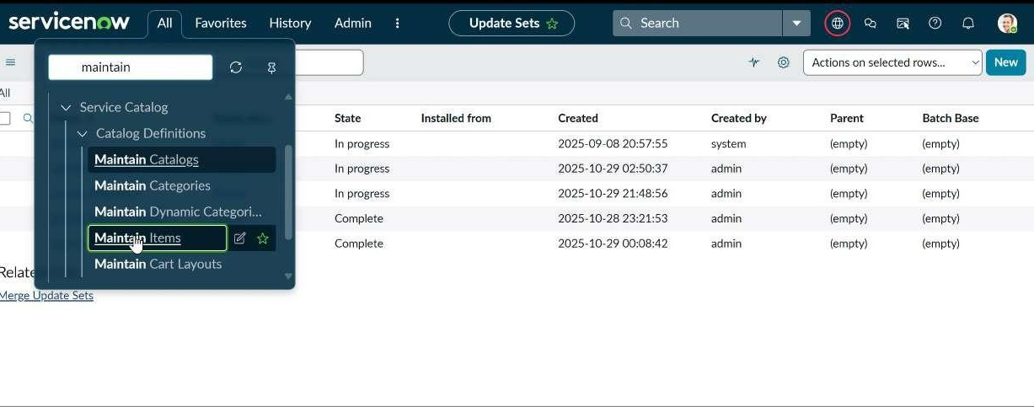

- After adding above variable which are added to newly created catalog item
- Then save the catalog item form

- After adding above variable which are added to newly created catalog item

6.Then save the catalog item
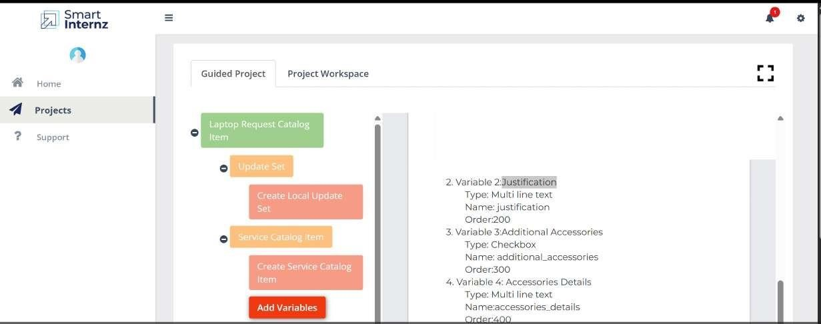
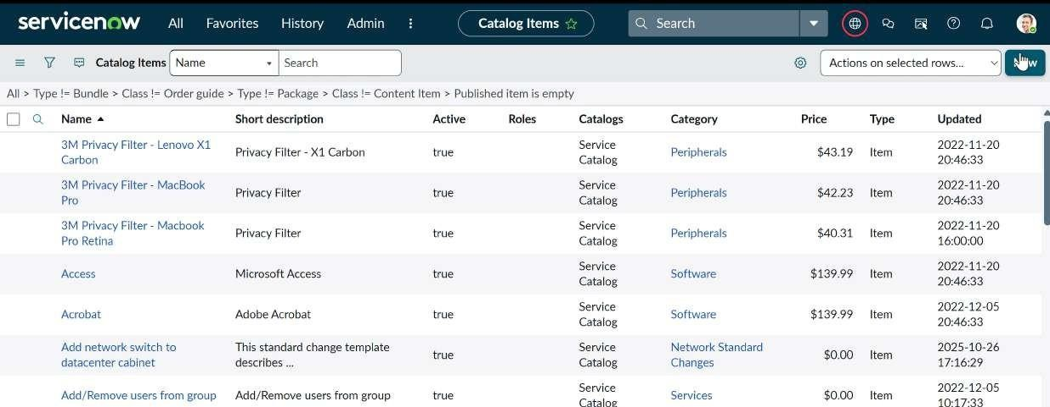

STEP 4: Create Catalog Ui policies

- Click on all>> search for service catalog
- Select maintain item under catalog definition
- Search for ‘laptop request’ which is created before
- Select ‘laptop request’ and scroll down click on “Catalog Ui policies”

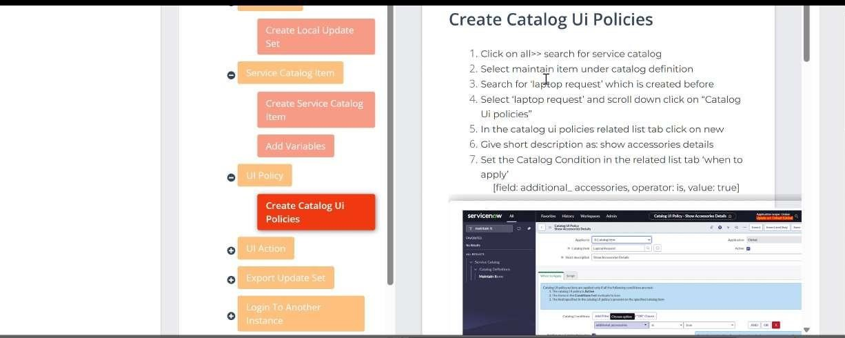

- In the catalog ui policies related list tab click on new

- Give short description as: show accessories details

- Set the Catalog Condition in the related list tab ‘when to apply’

[field: additional_ accessories, operator: is, value: true]

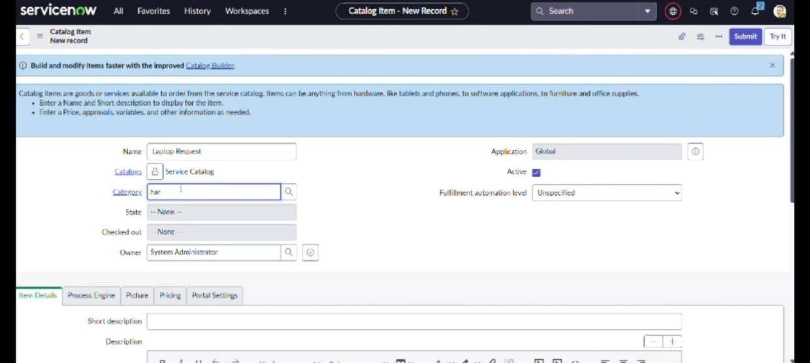

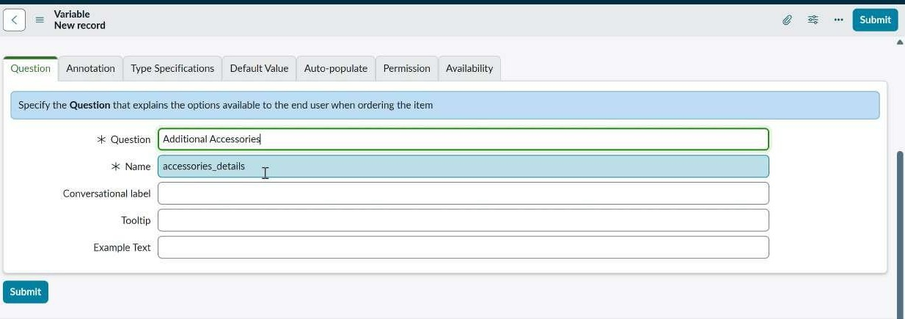

- Click on save.(do not click on submit)
- Scroll down and select ‘catalog ui action’
- Then click on new button
- Select variable name as: accessories_details

i. Order:100
- Mandatory: True
- Visible : True

- Click on save and again click save button of the catalog ui policy form

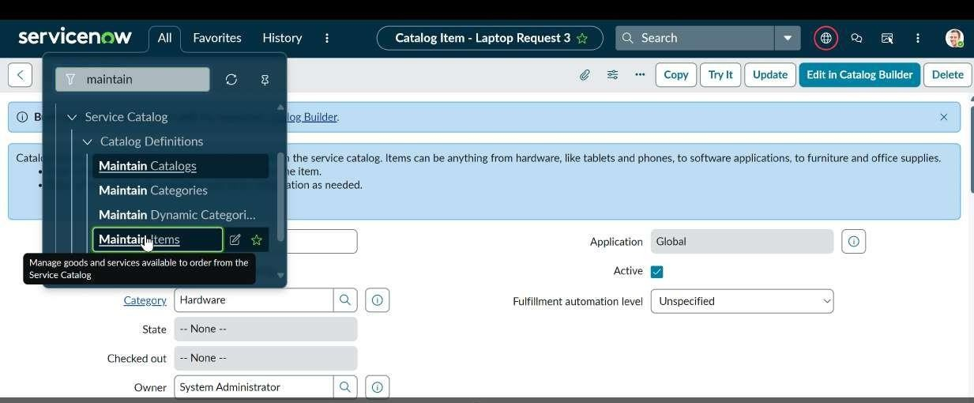
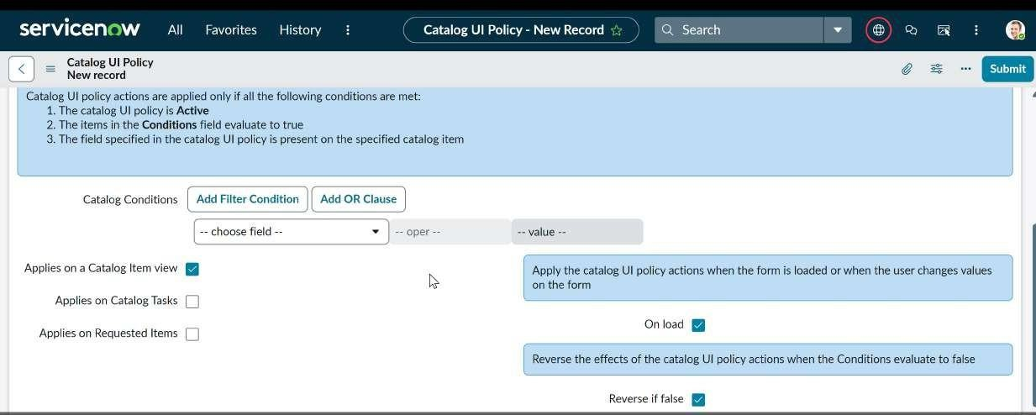

STEP 5: Create ui action

- Open service now.
- Click on All >> search for ui action
- Select ui actions under system definition
- Click on new
- Fill the following details to create ui action Table: shopping cart(sc_cart)
Order:100
Action name: Reset form Client : checked

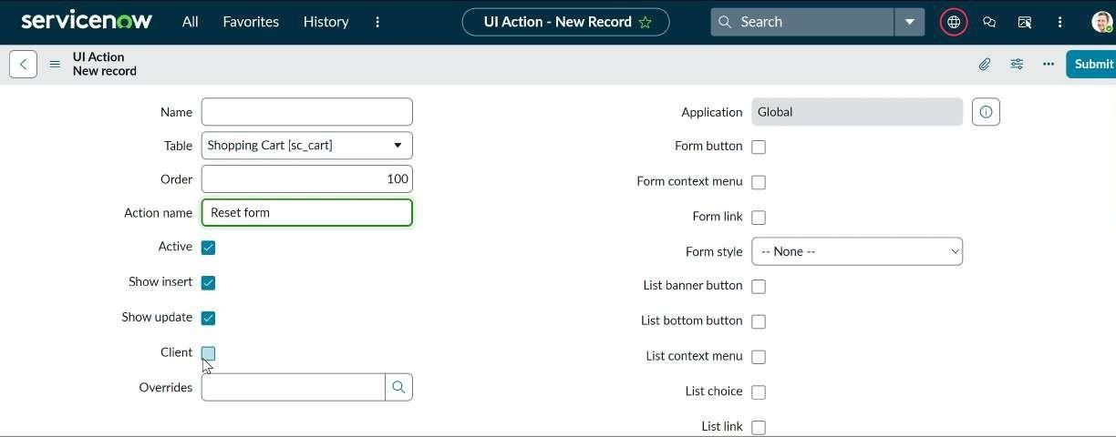

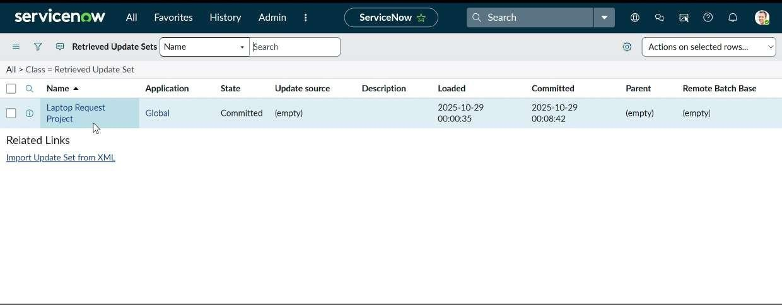
Script:
function resetForm() {
g_form.clearForm(); // Clears all fields in the form
alert("The form has been reset.");
}
Click on save

STEP 5:

STEP 6: Exporting changes to another instances

- Click on All >> search for update sets
- Select local update set
- Select created update set i.e. ‘Laptop Request Project’
- Set the state to ‘Complete’
- In the related list Update tab, updates are visible which we perform under this
update set.

- Click on export to XML ,it download one file

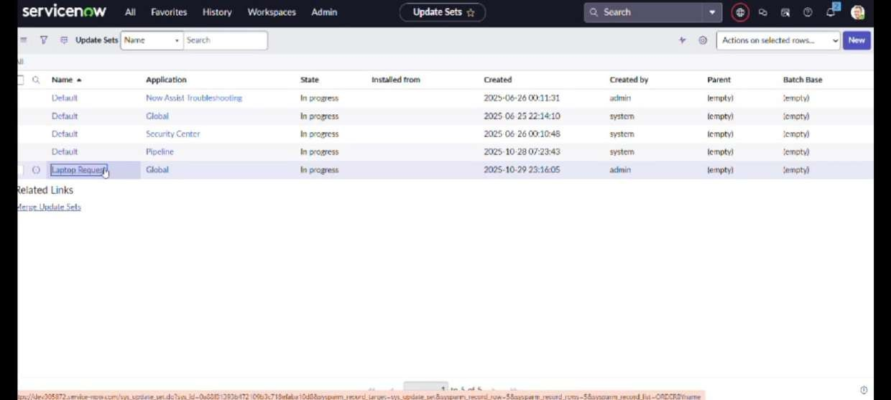

STEP 7:Retrieving the update set

- Open another instance in incognito window

- Login with credentials

- Click on all>> search for update sets

- Select “Retrieved update set” under system update set

- It open retrieved update set list and scroll down

- Click on Import update set from XML

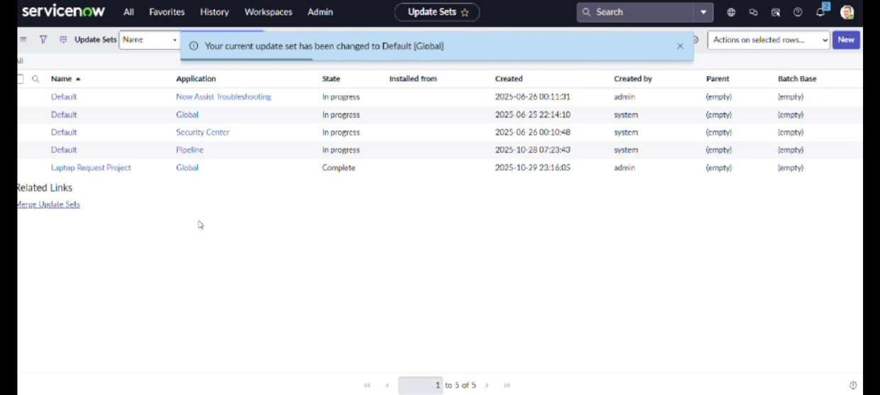

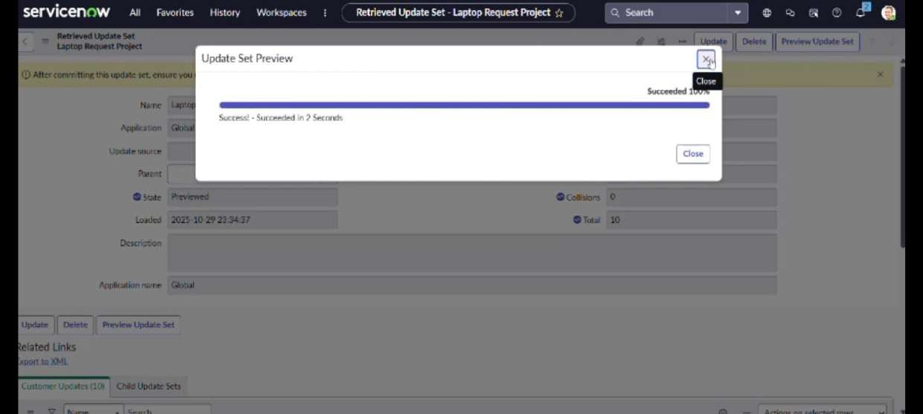

- Upload the downloaded file in XML file

- Click on Upload and it gets uploaded.

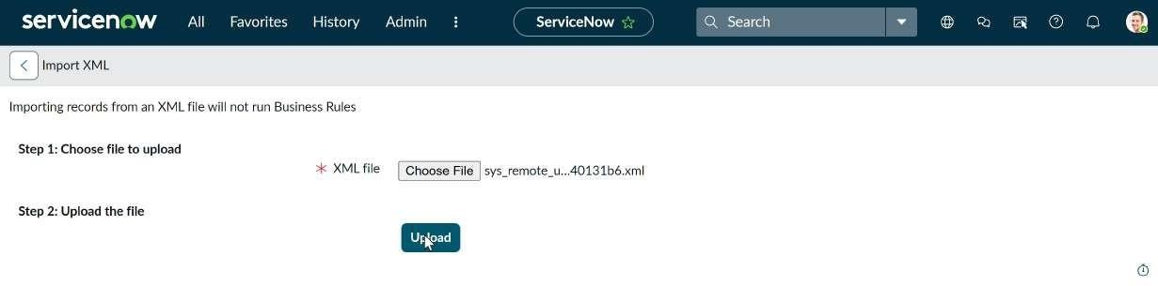

- Open retrieved update set ‘laptop request project’
- Click on preview update set
- And click on commit update set
- And also see the related tab updates
- After commiting update set in this instance we get all updates which are done in the previous instance

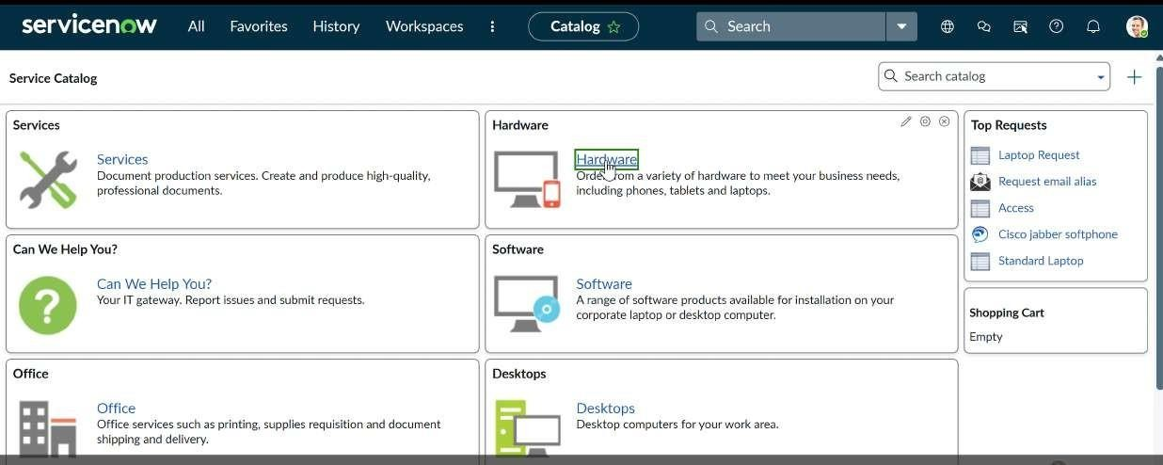

STEP 8: Test Catalog Item

- Search for service catalog in application navigator in target instance

- Select catalog under service catalog

- Select hardware category and search for ‘laptop request’ item

- Select laptop request item and open it

- It shows three variables only

- As per our scenario, when we click on additional accessories checkbox then accessories details fields is visible and that should be mandatory
- Now see the results,it fulfills our requirements

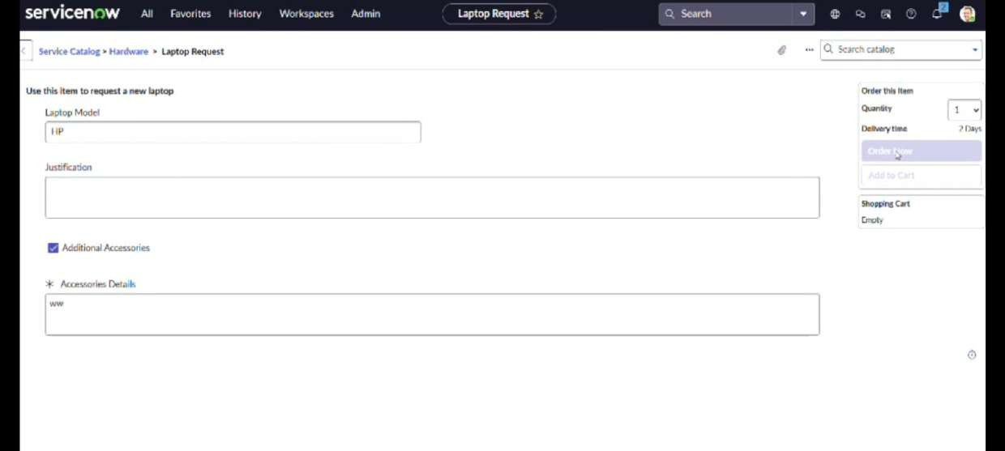

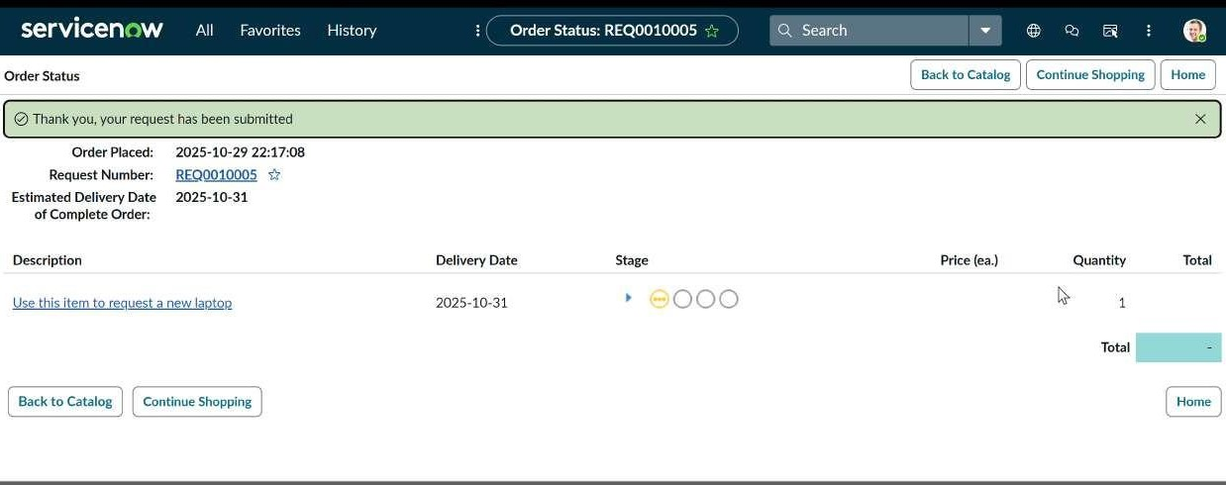

DONE BY,

Team ID : NM2025TMID07845

Team Leader : Sri Vaishnavi M

Team member : Muthu Benisiya R
Team member : Pritirani Limma
Team member : Ramaselvi M

THANK YOU!

