Ex. No. : 03 | Date:
Register No.: 231701501 | Name: Sri Vishnu K

A PYTHON PROGRAM TO IMPLEMENT
LOGISTIC MODEL

Aim:
A python program to implement logistic model
Requirements:
Jupyter Notebook with Python, Iris.csv dataset, and required Python libraries.

PROGRAM:
import pandas as pd
import numpy as np
import matplotlib.pyplot as plt
from sklearn.linear_model import LogisticRegression
data = pd.read_csv(r"C:\Users\srivishnu\Downloads\archive\Iris.csv")
data.columns = data.columns.str.strip()
data["target"] = (data["Species"] == "Iris-setosa").astype(int)
X = data[["PetalLengthCm"]].values
y = data["target"].values
model = LogisticRegression()
model.fit(X, y)
x_vals = np.linspace(X.min(), X.max(), 200).reshape(-1,1)
y_prob = model.predict_proba(x_vals)[:,1]
plt.scatter(X, y)
plt.plot(x_vals, y_prob)
plt.xlabel("Petal Length")
plt.ylabel("Probability")
plt.title("Logistic Regression Curve")
plt.show()
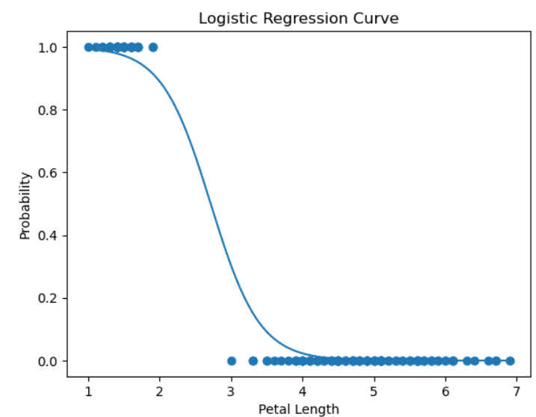
Result:
The Logistic model was successfully implemented on the Iris dataset.

