Ex. No. : 04 | Date:
Register No.: 231701501 | Name: Sri Vishnu K

A PYTHON PROGRAM TO IMPLEMENT
SINGLE LAYER PERCEPTION

Aim:
A python program to implement single layer perception
Requirements:
Jupyter Notebook with Python, Iris.csv dataset, and required Python libraries.

PROGRAM:
import numpy as np
import pandas as pd
import matplotlib.pyplot as plt
# Load dataset (give correct path)
data = pd.read_csv(r"C:\Users\srivishnu\Downloads\archive\Iris.csv")

# Select features (you can change)
X = data.iloc[:, 1:5].values # Sepal & Petal features
# Convert target to binary (Setosa = 1, Others = 0)
y = np.where(data['Species'] == 'Iris-setosa', 1, 0)

# Initialize weights and bias
weights = np.zeros(X.shape[1])
bias = 0
learning_rate = 0.01
epochs = 20

# Activation function (Step Function)
def activation(z):
return np.where(z >= 0, 1, 0)

# Training Perceptron
for epoch in range(epochs):
for i in range(len(X)):
linear_output = np.dot(X[i], weights) + bias
y_pred = activation(linear_output)

# Update rule
weights += learning_rate * (y[i] - y_pred) * X[i]
bias += learning_rate * (y[i] - y_pred)
# Predictions
predictions = []
for i in range(len(X)):
linear_output = np.dot(X[i], weights) + bias
predictions.append(activation(linear_output))

# Accuracy
accuracy = np.mean(predictions == y)
print("Accuracy:", accuracy)
# Plot (using first 2 features for visualization)
plt.scatter(X[:, 0], X[:, 1], c=y, cmap='bwr')
plt.xlabel("Sepal Length")
plt.ylabel("Sepal Width")
plt.title("Perceptron Classification")
plt.show()

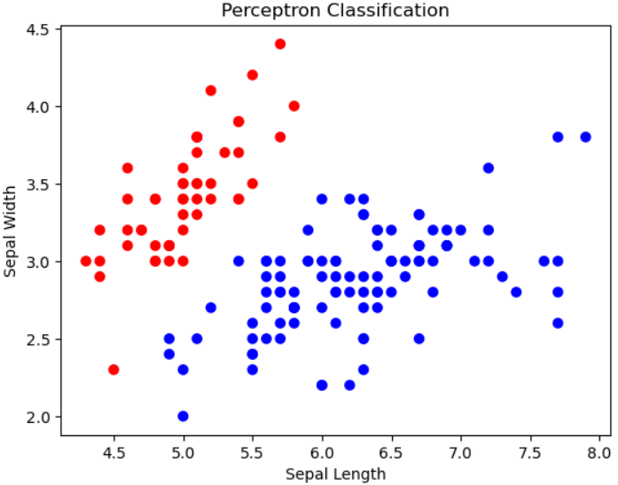

Result:
The Single Layer perception model was successfully implemented on the Iris dataset.

