

**LAPTOP REQUEST CATALOG ITEM**

**TEAM ID:** NM2025TMID15399

**TEAM SIZE:** 4

**TEAM LEADER:** Srinidhi V

**TEAM MEMBER 1:** Logeshwari R

**TEAM MEMBER 2:** Saraswathi E

**TEAM MEMBER 3:** Porkodi P

**PROBLEM STATEMENT:**

Employees in the organization need a quick and efficient way to request laptops for

work. The existing process is manual, prone to delays, and lacks dynamic form behavior,

which results in inconsistent data. To resolve this, a Service Catalog Item should be

created with variables, UI policies, UI actions, and controlled deployment through update

sets.

**OBJECTIVES:**

1.Create a Service Catalog Item for laptop requests.

2.Add variables to capture justification and accessory needs.

3.Use UI Policies to control field visibility.

4.Add UI Actions for form reset functionality.

5.Track changes with Update Sets and export/import between instances.

6.Validate the solution through testing.

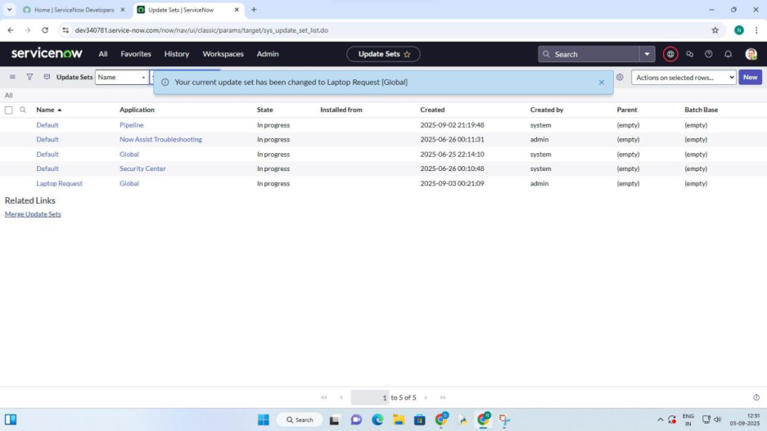

**SKILLS:**

ServiceNow, Service Catalog, UI Policy, UI Action, Update Set, Scripting, Testing

**TASK INITIATION:**

**Milestone 1: Users**

**Activity 1: Create Update Set**

1. Open ServiceNow.

2. Navigate: All →search for Update Sets.

3. Select Local Update Sets under System Update Sets.

4. Click New and enter:

5. Click Submit and Make Current.

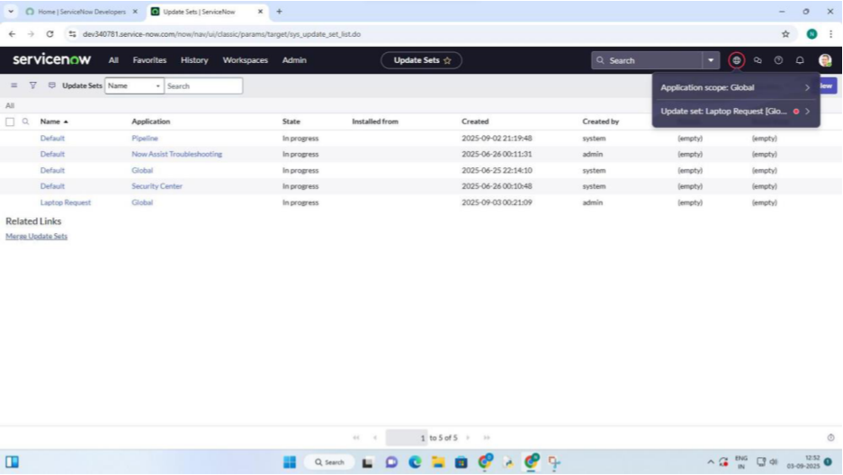

**Milestone 2 : Create Service Catalog Item**

**Activity 1: Create Catalog Item**

1. Navigate: All →Service Catalog →Maintain Items.

2. Click New.

3. Fill details:

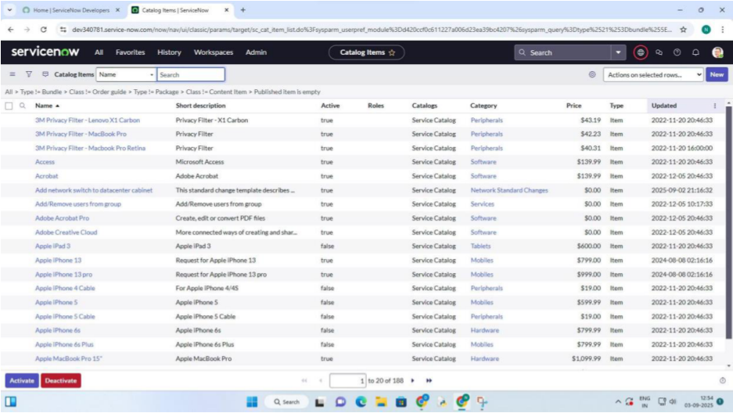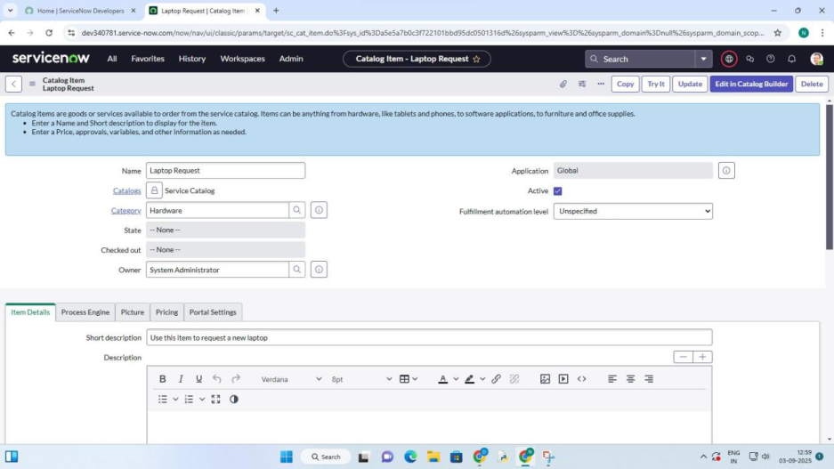

4. Click Save

**Milestone 3: Add Variables**

**Activity 1: Define Variables**

1. From the catalog item form, scroll to Variables →Click New.

**Variable 1**

**Question**: Laptop Model

**Type**: Single line text

**Name**: laptop_model

**Order**: 100

**Variable 2**

**Question**: Justification

**Type**: Multi line text

**Name**: justification

**Order**: 200

**Variable 3**

**Question**: Additional Accessories

**Type**: Checkbox

**Name**: additional_accessories

**Order**: 300

**Variable 4**

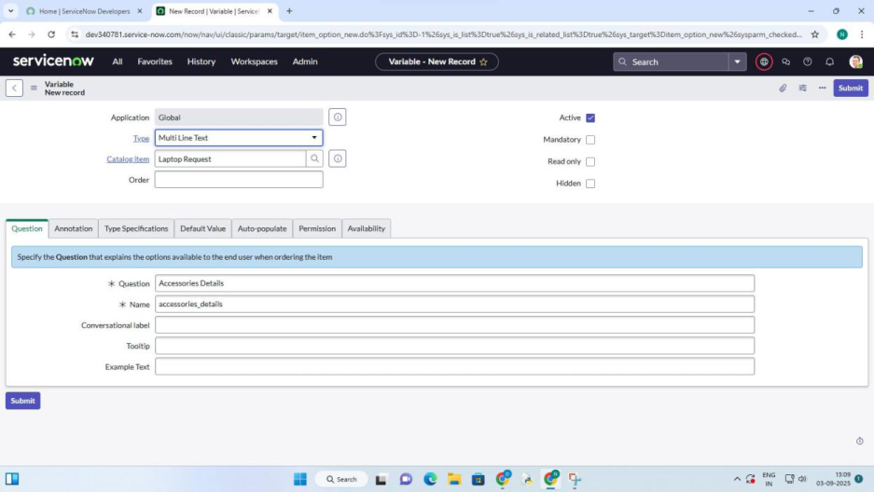

**Question**: Accessories Details

**Type**: Multi line text

**Name**: accessories_details

**Order**: 400

2. Save the form after adding all variables.

**Milestone 4: Create Catalog UI Policie**

**Activity 1: Define UI Policy**

1. Open Laptop Request catalog item.

2. Scroll to Catalog UI Policies →New.

3. Enter:

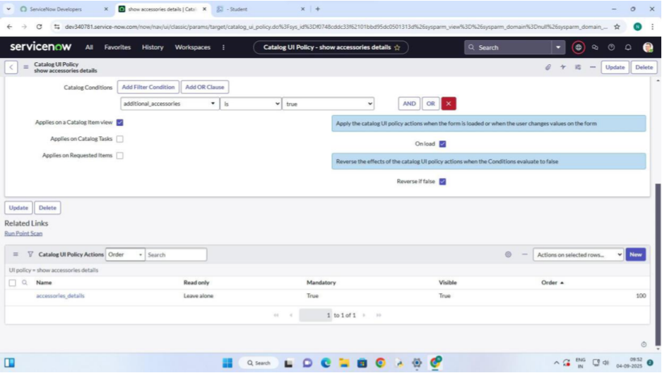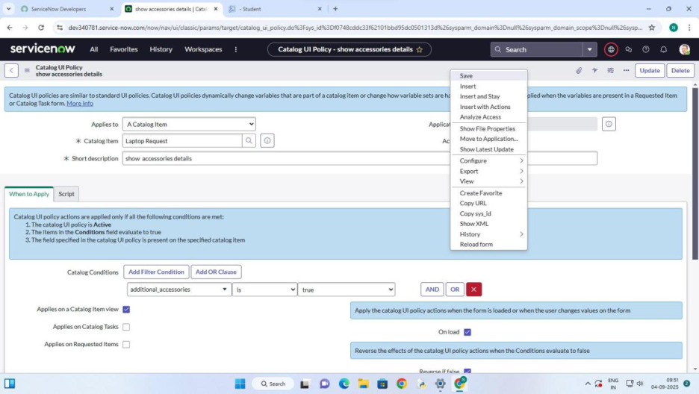

4. Save.

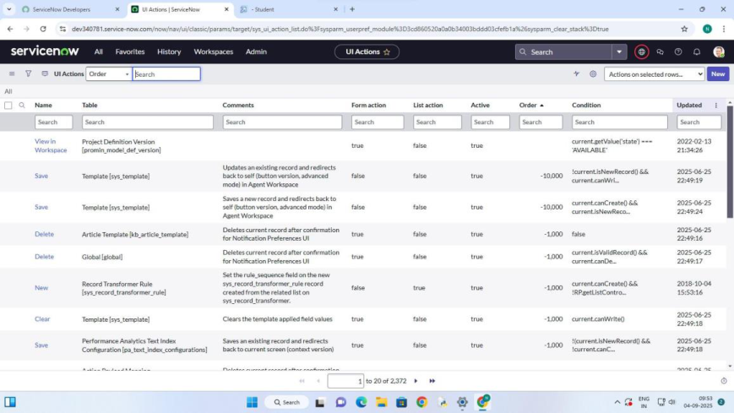

**Milestone 5: Create Catalog UI Actions**

**Activity 1: Add Reset Button**

1. Navigate: All →UI Actions under System Definition.

2. Click New.

3. Fill details:

**Table**: Shopping Cart (sc_cart)

**Name**: Reset Form

**Order**: 100

**Action Name**: reset_form

**Client**: Checked

4. Add Script:

Function resetForm() {

G_form.clearForm(); // Clears all fields

Alert(“The form has been reset.”);

}

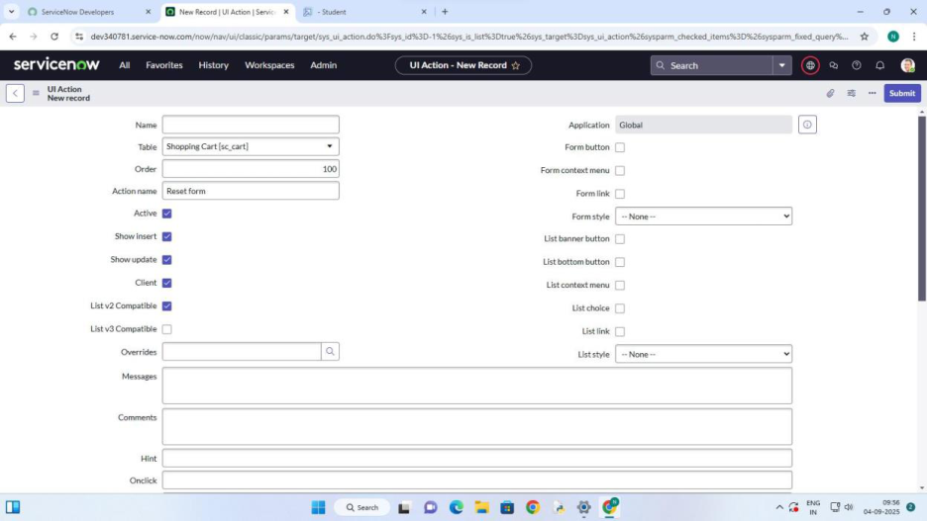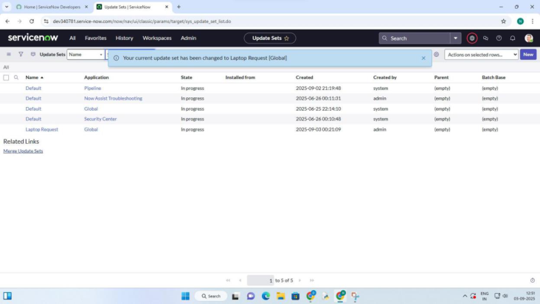

5. Save.

**Milestone 6: Export Update Set**

**Activity 1: Export Changes**

1. Navigate: All →Update Sets →Local Update Sets.   
2. Select the Laptop Request Project.

3. Set State = Complete.

4. In related list, verify updates are present.

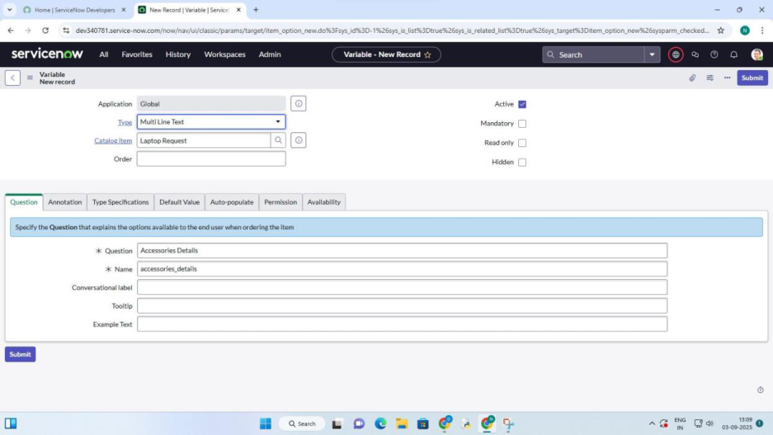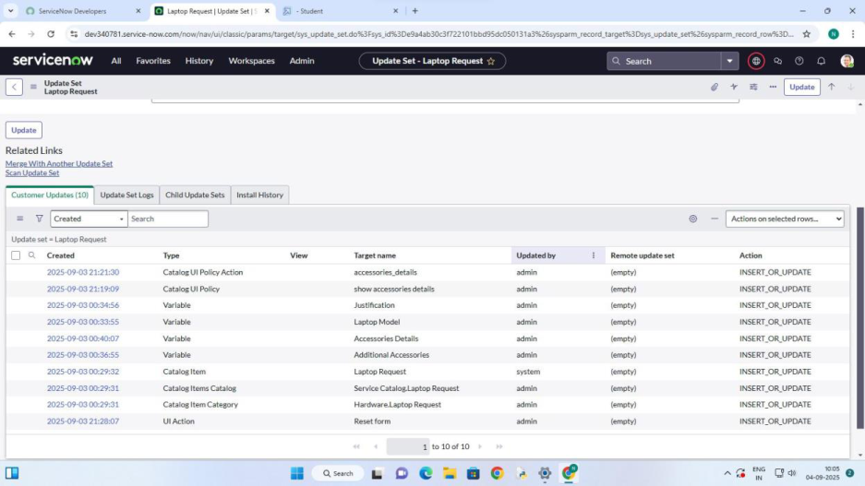

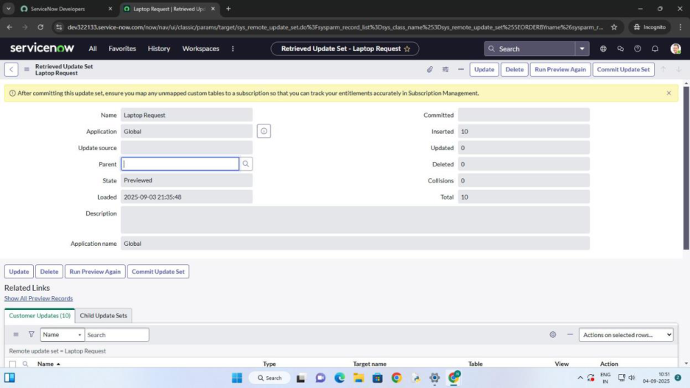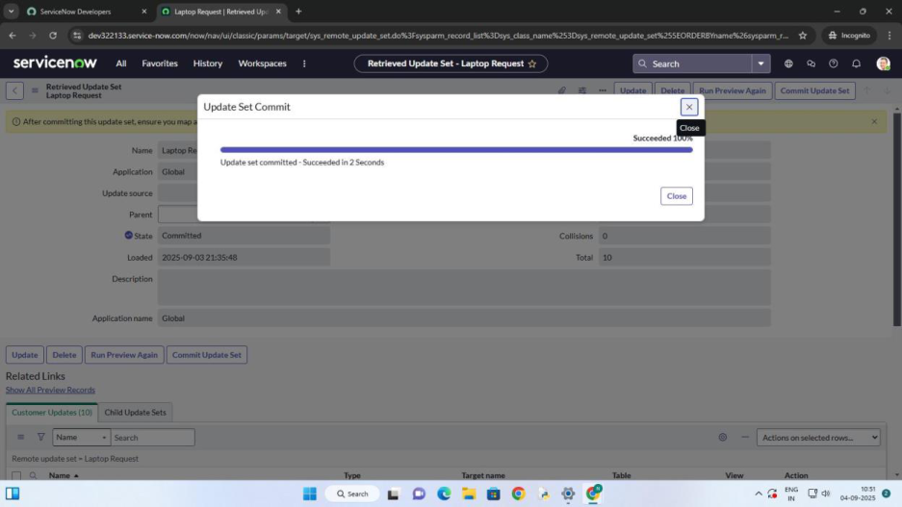

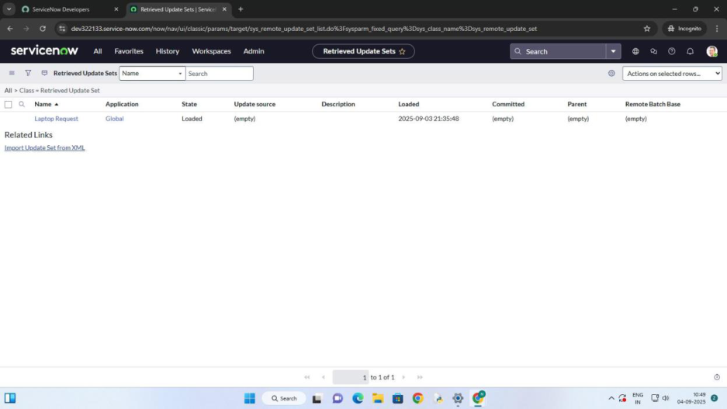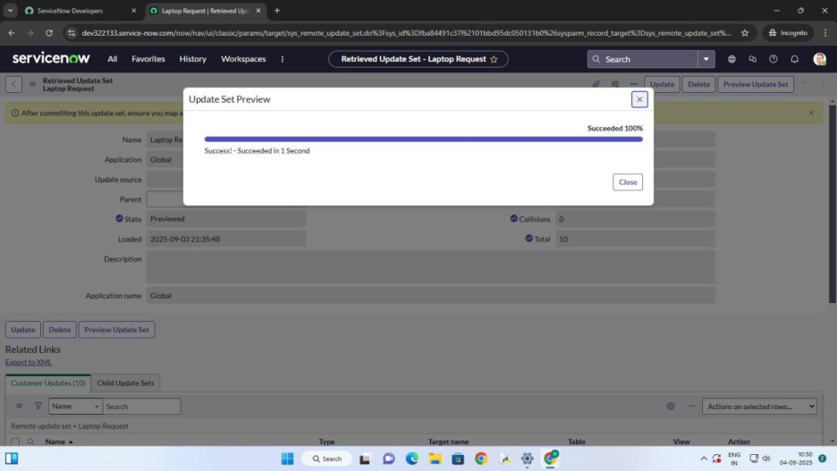

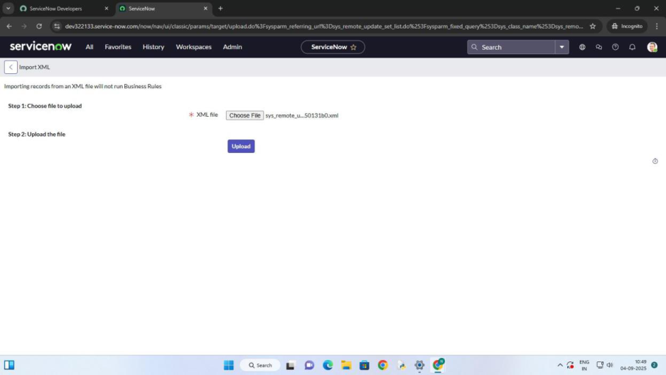

5. Click Export to XML →Download

**Milestone 7: Retrieve Update Set in Another Instance**

**Activity 1: Import Update Set**

1. Open another instance (e.g., incognito window).

2. Login with credentials.

3. Navigate: All →Update Sets →Retrieved Update Sets.

4. Click Import Update Set from XML.

5. Upload the downloaded file.

6. Click Upload →Imported successfully.

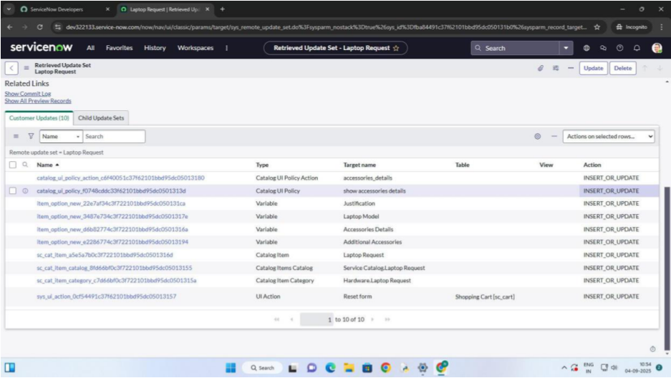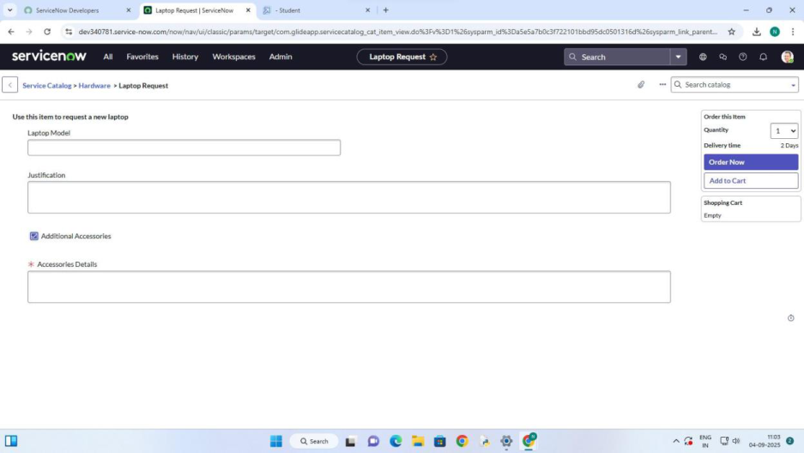



**Milestone 8: Testing**

**Activity 1: Validate the Catalog Item**

1. Login as a user.

2. Navigate to Service Catalog →Laptop Request.

**3. VERIFY THAT:**

All variables display correctly.

Accessories Details only appears when checkbox is selected.

Reset Form button clears inputs.

Request submits successfully.

**CONCLUSION:**

This guided project walks through building a Laptop Request Catalog Item in   
ServiceNow. The solution incorporates variables, UI policies, UI actions, and update set   
migration, ensuring that requests are easy to use, dynamic, and portable across instances.   
The process reduces delays, enforces governance, and provides a structured deployment   
approach.