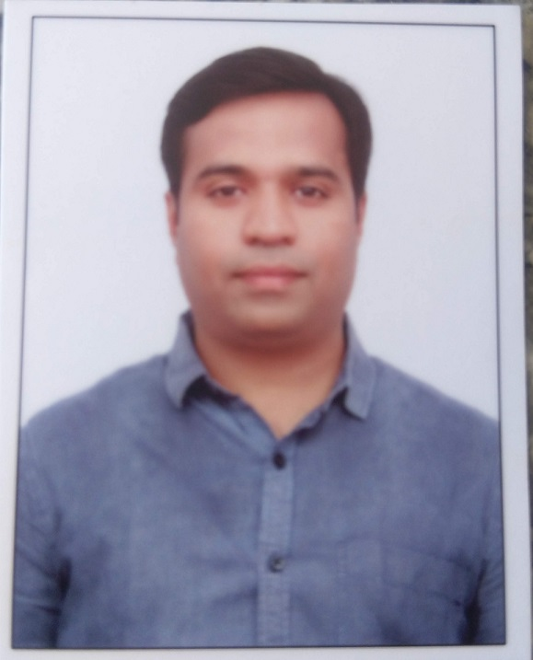

Passport size photograph
Candidate Information Form

GUIDELINES TO FILL FORM
- Use black ink to fill the form
- Please write in block letters

Personal Details

Full Name (as per govt id proof): Srikanth Namashivaya
Date of Birth |  |  |  |  |  | 14-Aug-1987
Marrital Status |  |  |  |  |  | Married
Spouse’s Name( If Married) |  |  |  |  |  | Akshaya Govind Chodekar

If spouse is working, please indicate the profession
If spouse is working with CGI, please mention |  |  |  |  |  |  |  | PSA ID |  |  |  |  | Project Name

Nationality: INDIAN
Current Location |  |  |  | Hyderabad |  |  |  |  | Preferred Job location |  |  |  |  |  | Hyderabad
Passport Details | Yes | Yes |  |  | No |  |  | Passport number |  |  |  | P3774210 |  |  |  | Valid upto |  | 05/07/2026

PAN No: AJUPN9280C

Contact Details
Contact Number (Mobile) |  |  | 9665553906 |  |  |  |  |  |  | Contact Number (Landline)
Email ID: shree546@gmail.com |  |  |  |  |  |  |  |  |  | Alternate Email ID: sri1442@gmail.com

Alternative Mobile Number (Family): 9030065421

Alternative Mobile Number (Friends): 8790315550

Academic Details (Please write in Block letters, please do not use short forms)
Particulars | Class X | Class XII / PUC | Graduation/ Engineering | Post-Graduation
Name of the degree | SSC | IPC | B.Tech
Specialization/  Stream | SSC | MPC | CSE
Name of the School/ College | SSSM High School | Narayana Jr College | DVR college of Engineering & Technology
Name of the University/Board | SSC | IPC | JNTU ,Hyderabad
Year of passing | 2002 | 2004 | 2008
Percentage/Class  /CGPA | 82.3% | 83.4% | 61.2%

Candidate Information Form

Name of the candidate | Srikanth Namashivaya

Additional Courses / Certifications (If Any)
Certificate/Course Name | Specialization | College/Institution |  |  |  | Year of Passing |  | Percentage/Class

Gaps / Breaks in Education (If any)
From Date | To Date |  | Degree / Course | Duration | Remarks / Reason for Gap
01-Jul-2008 | 01-Feb-2009 |  |  | 6 months | Waiting for PG Admission
Minimum time required to join (In Days) |  |  |  |  | 60
Have you been interviewed by CGI in last 6 months |  |  |  |  | YES |  |  |  | NO | No

Employment History (In Chronological Order)
From Date | To Date |  |  | Duration (In Months) |  |  | Organization | Designation
18-July-2016 | Till Date |  |  | 68 |  |  | Cognizant | Lead Architect
10-Feb-2011 | 15-July-2016 |  |  | 65 |  |  | Vegayan Systems | Lead Developer

Gaps / Breaks in Career (If any)
From Date |  | To Date | Duration (In Months) |  |  | Remarks / Reason for Gap
Total Experience (in months) |  |  |  |  | 133
Relevant Experience (in Yrs) |  |  |  |  | 133

I hereby declare that all information furnished here are true and correct to the best of my knowledge and belief.

08-Apr-2022 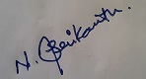
Date: _________________ Signature: ________________

