//By Related Keywords//

driver.findElement(By.className(className)
driver.findElement(By.cssSelector(selector)
driver.findElement(By.id(id)
driver.findElement(By.linkText(linkText)
driver.findElement(By.name(name)
driver.findElement(By.partialLinkText(linkText)
driver.findElement(By.tagName(name)
driver.findElement(By.xpath(xpathExpression)

Locating Elements By ID
Locating Element By ClassName
Locating Element By Tag Name
Locating Element By Name
Locating Element By Link Text Or Partial Link Text
Locating Element By cssSelector
Locating Element By XPath

Mostly Used Elements

name, id, CSS and XPath.

Example for Id :--

driver.findElement(By.id("username")).sendKeys("anand@developtest.com");
driver.findElement(By.id("submitButton")).click();

where username is identifier <input type="text" id="username" value="anand@developtest.com">
where sendKeys value is actual data.

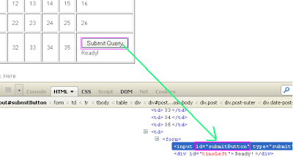

Example for className:-

URL :http://only-testing-blog.blogspot.in/2013/11/new-test.html#sthash.6ZJGYaBd.dpuf

<h2 class="date-header">
<span>Sunday, 17 November 2013</span>
</h2>
String datentime = driver.findElement(By.className("date-header")).getText();

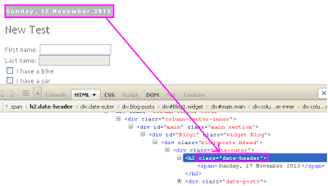

Look in to above image. Post date content has a class and we can use that class name to store that blog post date string. Notice one more thing in above image, blog post date string has not any ID so we can not locate it by ID

