Multi-Region Microservices Platform (AWS) – Documentation

1. Project Overview
Project Title: Multi-Region Microservices Platform
Domain: Compute + Networking + Serverless

Objective
To design and implement a scalable, secure microservices architecture using AWS services that supports:
- Advanced traffic routing
- Service isolation
- Static IP-based access
- Auto scaling based on demand

Services Used
- Amazon S3 (Frontend hosting)
- Application Load Balancer (Routing)
- AWS Lambda (Authentication)
- Network Load Balancer (Payments)
- Gateway Load Balancer (Security)
- Amazon EC2 (API servers)

🔹 2. Architecture Description
The system is designed using a microservices approach, where each component performs a dedicated function:
- Frontend is hosted using S3 static website
- API requests are routed through ALB to EC2 instances
- Authentication requests are handled by Lambda
- Payment traffic is managed through NLB with static IP
- All traffic passes through Gateway Load Balancer for inspection

3. Architecture Flow
- User accesses the frontend hosted on S3
- Requests are sent to the Application Load Balancer
- ALB routes traffic based on path:
  - /users/* → EC2 instances
  - /auth/* → Lambda function
- Payment traffic is handled separately via NLB
- Gateway Load Balancer inspects incoming traffic before routing
- Auto Scaling dynamically adjusts EC2 instances

4. Implementation Steps

Step 1: S3 Static Website Setup
- Created S3 bucket for frontend hosting
- Enabled static website hosting
- Configured CORS to allow API communication

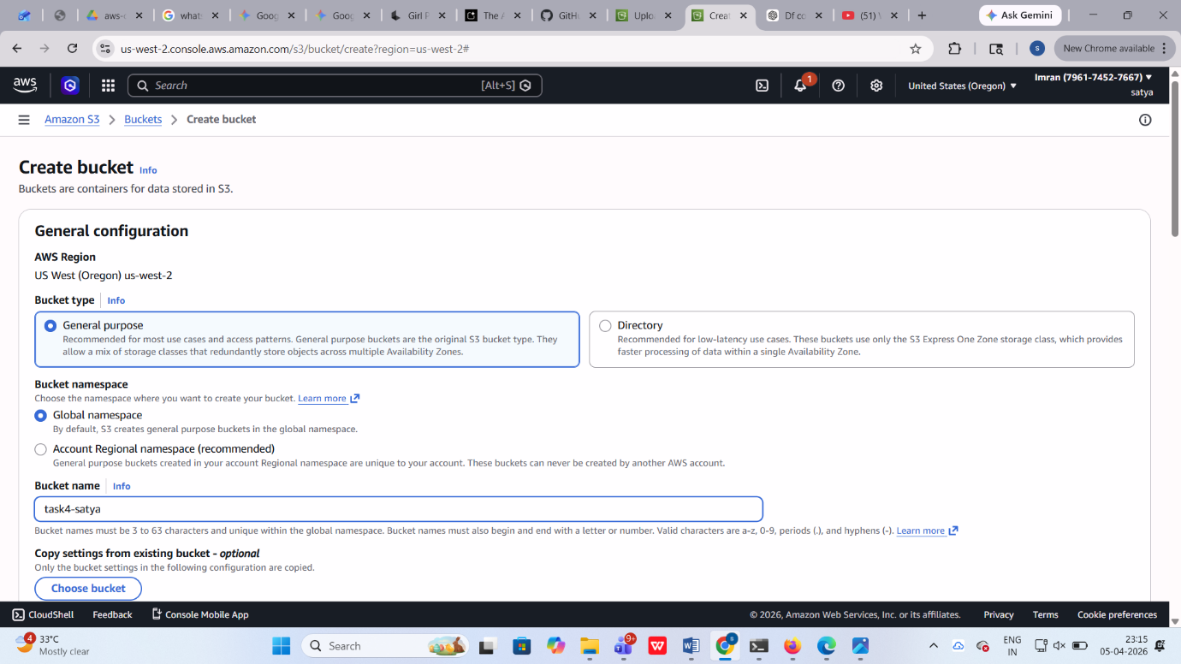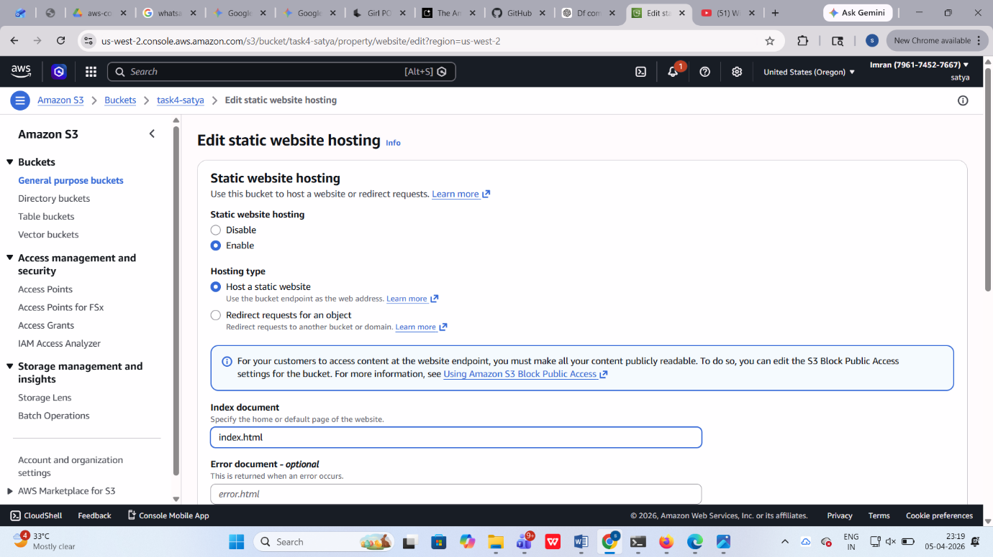

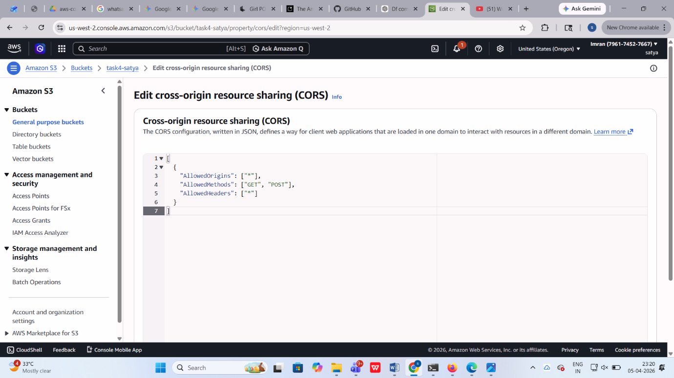

🔸 Step 2: EC2 Setup
- Launched multiple EC2 instances for API layer
- Configured instances in different Availability Zones
- Installed web server (apache)
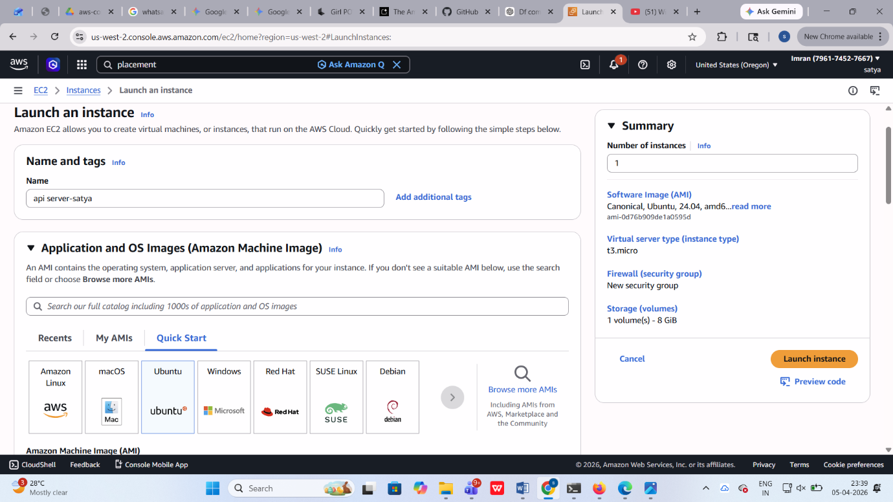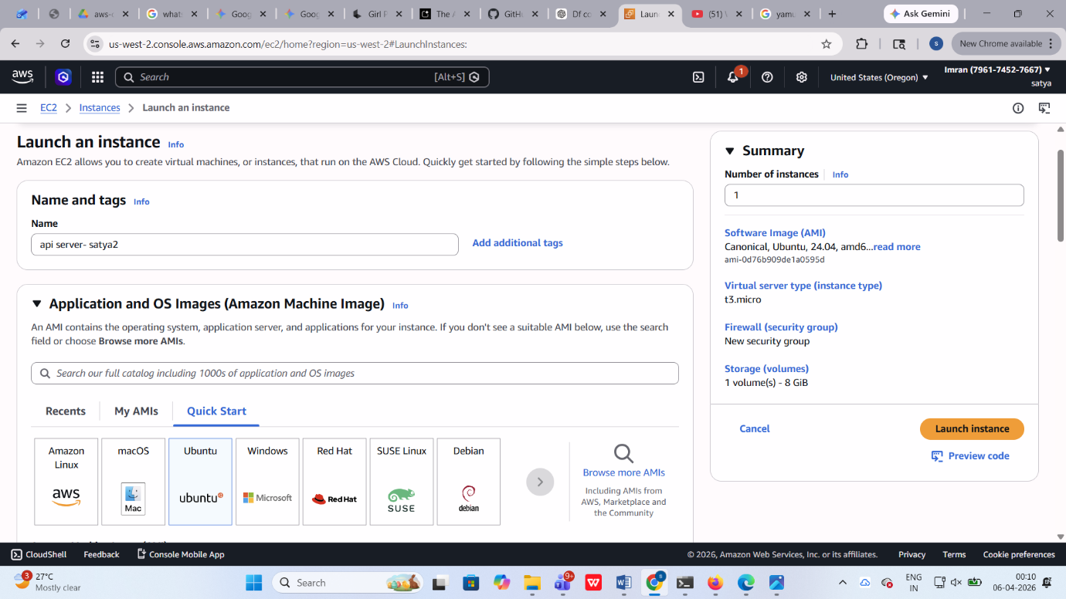

🔸 Placement Group
- Created Spread Placement Group
- Attached EC2 instances to ensure high availability
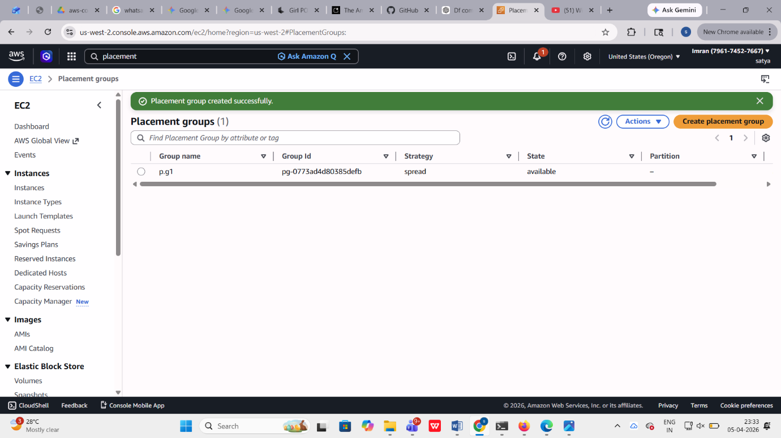

Secondary ENI
- Attached additional network interface to each instance
- Used for monitoring and network separation

🔸 Step 3: Target Groups
- Created separate target groups for:
  - EC2 instances (API traffic)
  - Lambda function (Auth service)
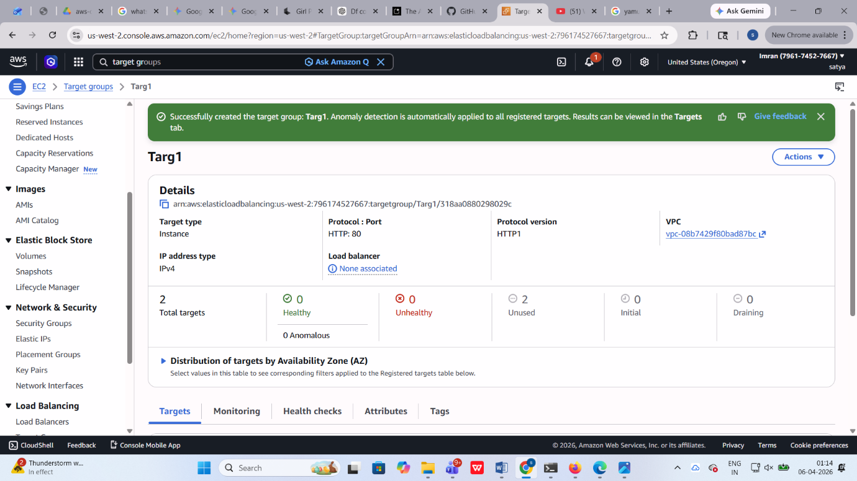

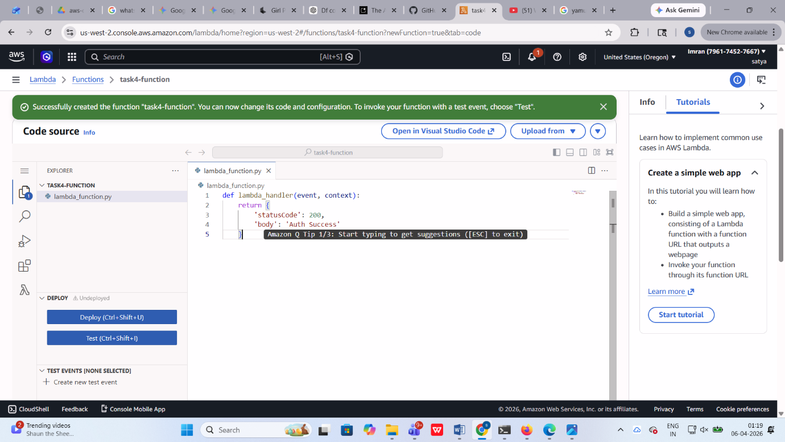

Step 4: Application Load Balancer
- Created ALB with internet-facing configuration
- Attached EC2 target group as default

Path-Based Routing:
- /users/* → EC2 instances
- /auth/* → Lambda

Additional Settings:
- Enabled sticky sessions
- Enabled cross-zone load balancing

Step 5: Lambda Configuration
- Created Lambda function for authentication
- Integrated Lambda with ALB target group

Step 6: Network Load Balancer
- Created NLB for payment service
- Configured TCP listener on port 443
- Assigned Elastic IP per Availability Zone
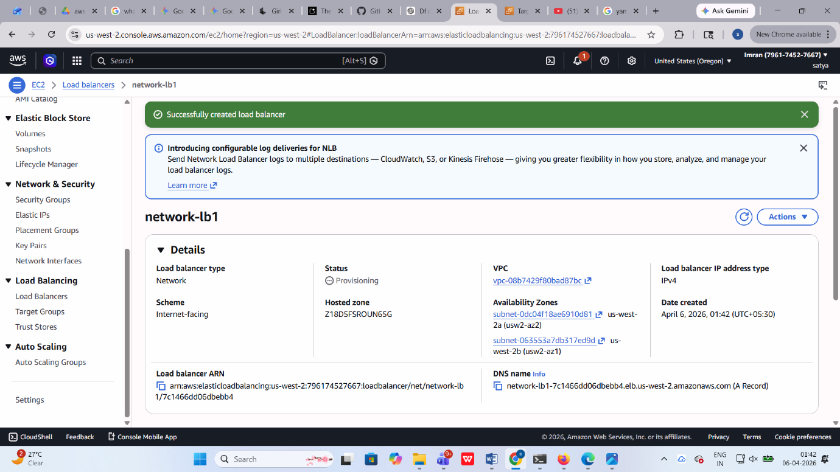

Step 7: Gateway Load Balancer
- Created Gateway Load Balancer
- Configured GENEVE protocol
- Attached EC2 instance as firewall appliance
- Created GWLB endpoint for traffic routing

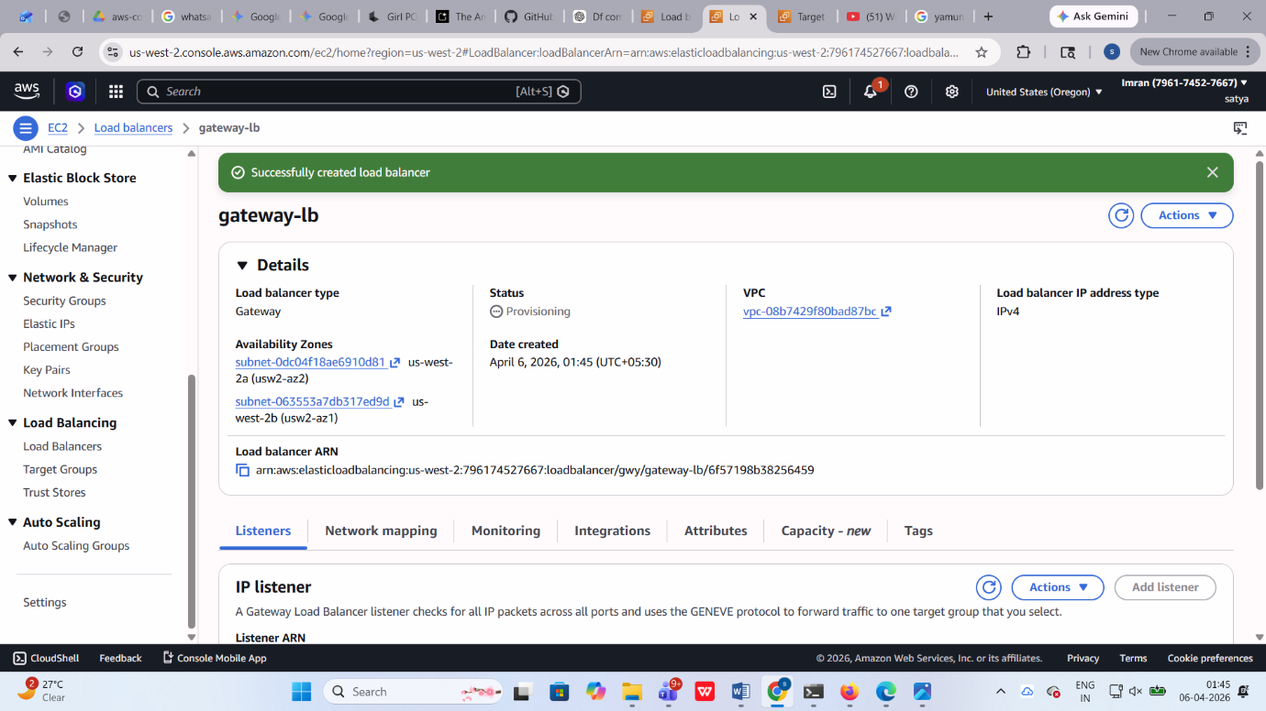

Step 8: Auto Scaling Group
- Created Launch Template with EC2 configuration
- Configured Auto Scaling Group:
  - Minimum: 2 instances
  - Maximum: 5 instances
  - Desired: 2 instances
- Attached Auto Scaling Group to ALB target group
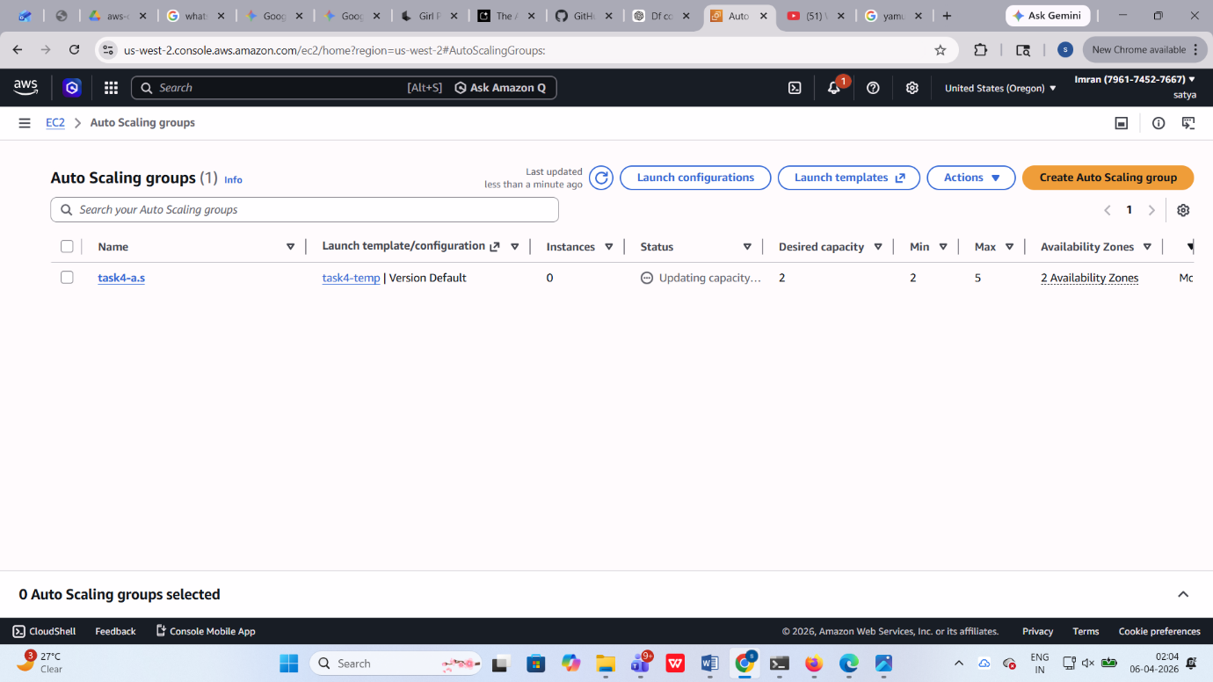

Step Scaling Policy
- Scale Out:
  - If CPU > 70% → Add 2 instances
- Scale In:
  - If CPU < 25% → Remove 1 instance

6. Key Concepts Demonstrated
- Path-based routing using ALB
- Serverless integration with Lambda
- Static IP handling using NLB
- Traffic inspection via Gateway Load Balancer
- High availability using Placement Groups
- Auto Scaling with step scaling policies

7. Conclusion
This architecture successfully implements a highly available, scalable, and secure microservices platform. It ensures efficient traffic routing, service isolation, and dynamic scaling while maintaining performance and fault tolerance across multiple availability zones.

