Cloud-Based Disaster Recovery & Backup Architecture (AWS)

1. Project Overview
Project Title: Cloud Disaster Recovery & Backup Implementation
Domain: Storage | Backup | Disaster Recovery

Objective
The aim of this project is to design and implement a reliable backup and disaster recovery solution that satisfies:
- RPO (Recovery Point Objective): 1 Hour
- RTO (Recovery Time Objective): 4 Hours

Scope of Solution
This implementation focuses on:
- Backup of EC2 workloads
- Shared storage using EFS
- Automated backup management
- Cross-region disaster recovery setup

2. Architecture Design

Core Components
- Amazon EC2 (Application layer)
- Amazon Elastic Block Store (EBS volumes)
- Amazon Elastic File System (EFS)
- AWS Backup
- Amazon S3 with Cross-Region Replication

3. Architecture Workflow
- Application runs on EC2 instances across multiple AZs
- EBS volumes provide persistent block storage
- EFS enables shared file access between instances
- AWS Backup automates snapshots and AMI backups
- Backup copies are replicated to a secondary region
- S3 buckets are configured with Cross-Region Replication (CRR) for DR

4. Implementation Steps

🔸 Step 1: EC2 Instance Setup
- Launched 2 EC2 instances in different Availability Zones
- Installed required NFS utilities:
sudo apt update
sudo apt install nfs-common -y

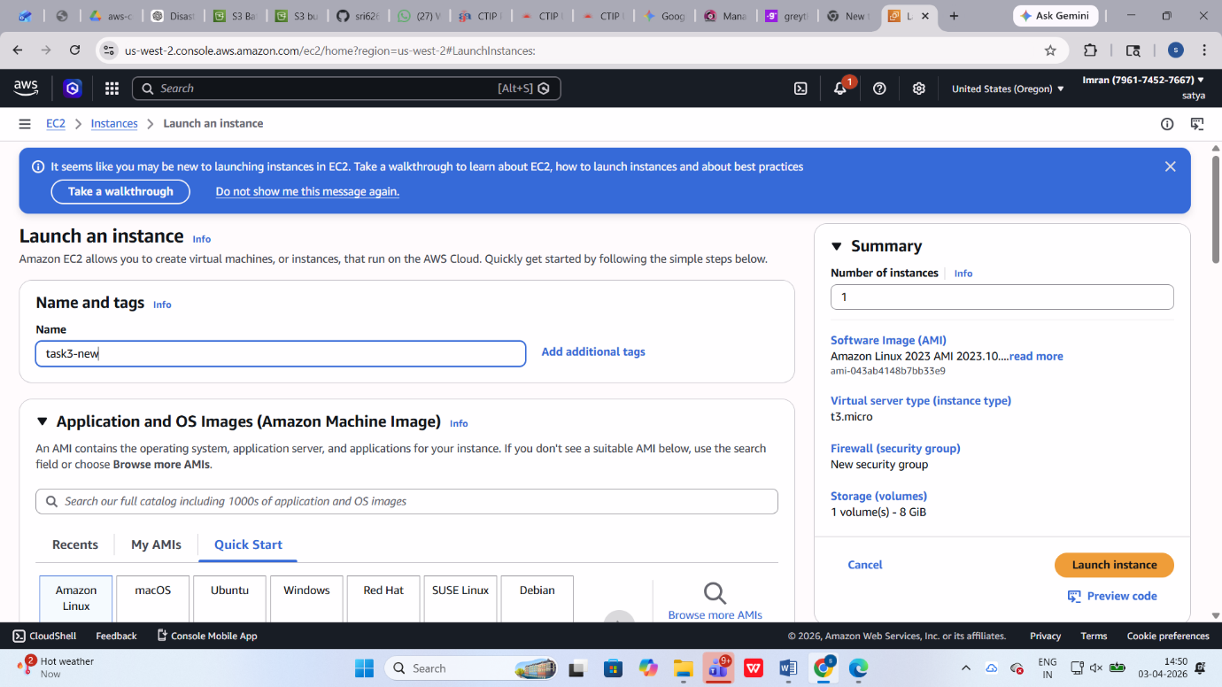

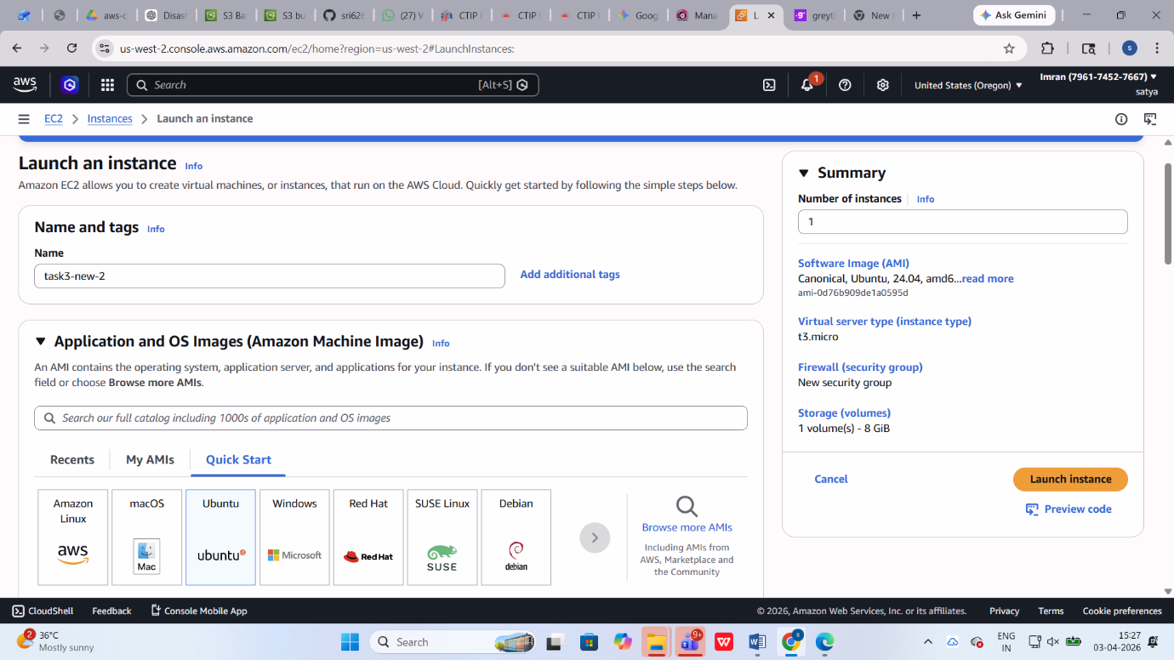

🔸 Step 2: EBS Multi-Attach Configuration

Volume Creation
- Type: gp3
- Size: 20 GB
- Multi-Attach: Enabled
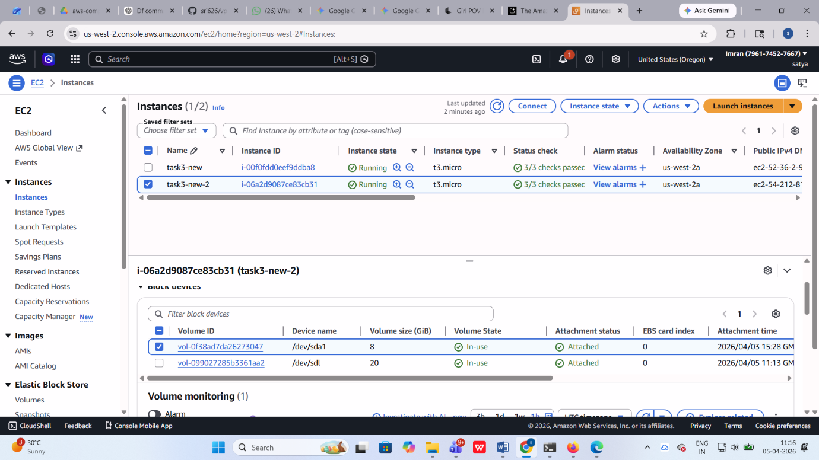

Attach & Mount
lsblk
sudo mkfs -t ext4 /dev/nvme1n1
sudo mount /dev/nvme1n1 /data
✔ Volume attached to two EC2 instances

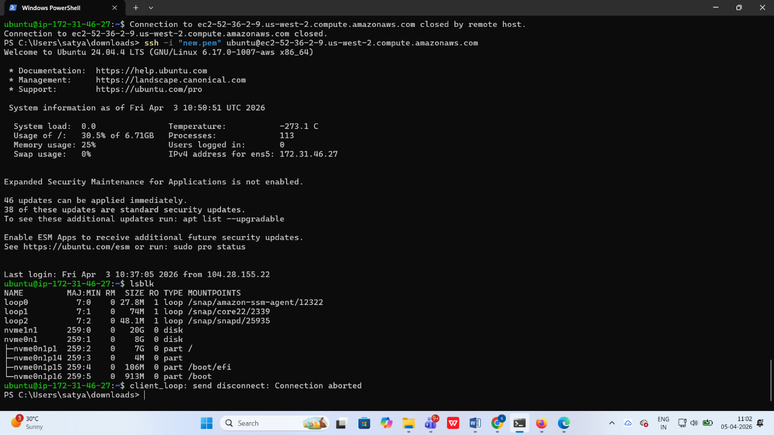

Resize Validation
- Volume resized without stopping instances
- Verified continuous availability

Step 3: EFS Configuration

File System Setup
- Created EFS file system
- Enabled mount targets in multiple AZs

Mount Command
sudo mount -t nfs4 fs-xxxx:/ /mnt/efs

Lifecycle Policy
- Transition to Infrequent Access (IA) after 30 days
- Transition to Archive after 90 days
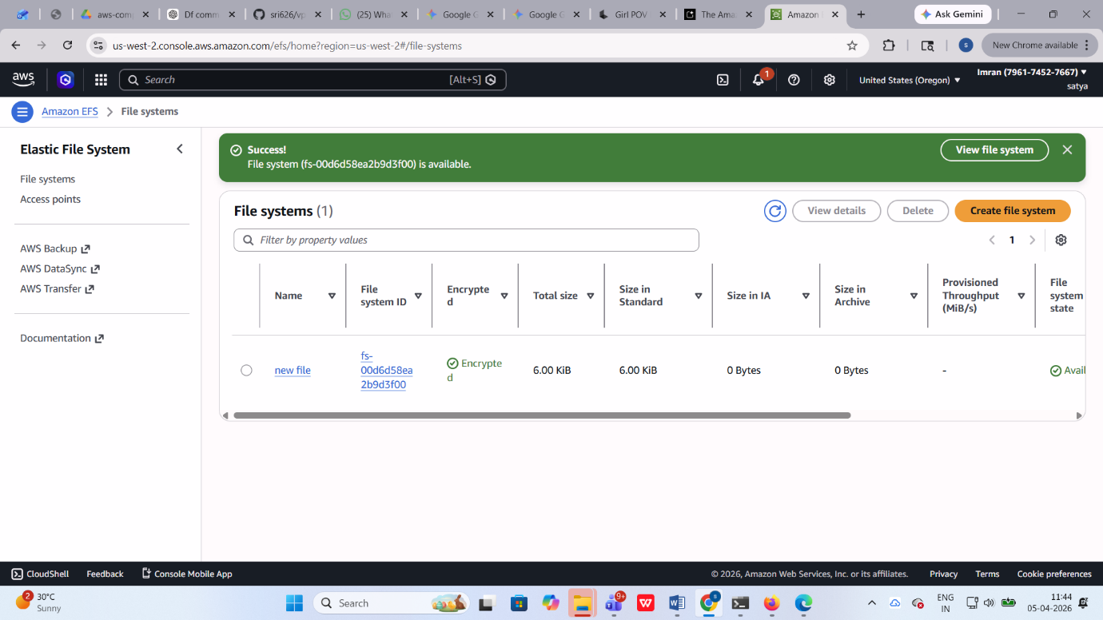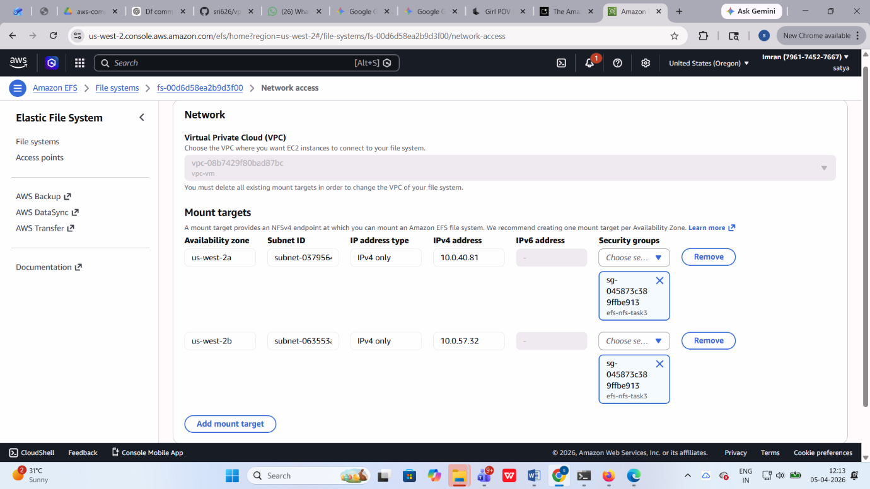

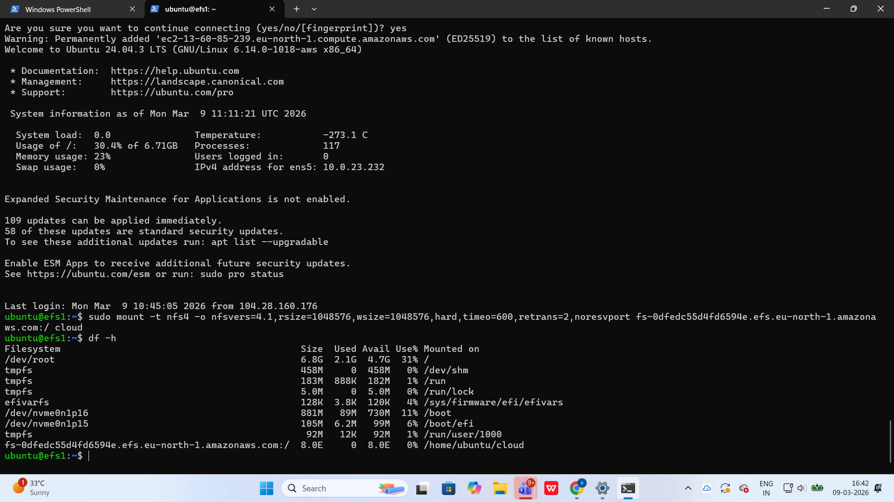

Step 4: Backup Configuration

Vault Setup
- Created backup vault
- Enabled encryption using KMS

Backup Plan
Resource | Frequency | Retention
EBS | Hourly | 24 Hours
EFS | Daily | 30 Days
AMI | Daily | 30 Days

Cross-Region Backup
- Destination: us-west-2
- Retention: 1 year
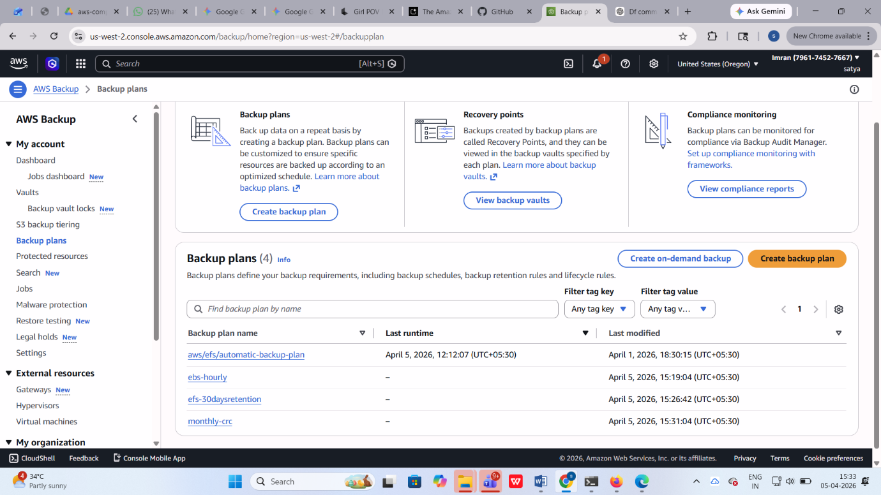

Step 5: S3 Cross-Region Replication

Configuration Steps
- Created source bucket (primary region)
- Created destination bucket (DR region)
- Enabled versioning on both buckets
- Configured replication rule
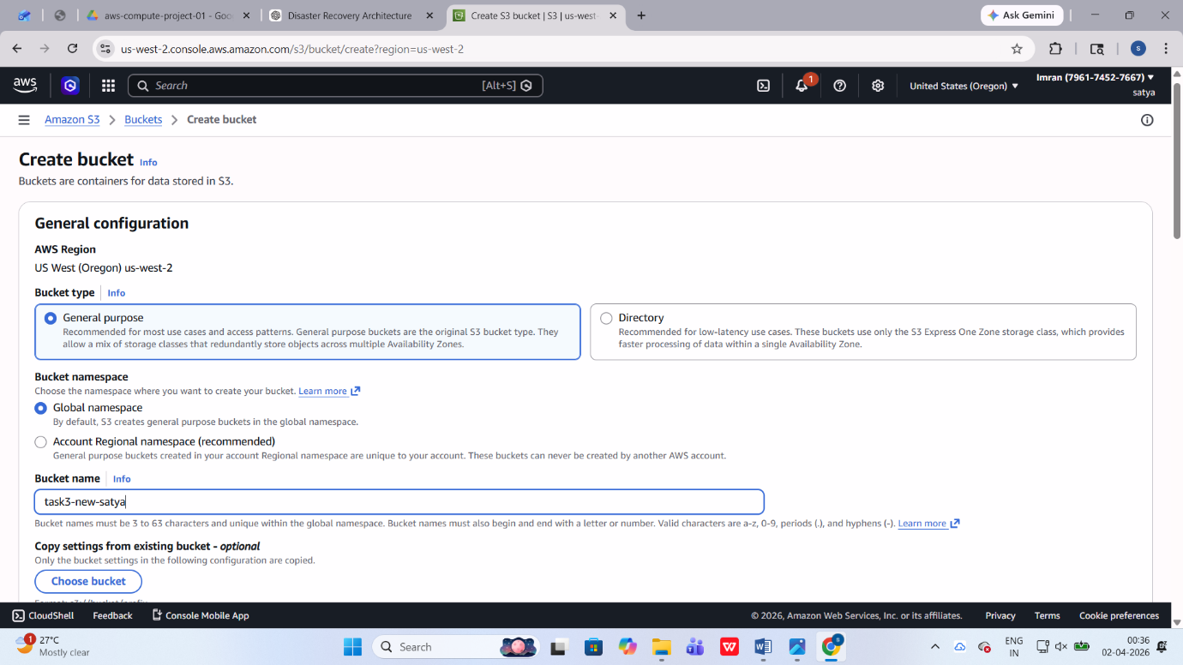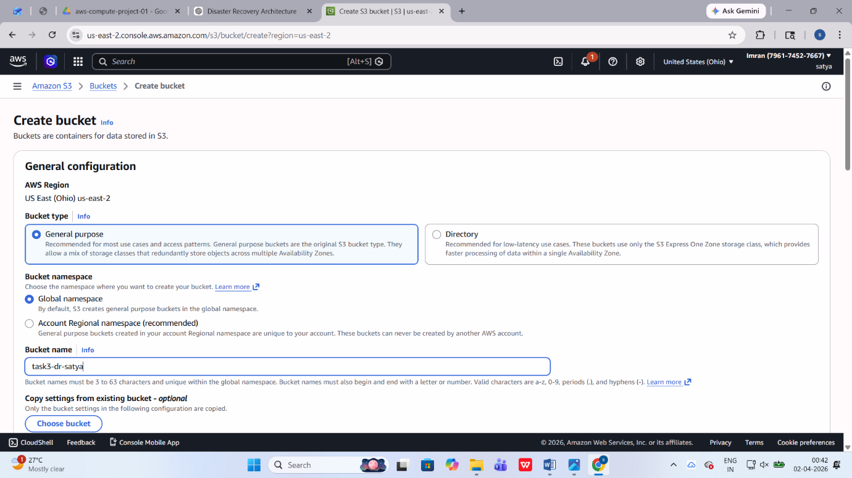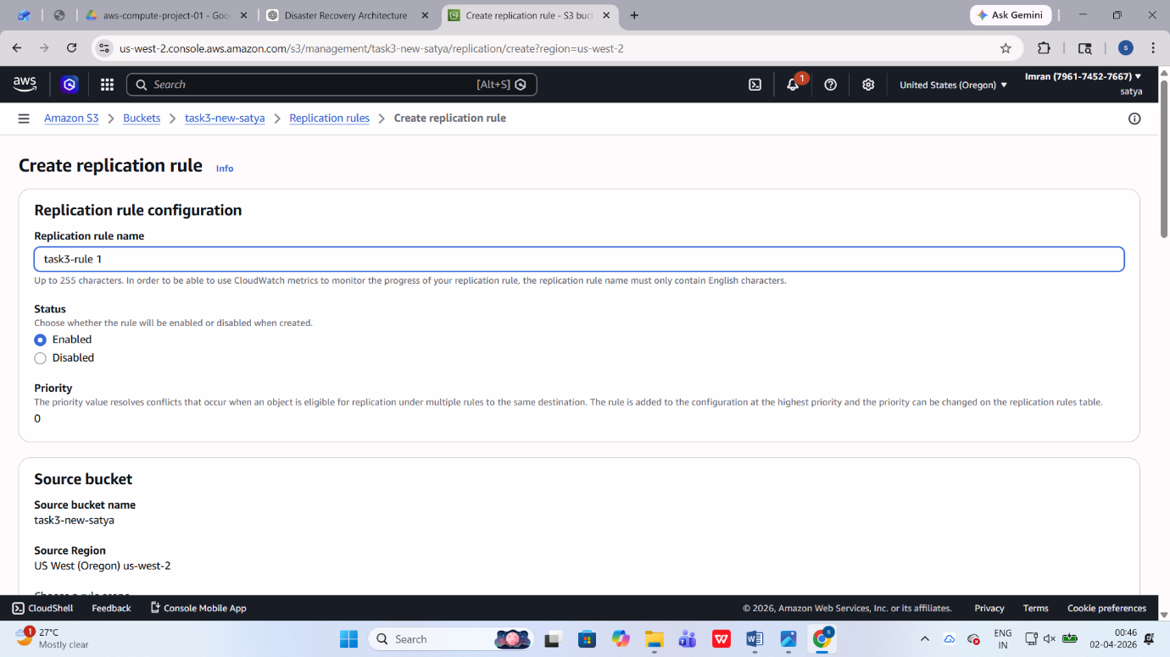

Verification
- Uploaded files in source bucket
- Verified automatic replication in destination bucket
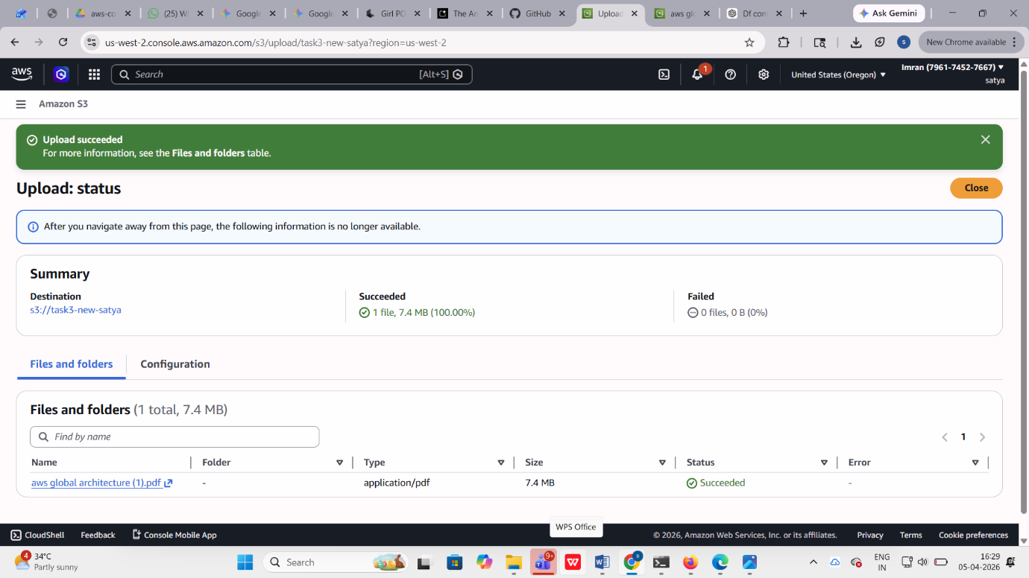

6. Key Concepts Demonstrated
- Backup automation using AWS Backup
- Multi-AZ high availability
- Cross-region disaster recovery
- Storage lifecycle optimization
- Data replication strategies

7. Conclusion
This solution successfully provides a robust disaster recovery architecture by:
- Ensuring data durability and availability
- Minimizing data loss (RPO: 1 hour)
- Enabling quick recovery (RTO: 4 hours)
- Implementing cross-region redundancy

