**Use case doc for appointment of patients to doctors**

**USE CASE NAME :** Scheduling appointment

**DESCRIPTION :** Patient makes an appointmentwith the admin and gives details about regarding the health issues and sickness complaints. Admin schedules an appointment with the doctor based on the given information. The appointment contains the doctor name , doctor id ,doctor’s specialization , timing , patient name and complaint. Depending upon the patient’s confirmation of the schedule made appointment schedule is sent to the respective doctor.

**ACTORS:**

**primary actors:** Patient.

**Secondary actors :** admin , doctor.

**TRIGGER:** patient making an appointment .

**PRECONDITIONS:** Need an appointment .

**BASIC FLOW :**

1. Patient details regarding their appointment along with their sickness complaints and their respective patient id’s are received by the admin.
2. Based on the complaints and the id the admin checks for the appointment availability.
3. The admin makes a schedule containing the doctor name , doctor id ,doctor’s specialization , timing , patient name and complaint.
4. The patient will be asked for the confirmation of the schedule .
5. With the patient’s positive response the final schedule copy is sent to the doctor .

**EXCEPTION:**

1. If in case , response to the schedule sent the patient wants it to be rescheduled then the admin would be notified regarding it.
2. Then the admin follows 2 steps .

* Cancel the current schedule .
* Reschedule the appointment from the beginning .

1. Again the new appointment schedule is sent to the patient for reconfirmation and the final copy of it is sent to the doctor.

**EXCEPTION:**

1. If there is a situation where the admin is unable to communicate with the patient regarding the confirmation of the schedule the admin can contact the patient through phone number .

**POSTCONDITION:** The final copy of the appointment scheduled should be sent to the doctor.

**LEVEL:** white level – high

**STAKEHOLDERS: - admin and doctors**

* If the patient cancels the appointment then it is a loss for the hospital and also will have an effect on the doctor’s schedules.
* It also increases the workload of admin to reschedule the appointment .

**NOUN PHRASES – IDENTIFIED:**

Patient , patient id , admin , doctor , schedule , doctor name , doctor id ,doctor’s specialization , timing , patient name , complaint

**NOUN AS CONCEPTUAL CLASS:**

Patient , admin, doctor , schedule

**OBJECT DIAGRAM:**

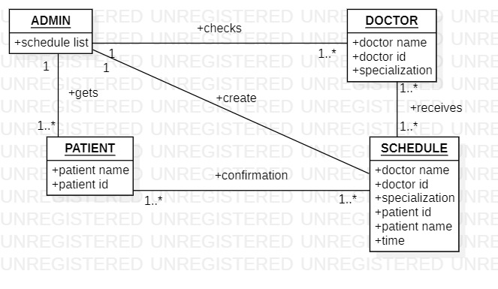

**TIME SEQUENCE DIAGRAM:**

