**DATA ANALYTICS WITH TABLEAU**

**1. INTRODUCTION**

**1.1 Overview**

Data analytics converts raw data into actionable insights. It includes a range of tools, technologies, and processes used to find trends and solve problems by using data. Data analytics can shape business processes, improve decision-making, and foster business growth.

As a term, data analytics predominantly refers to an assortment of applications, from basic [business intelligence](https://www.techtarget.com/searchbusinessanalytics/definition/business-intelligence-BI) (BI), reporting and online analytical processing ([OLAP](https://www.techtarget.com/searchdatamanagement/definition/OLAP)) to various forms of [advanced analytics](https://www.techtarget.com/searchbusinessanalytics/definition/advanced-analytics). In that sense, it's similar in nature to [business analytics](https://www.techtarget.com/searchbusinessanalytics/definition/business-analytics-BA), another umbrella term for approaches to analyzing data. The difference is that the latter is oriented to business uses, while data analytics has a broader focus.

The topic of my project is “**Tracing the growth of the global community - a population forecasting analysis”**

Global warming is one of the biggest challenges currently being faced by the human race, although correlation is not causation, a likely cause of global warming is due to increased atmospheric carbon dioxide from human activities. **CO2 Emission** refers to the Carbon Dioxide emitted throughout the world. For this analysis we will be focusing on CO2 Emissions and its effect on the world we live in as well as some key factors and stats that may play a role in the emission of CO2 globally. Fossil fuel use is the primary source of CO2. The data throws light onto how much fossil fuels are burnt, per year per nation, which amounts to an increase in CO2 every year. This will help researchers and environment experts to predict global warming. So countries should set a goal to decrease this amount yearly.

**1.2 Purpose**

Tableau is a data visualization tool first and foremost. Therefore, it’s technology is there to support complex computations, data blending and dashboarding for the purpose of creating beautiful visualizations that deliver insights that cannot easily be derived from staring at a spreadsheet. It has climbed to the top of the data visualization heap because of it’s dedication to this purpose.

Creating charts. The simple way to do it is to drag the categories into the 'Row' and 'Column' fields. Let's drag the 'Region' category into the Rows and the 'Sales' Category into Columns. Tableau then automatically creates a bar chart for us.

Using data analytics applications, the companies were able to find the best shipping routes, delivery time, as well as the most cost-efficient transport means. Data analytics is important because it helps businesses optimize their performances. Implementing it into the business model means companies can help reduce costs by identifying more efficient ways of doing business and by storing large amounts of data.

**2. PROBLEM DEFINITION AND DESIGN THINKING**

**2.1 Empathy Map**

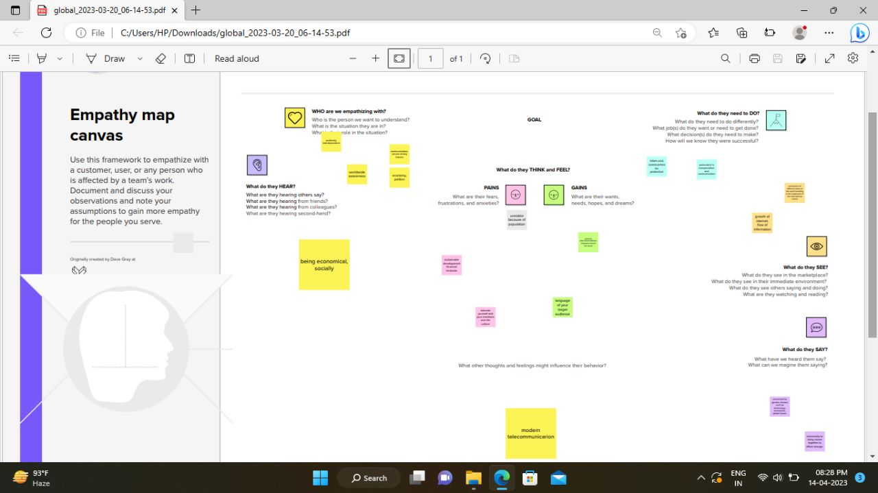

**2.2 Ideation and Brainstorming Map**

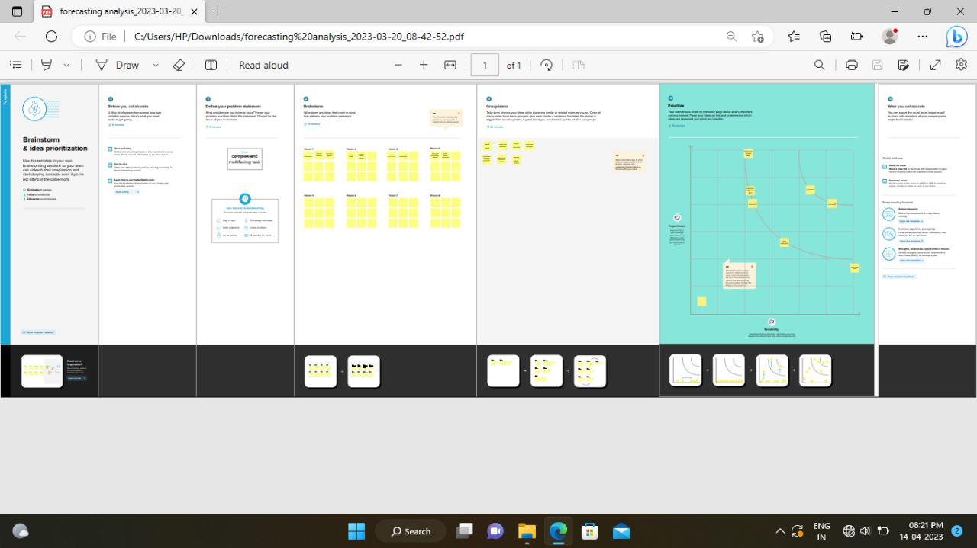

**3. RESULT**

Output of the Project

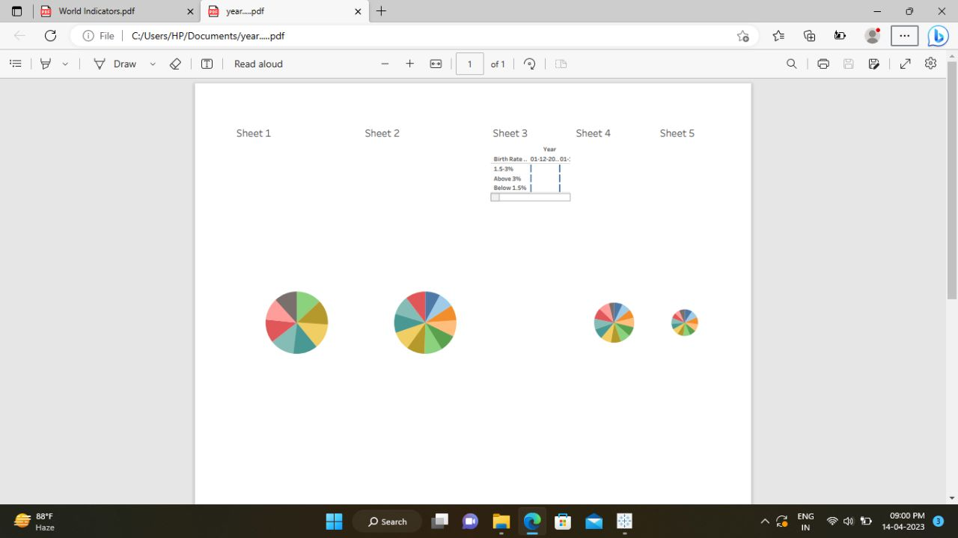

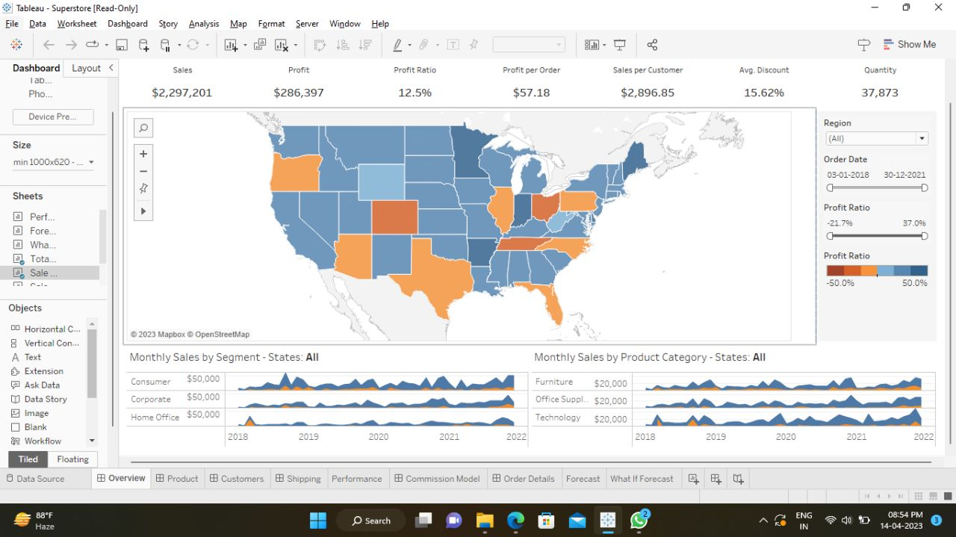

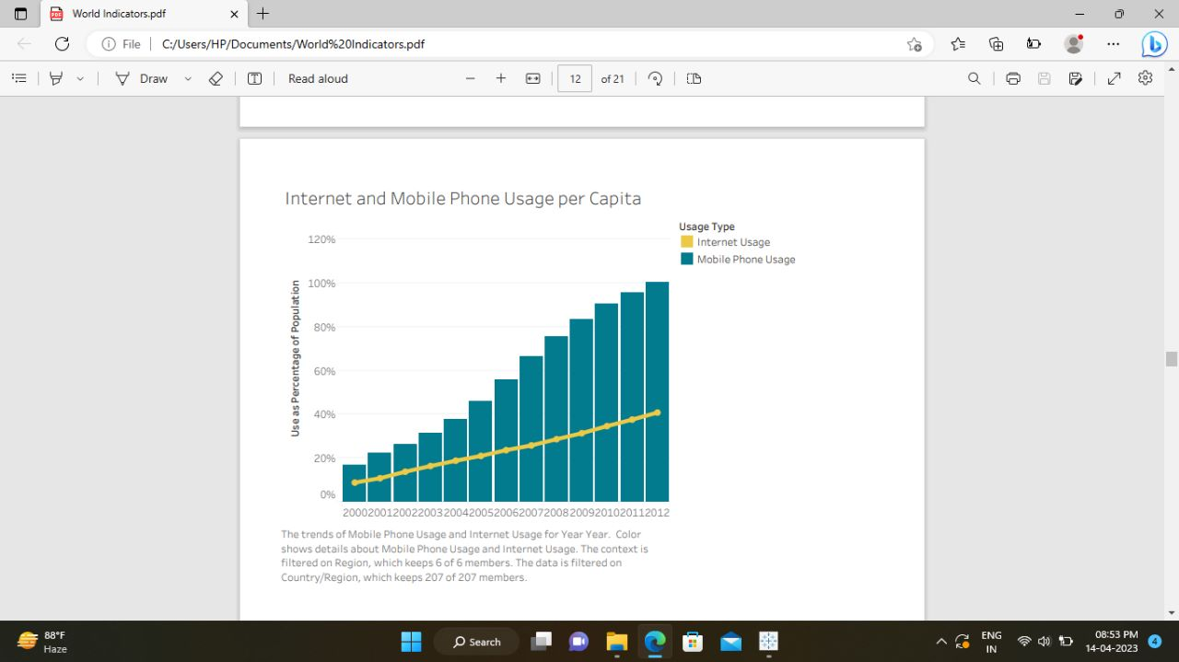

**4. ADVANTAGES AND DISADVANTAGES**

**4.1 Advantages**

If there are more people, the probability of finding a genius like Einsterin, Marie Curie, Beethoven increase. These exceptional people can lead to technological and cultural masterpieces which enrich our lives.

HIGHER ECONOMIC GROWTH

If economic growth if at the same rate as population growth, average living standards will not increase.

ECONOMIES OF SCALE

Farming and industry have been able to benefit from economies of scale, which means as the population growth, food output and manufacturing output have been able to growth even faster than population growth.

THE EFFICIENCY OF HIGHER POPULATION DENSITY

In terms of per capita carbon footprint, areas with a high population density are significantly more efficient than rural areas and places with a low population.

THE IMPROVED DEMOGRAPHIC STRUCTURE OF SOCIETY

Many western economies are now experiencing a falling population, with the result that their population demographic is being skewed to old, retired people. CRITICAL MASS Higher populations can enable a critical mass of people to enable a sider, more vibrant society. DISADVANTAGE OF POPULATION

**4.2 Disadvantages**

COST TO THE ENVIRONMENT

Trying to reduce carbon and methane emissions to reduce global warming is relatively more difficult as the population. CONGESTION

Too many people in a small space will lead to various types of congestion.

WATER SHORTAGES

Already up to 40% of the world’s population face water scarcity and the risk of drought.

GENERATING UNSUSTAINABLE WASTE

We are currently generating non-biodegradable rubbish that we are struggling to process.it tends to end in landfill, causing methane emissions and other toxic problems.

**5. APPLICATION**

Data on population growth in Beringin Jaya –Village ,Riau province, Indonesia, never recorded every year. Data are often changed each time needed because the administration office never recorded real data every year and there is no system applied to it. This condition gives difficulties for the Headman to know the real condition of human population growth every year and to modernize the village when the Headman wants to purpose funds to higher authority side in the next year .To assist the Headman to purpose a fune ,a system in needed to predict population growth in the future. Forecast system in an important aid tool for headman, to arrange the improvement plans of the village in future effectively and efficiently . The research is one way to help the Headman of Beringin Jaya Village to collect and record of data. Research uses the single moving average.

Forecasting ability can be classified based on the significant of MAPE.. The smallest MAPE indicates the best forecast obtained in general results of the research show the best prediction of population growth total (2012-2017) in one year is in 2014.

**6.FUTURE SCOPE**

• Further advancements in collaboration and sharing capabilities, making it easier for teams to work Tableau is a widely-used data visualization tool that has a strong future scope. It is expected to continue to be a popular choice for businesses and organizations that need to analyse and understand large sets of data. Some of the ways that Tableau is expected to evolve in the future include:

• Increasing integration with other tools and technologies, such as machine learning and artificial intelligence, to provide even more advanced data analysis and insights.

• Continued development of mobile capabilitiestogether on data projects and share insights with others.

• Tableau is a good to have knowledge, but building a career out of tableau is never advisable. Tools keep on changing as technology updates.

• So learning tableau is good, it is a steeping stone of your career. Don't try to build an entire career based on that. Overall, the future looks bright for Tableau as a powerful and valuable tool for data analysis and decision-making

**7. CONCLUSION**

Tableau is a very effective tool for graphical representation, and it has more than 24 different graphical views to display data. Though the dataset is complex or the dataset is very big, in tableau, we can create dashboards very easily and within less time.

 Good data visualization should communicate a data set clearly and effectively by using graphics. The best visualizations make it easy to comprehend data at a glance.

In this Data Analytics project we learned a lot about many applications such as Tableau, My SQL etc., Also we learned how to draw a graph for Data in a easy way with the help of Tableau application.