**Chaitra Navraatri**

(23rd March to 1st May2012)

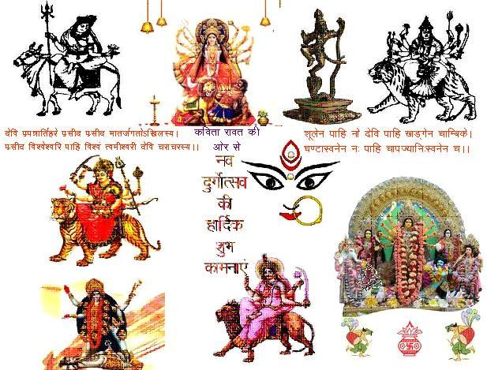

Extends all over universe, the power and energy at the time of landing on this earth is called Navraatri. However 1st January becomes first day of New Year according to Gregorian calendar. In same way the first Chaitra Navraatri inaugurated the New Year according to Bhartiya Vikram samvat Panchang. Navraatri became celebrated in a very unique sense; the peoples were waiting these nine auspicious days and night. Durga Puja of Bengal and Navraatri Garba is famous all over the world. Even navraatri comes four times in a year but chaitra navraatri and aashvin navraatri is very important to everyone. This time Chaitra Navraatri comes with a great moment of change. If we could maintain our life routine spiritually in these day, then mother Shakti remove all of the impurities, weaknesses and sins from our inner self, enlightened to our soul by the divine flame of mother Addhya Shakti. For the imbibe of this auspicious occasion. I believe that following explanation will be helpful.

***Navraatri and Astronomy –*** Sun is the center of all conscious activities. The earth keeps the orbiting of the sun. Four times earth is tilted 23.5 degree towards the sun. At the same time of H.H. Rishis declared to the Navraatri. When the earth becomes 90 degree true north from the sun and dictated the distance approx 387800 Km with the speed of 30 Km/Second then the getting time is known as a Chaitra Navratri. 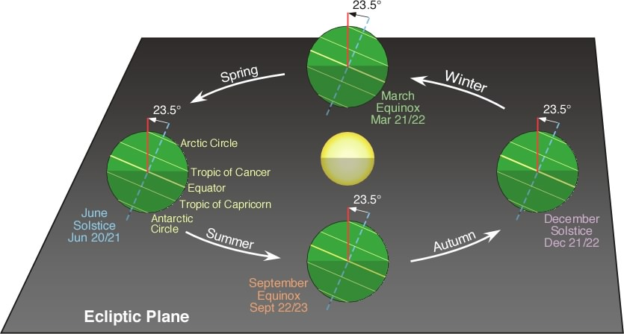

This special time can be says the sweet union between sun and earth. The earth is waiting to this particular time and comes down at the speed of 30 Km/second from 54 Km/second. Thus the earth save some time for loving sun. The Tantrik experts well known that this intersection of earth and sun is a conception of nature. In this period there were a creative atmosphere comes at this planet, this divine atmosphere makes a man energetic and powerful.

**Navraatri and mathematics –** 9 number is totally integral number in math. The 9 nights of power is interrelated with this calculation .Some examples are as under –

1. Add how many times in 9 to 9 the sum have been always 9 –

a. 9+9 =18= 1+8 =9

b.9+9+9+9=36=3+6=9

**2**. Multiple to any number with 9 the sum result will be always 9

9 * 9=81=1+8=9

10 * 9=90=9+0=9

11*9=99=9+9=18=1+8=9

8654*9=77886=7+7+8+8+6=36=3+6=9

3. The total number of hymns from Veds is-19404

1+9+4+0+4=18=1+8=9

4.The total Verses in Tulsi’s Ramayan – 9990

9+9+9+0=27=2+7=9

5.The total number of Purans is – 18

1+8=9

6. The total number of Planets – 9

7. The total number of constellation – 27=2+7=9

8. Total no in chanting beads are -108=1+0+8=9

Thus we can see that 9 number is symbol of perfectness. its interrelation with 9 glorious nights shown that Navratri makes perfect to his deciple.

………….contd.

Highlights of next-

-Navratri in Hindu Myths.

-Navratri and Islam from holy Quoran.

- Navratri and Christianity from holy Bible.

- Vedic methods of Navratri festival and worship.