AI/ML
Creation of image of all above problem statement in a single template and also check all this problem statement are working in a single chartboard
Requriments:
- Creation of universal chart board(AIML)
- Inside this chart board I required a list of Educational text book’s(Prompt Engineering)
- Inside this text book I need to search are different topics in a vedio graphical manner(Agent AI)
- What every the above mention points are there should be done in an sequential manner automatically (Agentic AI)
Block diagram:
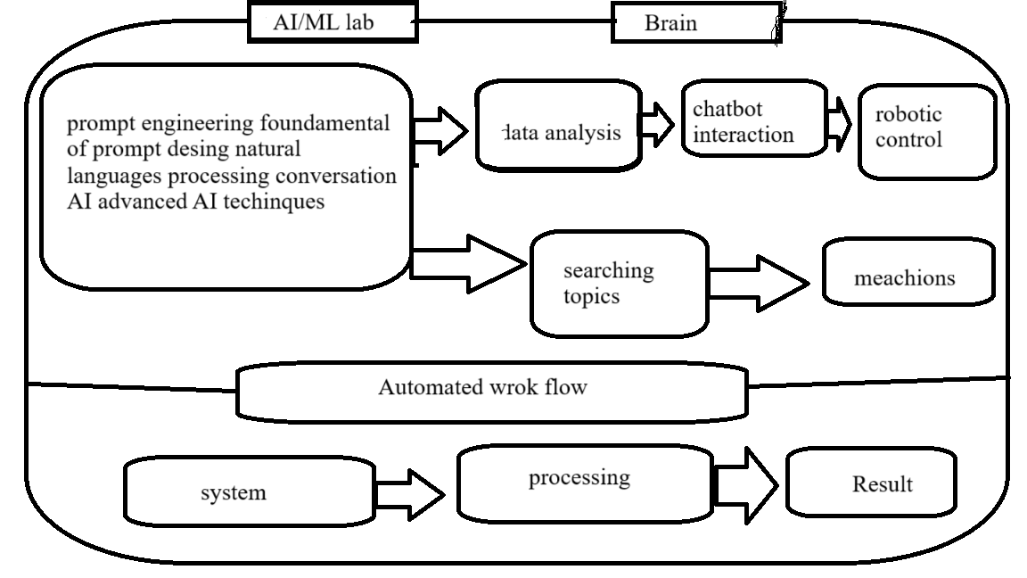
Explanation:
- AI/ML: robots/data dashboards automated workflow Brain learning ability
- Prompt Engineering: foundations of prompt design input language
- Generative AI|: text, image, create code
- Agent AI: data analysis chartbot interaction and work robot
- Agentic AI: multiple robots and robotic arms advanced autonomous plans tasks decides next uses tools
Diagram:
