**EXPERIMENT-10**

**AIM:**

To computea Pandas program to highlight the negative numbers red and positive numbers black.

**PROGRAM:**

import pandas as pd

import numpy as np

np.random.seed(0)

df = pd.DataFrame(np.random.randn(10, 5), columns=list('ABCDE'))

def highlight_negatives(val):

color = 'red' if val < 0 else 'black'

return f'color: {color}'

styled_df = df.style.map(highlight_negatives)

styled_df

styled_df.to_html('styled_dataframe.html')

import webbrowser

webbrowser.open('styled_dataframe.html')

**OUTPUT:**

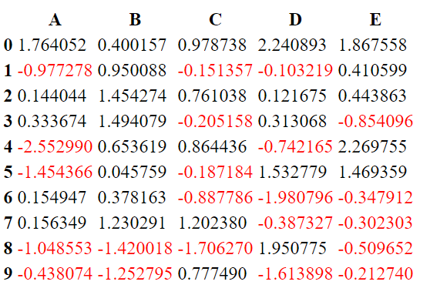

**RESULT:**

The pythonprogram to highlight the negative numbers red and positive numbers black is executed and verified.