**EXPERIMENT-11**

**AIM:**

To computea Pandas program which will highlight the nan values.

**PROGRAM:**

import pandas as pd

import numpy as np

np.random.seed(0)

data = np.random.randn(10, 4)

df = pd.DataFrame(data, columns=['A', 'B', 'C', 'D'])

df.iloc[2, 0] = np.nan

df.iloc[5, 2] = np.nan

df.iloc[8, 3] = np.nan

def highlight_nan(value):

if pd.isna(value):

return 'background-color: yellow'

else:

return ''

styled_df = df.style.applymap(highlight_nan)

styled_df

styled_df.to_html('styled_dataframe.html')

import webbrowser

webbrowser.open('styled_dataframe.html')

**OUTPUT:**

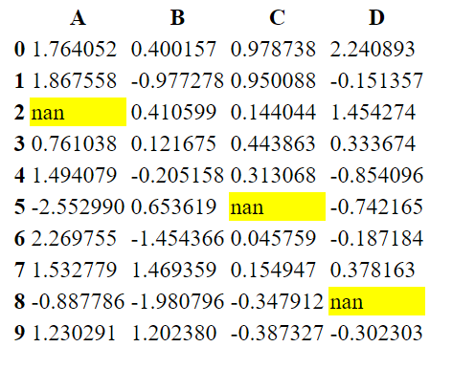

**RESULT:**

The pythonprogram to highlight the nan values is executed and verified.