**EXPERIMENT-12**

**AIM:**

To computea Pandas program to set dataframe background Color black and font color yellow.

**PROGRAM:**

import pandas as pd

import numpy as np

np.random.seed(0)

df = pd.DataFrame(np.random.randn(10, 5), columns=['A', 'B', 'C', 'D', 'E'])

df.loc[::2, 'C'] = np.nan

styled_df = df.style.applymap(lambda x: 'background-color: black; color: yellow')

styled_df

styled_df.to_html('styled_dataframe.html')

import webbrowser

webbrowser.open('styled_dataframe.html')

**OUTPUT:**

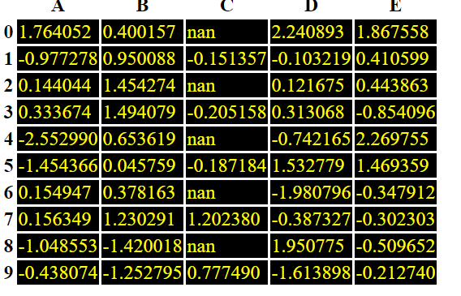

**RESULT:**

The pythonprogram to set dataframe background Color black and font color yellow is executed and verified.