**EXPERIMENT-13**

**AIM:**

To computea Pandas program to detect missing values of a given DataFrame. Display True or False.

**PROGRAM:**

import pandas as pd

import numpy as np

data = {

'ord_no': [70001.0, np.nan, 70002.0, 70004.0, np.nan, 70005.0, np.nan, 70010.0, 70003.0, 70012.0, np.nan, 70013.0],

'purch_amt': [150.50, 270.65, 65.26, 110.50, 948.50, 2400.60, 5760.00, 1983.43, 2480.40, 250.45, 75.29, 3045.60],

'ord_date': ['2012-10-05', '2012-09-10', np.nan, '2012-08-17', '2012-09-10', '2012-07-27', '2012-09-10', '2012-10-10', '2012-10-10', '2012-06-27', '2012-08-17', '2012-04-25'],

'customer_id': [3002, 3001, 3001, 3003, 3002, 3001, 3001, 3004, 3003, 3002, 3001, 3001],

'salesman_id': [5002.0, 5003.0, 5001.0, np.nan, 5002.0, 5001.0, 5001.0, np.nan, 5003.0, 5002.0, 5003.0, np.nan]

}

df = pd.DataFrame(data)

missing_values = df.isna()

print(missing_values)

**OUTPUT:**

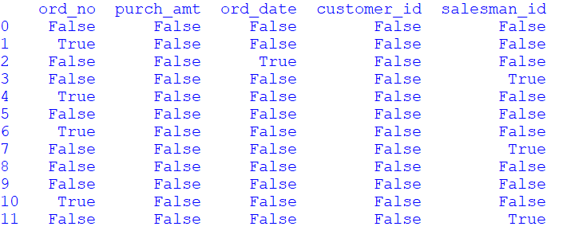

**RESULT:**

The pythonprogram to detect missing values of a given DataFrame is executed and verified.