**EXPERIMENT-14**

**AIM:**

To computea Pandas program to find and replace the missing values in a given DataFrame which do not have any valuable information.

**PROGRAM:**

import pandas as pd

import numpy as np

data = {

'ord_no': [70001.0, np.nan, 70002.0, 70004.0, np.nan, 70005.0, '--', 70010.0, 70003.0, 70012.0, np.nan, 70013.0],

'purch_amt': [150.5, 270.65, 65.26, 110.5, 948.5, 2400.6, 5760.0, '?', 12.43, 2480.4, 250.45, 3045.6],

'ord_date': ['?', '2012-09-10', np.nan, '2012-08-17', '2012-09-10', '2012-07-27', '2012-09-10', '2012-10-10', '2012-10-10', '2012-06-27', '2012-08-17', '2012-04-25'],

'customer_id': [3002, 3001, 3001, 3003, 3002, 3001, 3001, 3004, '--', 3002, 3001, 3001],

'salesman_id': [5002.0, 5003.0, '?', 5001.0, np.nan, 5002.0, 5001.0, '?', 5003.0, 5002.0, 5003.0, '--']

}

df = pd.DataFrame(data)

df.replace(['?', '--'], np.nan, inplace=True)

missing_values = df.isna()

print(missing_values)

print("\nDataFrame after replacing missing values:")

print(df)

**OUTPUT:**

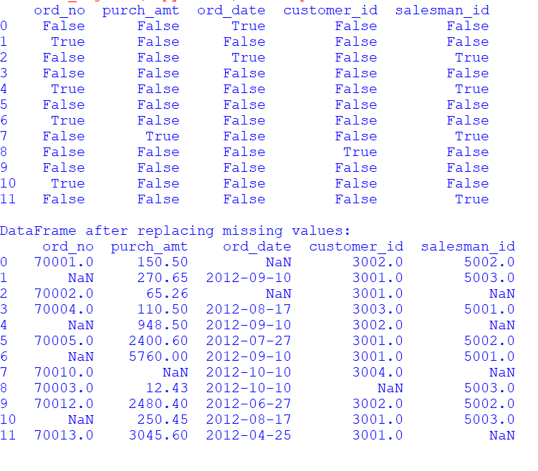

**RESULT:**

The pythonprogram to find and replace the missing values in a given DataFrame which do not have any valuable information is executed and verified.