**EXPERIMENT-15**

**AIM:**

To computea Pandas program to keep the rows with at least 2 NaN values in a given DataFrame.

**PROGRAM:**

import pandas as pd

import numpy as np

data = {

'ord_no': [np.nan, np.nan, 70002.0, np.nan, np.nan, 70005.0, np.nan, 70010.0, 70003.0, 70012.0, np.nan, np.nan],

'purch_amt': [np.nan, 270.65, 65.26, np.nan, 948.50, 2400.60, 5760.00, 1983.43, 2480.40, 250.45, 75.29, np.nan],

'ord_date': [np.nan, '2012-09-10', np.nan, np.nan, '2012-09-10', '2012-07-27', '2012-09-10', '2012-10-10', '2012-10-10', '2012-06-27', '2012-08-17', np.nan],

'customer_id': [np.nan, 3001.0, 3001.0, np.nan, 3002.0, 3001.0, 3001.0, 3004.0, 3003.0, 3002.0, 3001.0, np.nan]

}

df = pd.DataFrame(data)

df_with_at_least_2_nans = df[df.isnull().sum(axis=1) >= 2]

print(df_with_at_least_2_nans)

**OUTPUT:**

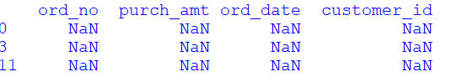

**RESULT:**

The pythonprogram to keep the rows with at least 2 NaN values in a given DataFrame is executed and verified.