**EXPERIMENT-16**

**AIM:**

To computea Pandas program to split the following dataframe into groups based on school code.

**PROGRAM:**

import pandas as pd

df = pd.DataFrame({'school': ['V', 'V', 'VI', 'VI', 'V', 'VI'],

'class': ['-', 'V', 'VI', 'VI', 'V', 'VI'],

'name': ['Alberto Franco', 'Gino Mcneill', 'Ryan Parkes',

'Eesha Hinton', 'Gino Mcneill', 'David Parkes'],

'date_Of_Birth': ['15/05/2002', '17/05/2002', '16/02/1999',

'25/09/1998', '11/05/2002', '15/09/1997'],

'age': [12, 12, 13, 13, 14, 12],

'height': [173, 192, 186, 167, 151, 159],

'weight': [35, 32, 33, 30, 31, 32]})

grouped_by_school_code = df.groupby('school')

print(type(grouped_by_school_code))

**OUTPUT:**

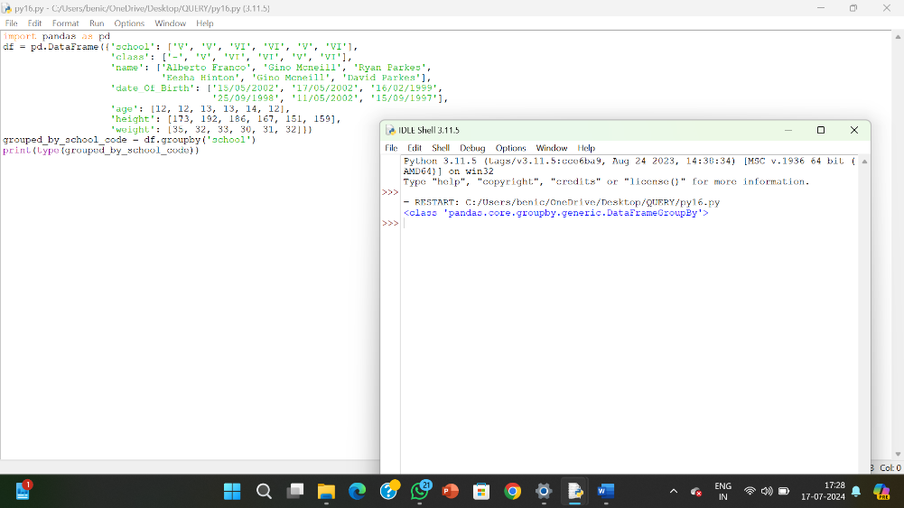

**RESULT:**

The pythonprogram to split the following dataframe into groups based on school code is executed and verified.