**EXPERIMENT-18**

**AIM:**

To computea Pandas program to split the following given dataframe into groups based on school code and class.

**PROGRAM:**

import pandas as pd

df = pd.DataFrame({

'S1': ['s001', 's002', 's003', 's001', 's002', 's004'],

'school': ['V', 'V', 'VI', 'VI', 'V', 'VI'],

'class': ['-', 'V', 'VI', 'VI', 'V', 'VI'],

'name': ['Alberto Franco', 'Gino Mcneill', 'Ryan Parkes', 'Eesha Hinton', 'Gino Mcneill', 'David Parkes'],

'date_Of_Birth': ['15/05/2002', '17/05/2002', '16/02/1999', '25/09/1998', '11/05/2002', '15/09/1997'],

'age': [12, 12, 13, 13, 14, 12],

'height': [173, 192, 186, 167, 151, 159],

'weight': [35, 32, 33, 30, 31, 32],

'address': ['street1', 'street2', 'street3', 'street1', 'street2', 'street4']})

grouped_by_school_class = df.groupby(['school', 'class'])

print("Groups:")

for name, group in grouped_by_school_class:

print(f"Group: {name}")

print(group)

print()

age_stats = grouped_by_school_class['age'].agg(['mean', 'min', 'max'])

print("Age Statistics:")

print(age_stats)

height_stats = grouped_by_school_class['height'].agg(['mean', 'min', 'max'])

print("Height Statistics:")

print(height_stats)

weight_stats = grouped_by_school_class['weight'].agg(['mean', 'min', 'max'])

print("Weight Statistics:")

print(weight_stats)

**OUTPUT:**

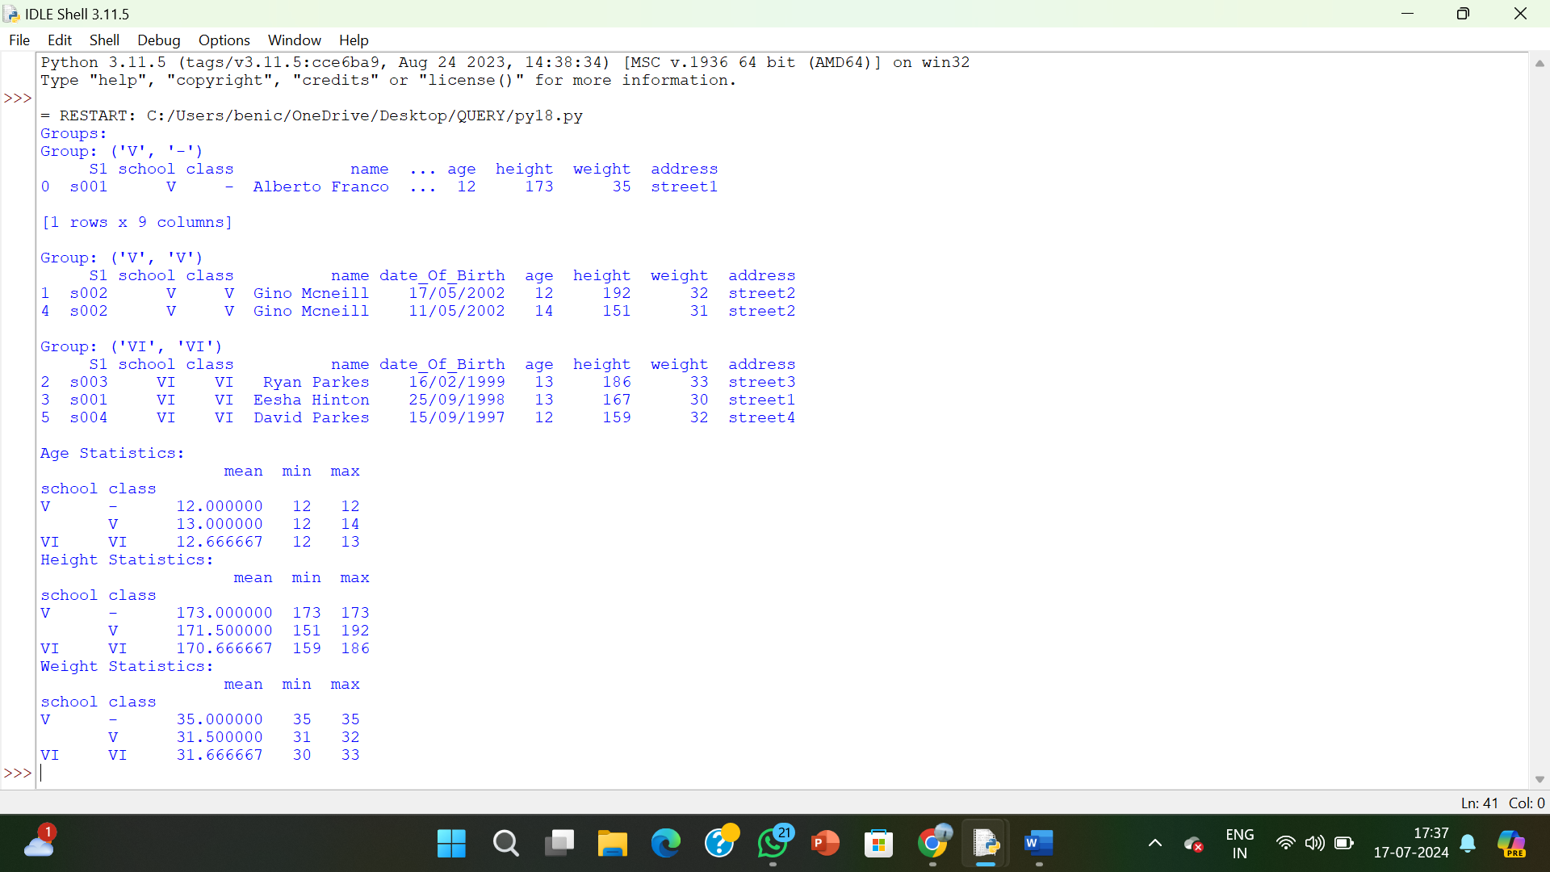

**RESULT:**

The pythonprogram to split the following given dataframe into groups based on school code and class is executed and verified.