**EXPERIMENT-19**

**AIM:**

To computea Pandas program to display the dimensions or shape of the World alcohol consumption dataset.

**PROGRAM:**

import pandas as pd

df = pd.DataFrame({

'Year': [1986, 1986, 1985, 1986, 1987],

'WHO region': ['Western Pacific', 'Americas', 'Africa', 'Americas', 'Americas'],

'Country': ['Viet Nam', 'Uruguay', 'Cte d\'Ivoire', 'Colombia', 'Saint Kitts and Nevis'],

'Beverage Types': ['Wine', 'Other', 'Wine', 'Beer', 'Beer'],

'Display Value': [0.00, 0.50, 1.62, 4.27, 1.98]})

print(df.shape)

print(df.columns.tolist())

**OUTPUT:**

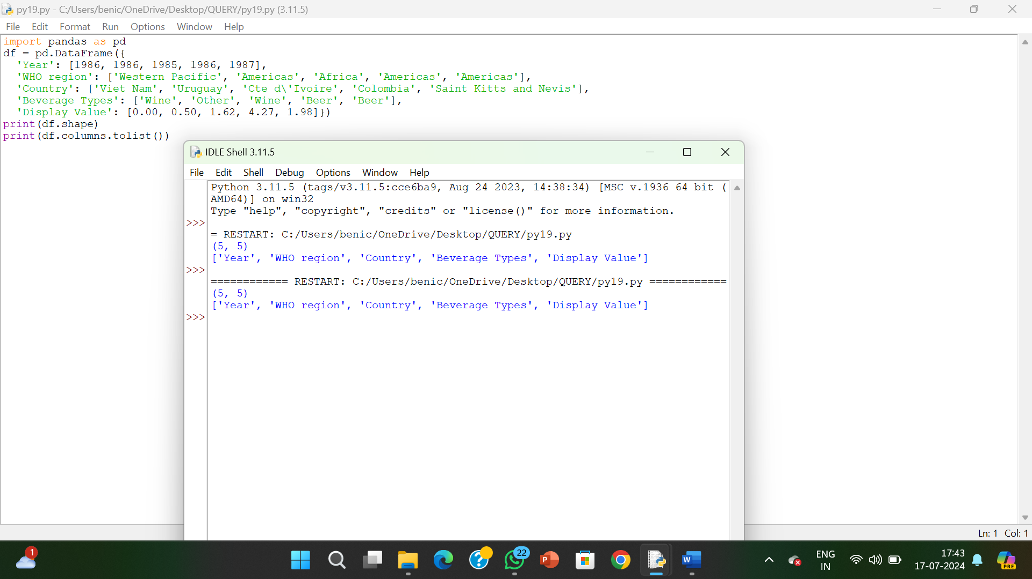

**RESULT:**

The pythonprogram to display the dimensions or shape of the World alcohol consumption dataset is executed and verified.