**EXPERIMENT-2**

**AIM:**

To computea Pandas program to display the ID for those employees who did two or more jobs in the past.

**PROGRAM:**

import pandas as pd

data = {

'EMPLOYEE_ID': [102, 101, 101, 201, 114, 122, 200, 176, 176, 200],

'START_DATE': ['2001-01-13', '1997-09-21', '2001-10-28', '2004-02-17', '2006-03-24', '2007-01-01', '1995-09-17', '2006-03-24', '2007-01-01', '2002-07-01'],

'END_DATE': ['2006-07-24', '2001-10-27', '2005-03-15', '2007-12-19', '2007-12-31', '2007-12-31', '2001-06-17', '2006-12-31', '2007-12-31', '2006-12-31'],

'JOB_ID': ['IT_PROG', 'AC_ACCOUNT', 'AC_MGR', 'MK_REP', 'ST_CLERK', 'ST_CLERK', 'AD_ASST', 'SA_REP', 'SA_MAN', 'AC_ACCOUNT'],

'DEPARTMENT_ID': [60, 110, 110, 20, 50, 50, 90, 80, 80, 90]

}

df = pd.DataFrame(data)

job_counts = df.groupby('EMPLOYEE_ID').size()

employees_with_multiple_jobs = job_counts[job_counts >= 2].index

print(employees_with_multiple_jobs.tolist())

**OUTPUT:**

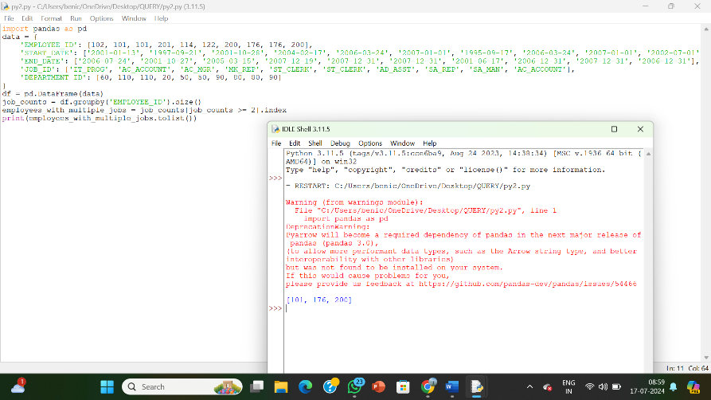

**RESULT:**

The pythonprogram to display the ID for those employees who did two or more jobs in the past is executed and verified.