**EXPERIMENT-20**

**AIM:**

To computea Pandas program to find the index of a given substring of a DataFrame column.

**PROGRAM:**

import pandas as pd

df = pd.DataFrame({'name': ['Alice Smith', 'Bob Johnson', 'Charlie Brown',

'David Miller', 'Emily Williams', 'Frank Garcia']})

substring = "er"

indices = [i for i, name in df['name'].items() if substring in name]

print("Indices using list comprehension:", indices)

positions = df['name'].apply(lambda x: x.find(substring))

print("Positions using apply():")

print(positions)

**OUTPUT:**

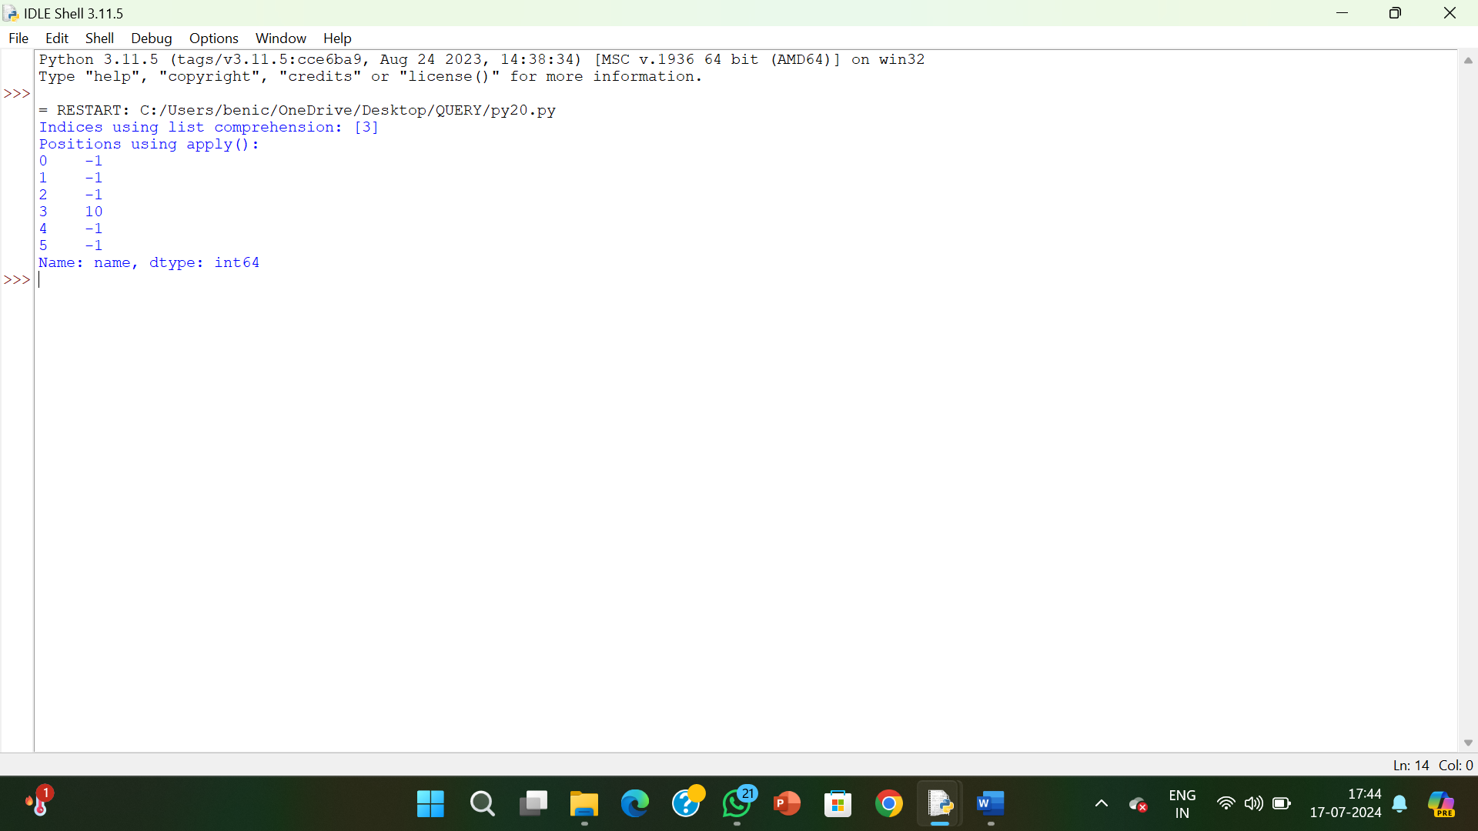

**RESULT:**

The pythonprogram to find the index of a given substring of a DataFrame column is executed and verified.