**EXPERIMENT-21**

**AIM:**

To computea Pandas program to swap the cases of a specified character column in a given DataFrame.

**PROGRAM:**

import pandas as pd

df = pd.DataFrame({'name': ['Alice Smith', 'BoB JohnsoN', 'CHarlie Brown'],

'age': [25, 30, 28]})

column_name = 'name'

df[column_name] = df[column_name].str.swapcase()

print(df)

**OUTPUT:**

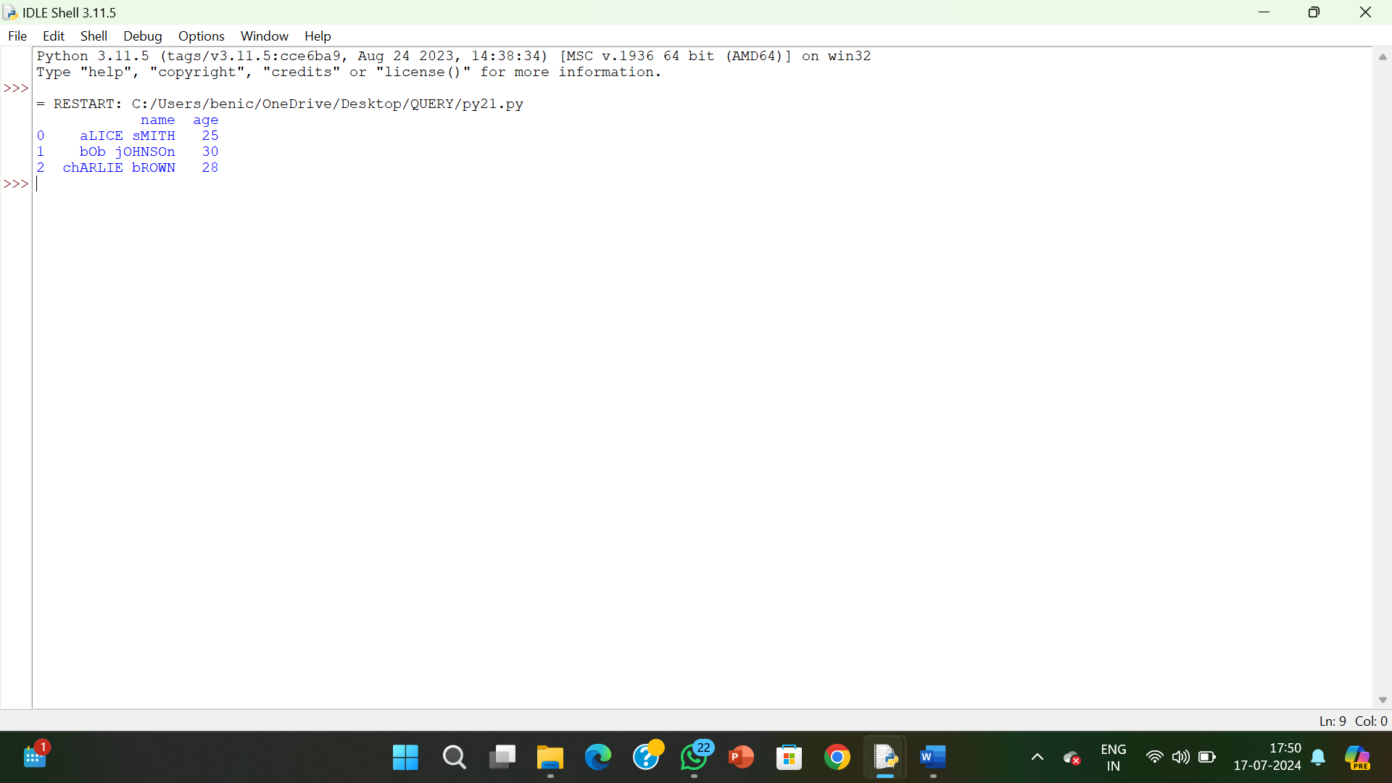

**RESULT:**

The pythonprogram to swap the cases of a specified character column in a given DataFrame is executed and verified.