**EXPERIMENT-22**

**AIM:**

To computea Pandas program to draw a line with suitable label in the x axis, y axis and a title.

**PROGRAM:**

import matplotlib.pyplot as plt

x = [10, 20, 30, 40, 50]

y = [10, 20, 30, 40, 50]

plt.plot(x, y)

plt.xlabel("X-axis")

plt.ylabel("Y-axis")

plt.title("Line Graph")

plt.show()

**OUTPUT:**

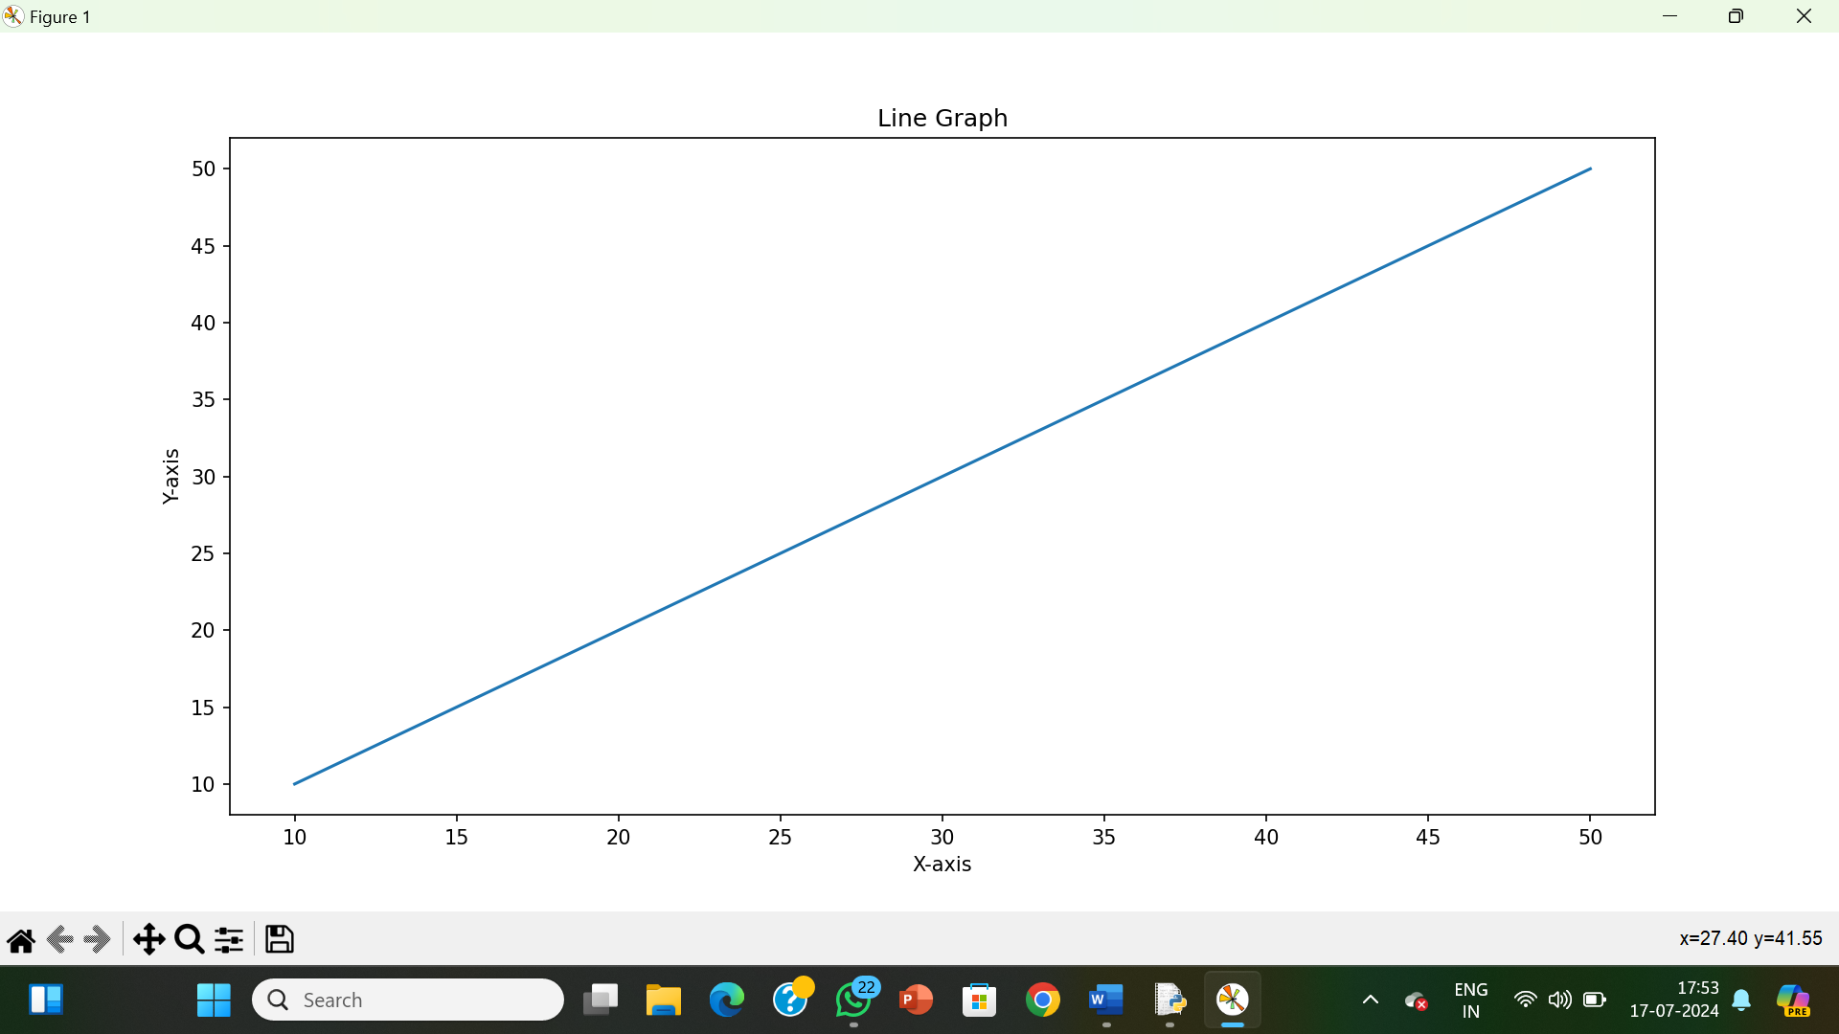

**RESULT:**

The pythonprogram to draw a line with suitable label in the x axis, y axis and a title is executed and verified.