**EXPERIMENT-23**

**AIM:**

To computea Pandas program to draw a line using given axis values taken from a text file, with suitable label in the x axis, y axis and a title.  
  
**PROGRAM:**

import matplotlib.pyplot as plt

filename = "test.txt"

try:

with open(filename, 'r') as file:

data = [line.strip().split() for line in file]

x = [float(item[0]) for item in data]

y = [float(item[1]) for item in data]

plt.plot(x, y)

plt.xlabel("X-axis")

plt.ylabel("Y-axis")

plt.title("Line Graph")

plt.show()

except FileNotFoundError:

print(f"Error: File '{filename}' not found.")

except ValueError:

print("Error: Invalid data format in the file.")

**OUTPUT:**

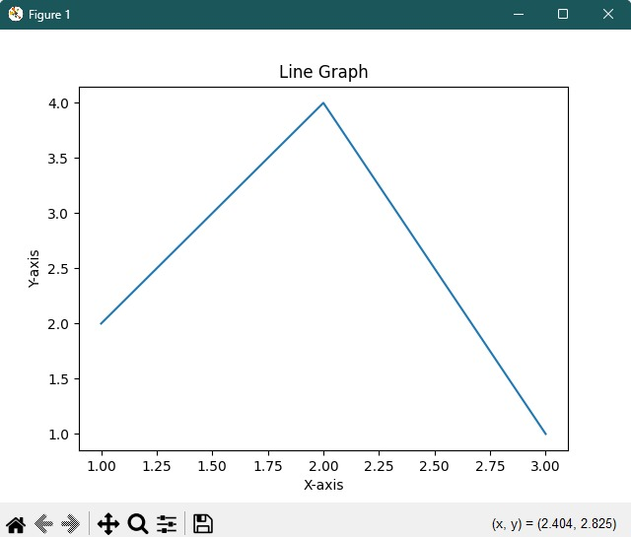

**RESULT:**

The pythonprogram to draw a line using given axis values taken from a text file, with suitable label in the x axis, y axis and a title is executed and verified.