**EXPERIMENT-24**

**AIM:**

To computea Pandas program to draw line charts of the financial data of Alphabet Inc. between October 3, 2016 to October 7, 2016.  
  
**PROGRAM:**

import pandas as pd

import matplotlib.pyplot as plt

fdata = pd.DataFrame({

'Date': ['10-03-16', '10-04-16', '10-05-16', '10-06-16', '10-07-16'],

'Open': [774.25, 776.030029, 779.309998, 779, 779.659973],

'High': [776.065002, 778.710022, 782.070007, 780.47998, 779.659973],

'Low': [769.5, 772.890015, 775.650024, 775.539978, 770.75],

'Close': [772.559998, 776.429993, 776.469971, 776.859985, 775.080017]

})

fdata['Date'] = pd.to_datetime(fdata['Date'])

fdata.set_index('Date', inplace=True)

fig, ax = plt.subplots(figsize=(10, 6))

ax.plot(fdata.index, fdata['Open'], label='Open')

ax.plot(fdata.index, fdata['High'], label='High')

ax.plot(fdata.index, fdata['Low'], label='Low')

ax.plot(fdata.index, fdata['Close'], label='Close')

ax.set_title('Alphabet Inc. Financial Data (Oct 3-7, 2016)')

ax.set_xlabel('Date')

ax.set_ylabel('Price ($)')

ax.legend()

plt.show()

**OUTPUT:**

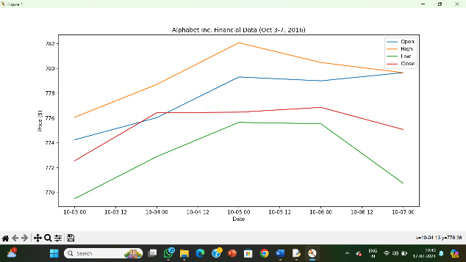

**RESULT:**

The pythonprogram to draw line charts of the financial data of Alphabet Inc. between October 3, 2016 to October 7, 2016 is executed and verified.