**EXPERIMENT-25**

**AIM:**

To computea program to plot two or more lines with legends, different widths and colors.  
  
**PROGRAM:**

import matplotlib.pyplot as plt

x = [0, 1, 2, 3, 4, 5]

y1 = [0, 1, 4, 9, 16, 25]

y2 = [0, 1, 8, 27, 64, 125]

plt.plot(x, y1, color='blue', linewidth=2, label='y = x^2')

plt.plot(x, y2, color='red', linewidth=4, label='y = x^3')

plt.title('Plot of two lines with legends, different widths, and colors')

plt.xlabel('X-axis')

plt.ylabel('Y-axis')

plt.legend()

plt.show()

**OUTPUT:**

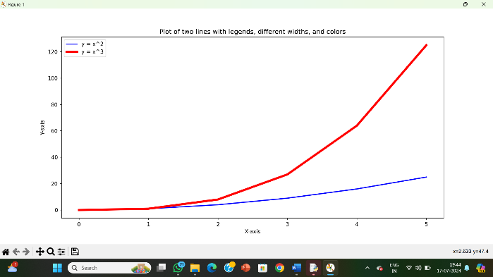

**RESULT:**

The pythonprogram to plot two or more lines with legends, different widths and colors is executed and verified.