**EXPERIMENT-26**

**AIM:**

To computea program to create multiple plots.  
**PROGRAM:**

import matplotlib.pyplot as plt

import numpy as np

x = np.linspace(0, 10, 100)

y1 = np.sin(x)

y2 = np.cos(x)

y3 = np.tan(x)

y4 = x**2

fig, axs = plt.subplots(2, 2, figsize=(10, 8))

axs[0, 0].plot(x, y1, color='blue', linewidth=2, label='sin(x)')

axs[0, 0].set_title('Plot of sin(x)')

axs[0, 0].legend()

axs[0, 1].plot(x, y2, color='green', linewidth=2, label='cos(x)')

axs[0, 1].set_title('Plot of cos(x)')

axs[0, 1].legend()

axs[1, 0].plot(x, y3, color='red', linewidth=2, label='tan(x)')

axs[1, 0].set_title('Plot of tan(x)')

axs[1, 0].set_ylim(-10, 10)

axs[1, 0].legend()

axs[1, 1].plot(x, y4, color='purple', linewidth=2, label='x^2')

axs[1, 1].set_title('Plot of x^2')

axs[1, 1].legend()

fig.suptitle('Multiple Plots Example')

plt.tight_layout()

plt.subplots_adjust(top=0.9)

plt.show()

**OUTPUT:**

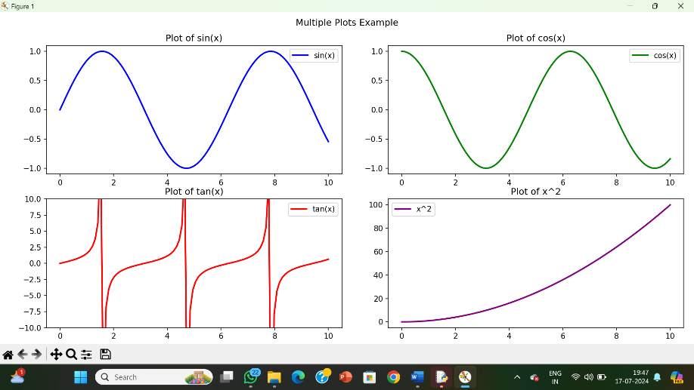

**RESULT:**

The pythonprogram to create multiple plots is executed and verified.