**EXPERIMENT-27**

**AIM:**

To computea program to display a bar chart of the popularity of programming Languages.  
**PROGRAM:**

import matplotlib.pyplot as plt

languages = ['Java', 'Python', 'PHP', 'JavaScript', 'C#', 'C++']

popularity = [22.2, 17.6, 8.8, 8, 7.7, 6.7]

plt.figure(figsize=(10, 6))

plt.bar(languages, popularity, color=['blue', 'green', 'red', 'purple', 'orange', 'cyan'])

plt.title('Popularity of Programming Languages')

plt.xlabel('Programming Languages')

plt.ylabel('Popularity (%)')

plt.show()

**OUTPUT:**

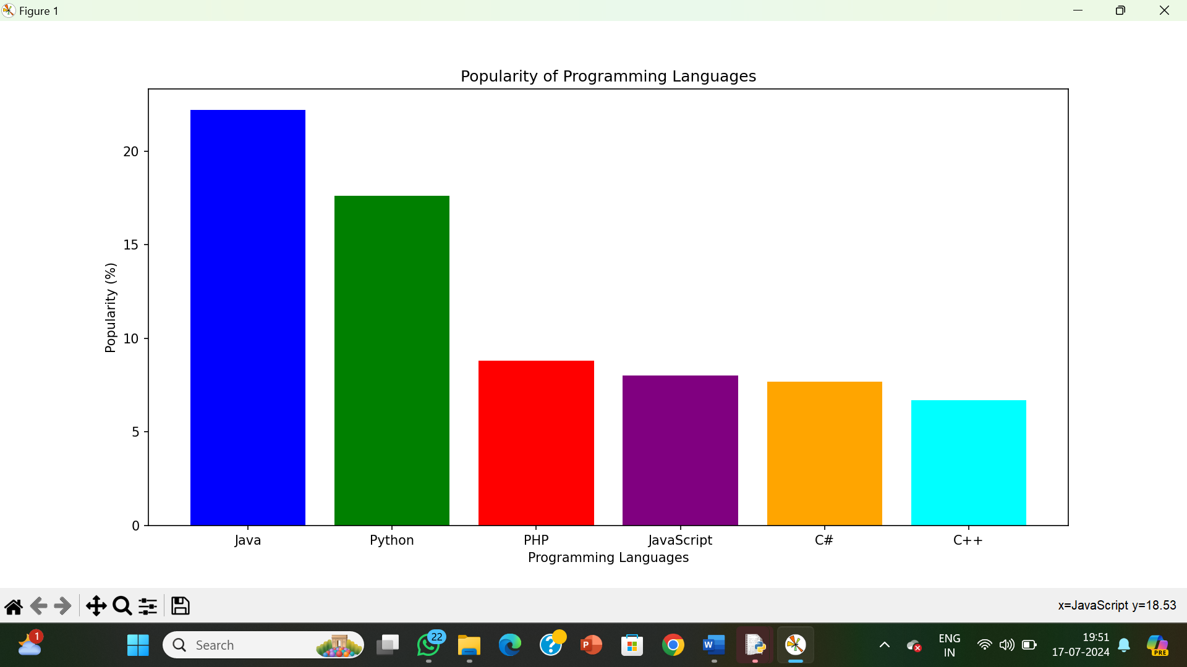

**RESULT:**

The pythonprogram to display a bar chart of the popularity of programming Languages is executed and verified.