**EXPERIMENT-3**

**AIM:**

To computea Pandas program to display the details of jobs in descending sequence on job title.

**PROGRAM:**

import pandas as pd

data = {

'JOB_ID': ['AD_PRES', 'AD_VP', 'AD_ASST', 'FI_MGR', 'FI_ACCOUNT', 'AC_MGR', 'AC_ACCOUNT',

'SA_MAN', 'SA_REP', 'PU_MAN', 'PU_CLERK', 'ST_MAN', 'ST_CLERK', 'SH_CLERK',

'IT_PROG', 'MK_MAN', 'MK_REP', 'HR_REP', 'PR_REP'],

'JOB_TITLE': ['President', 'Administration Vice President', 'Administration Assistant',

'Finance Manager', 'Accountant', 'Accounting Manager', 'Public Accountant',

'Sales Manager', 'Sales Representative', 'Purchasing Manager', 'Purchasing Clerk',

'Stock Manager', 'Stock Clerk', 'Shipping Clerk', 'Programmer',

'Marketing Manager', 'Marketing Representative', 'Human Resources Representative',

'Public Relations Representative'],

'MIN_SALARY': [20080, 15000, 3000, 8200, 4200, 8200, 4200, 10000, 6000, 8000, 2500, 5500, 2008,

2500, 4000, 9000, 4000, 4000, 4500],

'MAX_SALARY': [40000, 30000, 6000, 16000, 9000, 16000, 9000, 20080, 12008, 15000, 5500, 8500,

5000, 5500, 10000, 15000, 9000, 9000, 10500]

}

df = pd.DataFrame(data)

df_sorted = df.sort_values(by='JOB_TITLE', ascending=False)

print(df_sorted)

**OUTPUT:**

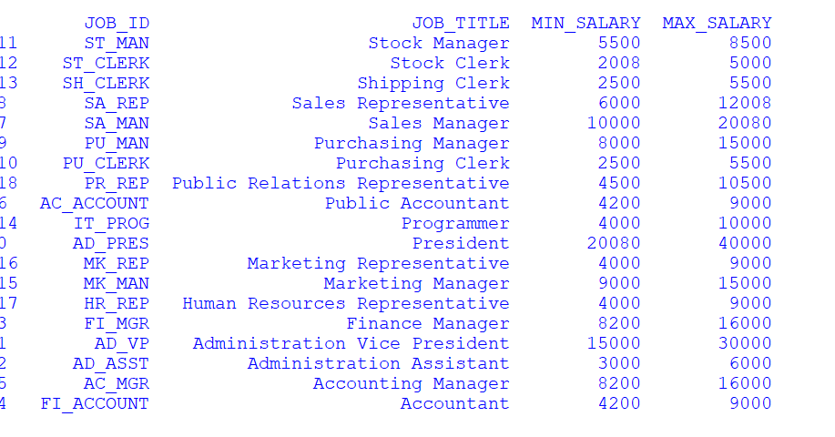

**RESULT:**

The pythonprogram to to display the details of jobs in descending sequence on job title is executed and verified.