**EXPERIMENT-30**

**AIM:**

To computea program to create bar plot of scores by group and gender. Use multiple X values on the same chart for men and women.  
**PROGRAM:**

import matplotlib.pyplot as plt

import numpy as np

groups = ['A', 'B', 'C', 'D', 'E']

means_men = [22, 30, 35, 35, 26]

means_women = [25, 32, 30, 35, 29]

n_groups = len(groups)

index = np.arange(n_groups)

bar_width = 0.35

fig, ax = plt.subplots(figsize=(10, 6))

bars1 = ax.bar(index, means_men, bar_width, label='Men', color='blue')

bars2 = ax.bar(index + bar_width, means_women, bar_width, label='Women', color='pink')

ax.set_xlabel('Group')

ax.set_ylabel('Scores')

ax.set_title('Scores by group and gender')

ax.set_xticks(index + bar_width / 2)

ax.set_xticklabels(groups)

ax.legend()

plt.show()

**OUTPUT:**

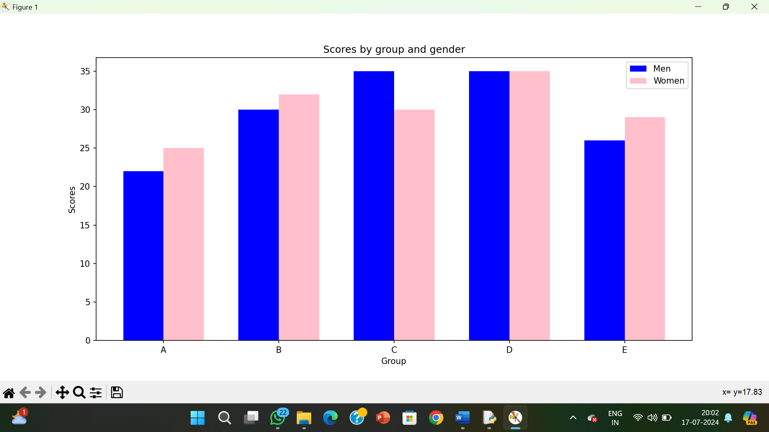

**RESULT:**

The pythonprogram to create bar plot of scores by group and gender. Use multiple X values on the same chart for men and women is executed and verified.