**EXPERIMENT-31**

**AIM:**

To computea program to create a stacked bar plot with error bars  
**PROGRAM:**

import numpy as np

import matplotlib.pyplot as plt

means_men = [22, 30, 35, 35, 26]

means_women = [25, 32, 30, 35, 29]

std_men = [4, 3, 4, 1, 5]

std_women = [3, 5, 2, 3, 3]

ind = np.arange(len(means_men))

width = 0.35

fig, ax = plt.subplots()

men_bars = ax.bar(ind, means_men, width, yerr=std_men, label='Men', capsize=5)

women_bars = ax.bar(ind, means_women, width, bottom=means_men, yerr=std_women, label='Women', capsize=5)

ax.set_xlabel('Groups')

ax.set_ylabel('Scores')

ax.set_title('Scores by group and gender with error bars')

ax.set_xticks(ind)

ax.set_xticklabels(('G1', 'G2', 'G3', 'G4', 'G5'))

ax.legend()

plt.show()

**OUTPUT:**

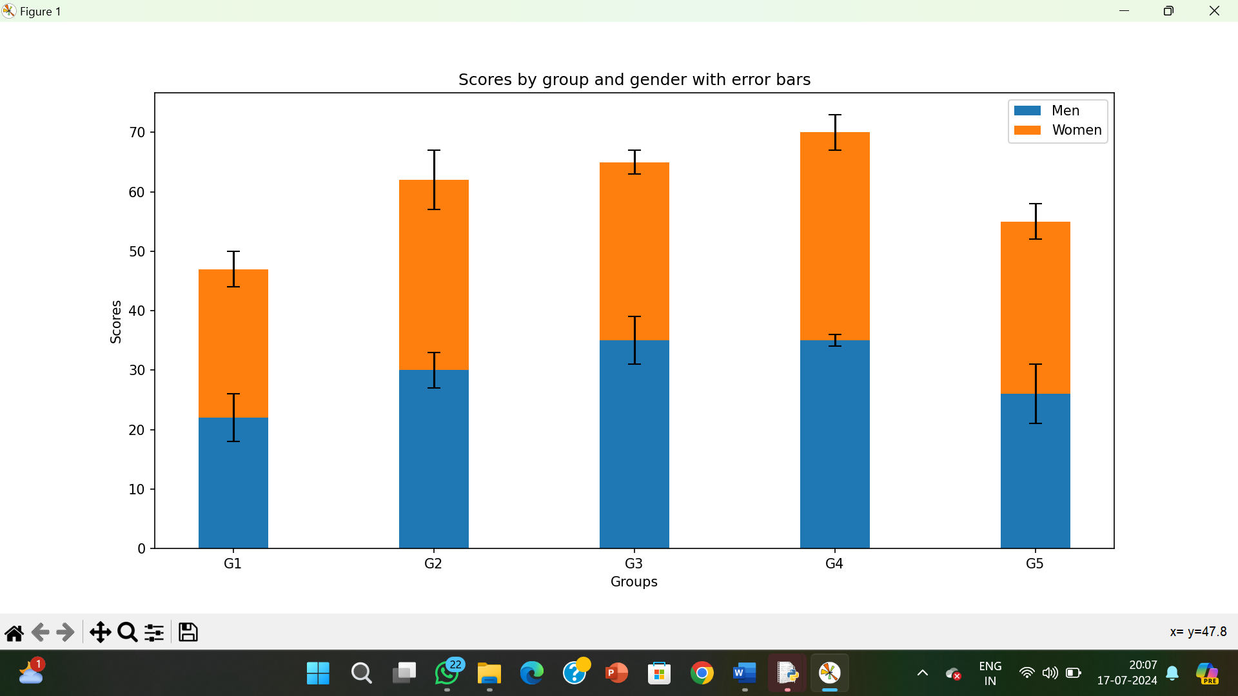

**RESULT:**

The pythonprogram to create a stacked bar plot with error bars is executed and verified.