**EXPERIMENT-33**

**AIM:**

To computea program to draw a scatter plot with empty circles taking a random distribution in X and Y and plotted against each other.

**PROGRAM:**

import numpy as np

import matplotlib.pyplot as plt

np.random.seed(0)

x = np.random.randn(100)

y = np.random.randn(100)

plt.scatter(x, y, facecolors='none', edgecolors='b')

plt.xlabel('X-axis')

plt.ylabel('Y-axis')

plt.title('Scatter Plot of Random Distributions with Empty Circles')

plt.show()

**OUTPUT:**

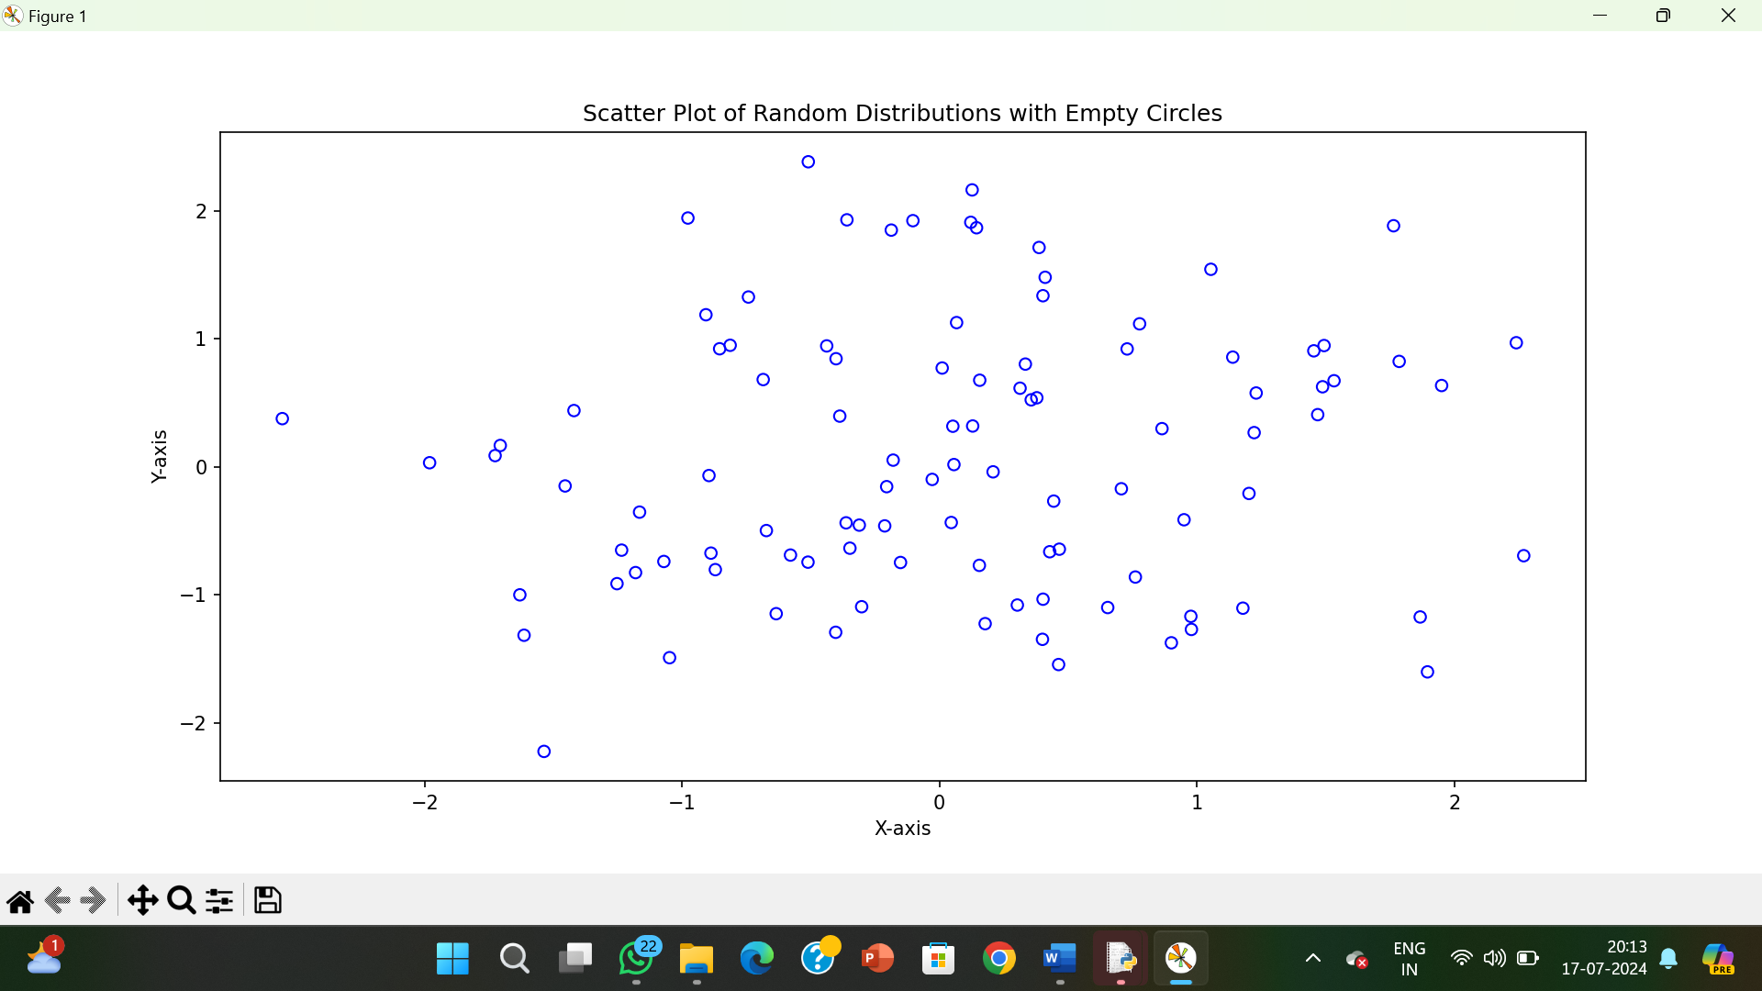

**RESULT:**

The pythonprogram to draw a scatter plot with empty circles taking a random distribution in X and Y and plotted against each other is executed and verified.