**EXPERIMENT-34**

**AIM:**

To computea program to draw a scatter plot using random distributions to generate balls of different sizes.

**PROGRAM:**

import numpy as np

import matplotlib.pyplot as plt

np.random.seed(0)

x = np.random.randn(50)

y = np.random.randn(50)

sizes = np.random.randint(10, 100, 50)

plt.scatter(x, y, s=sizes, alpha=0.7)

plt.xlabel('X-axis')

plt.ylabel('Y-axis')

plt.title('Scatter Plot with Randomly Sized Balls')

plt.show()

**OUTPUT:**

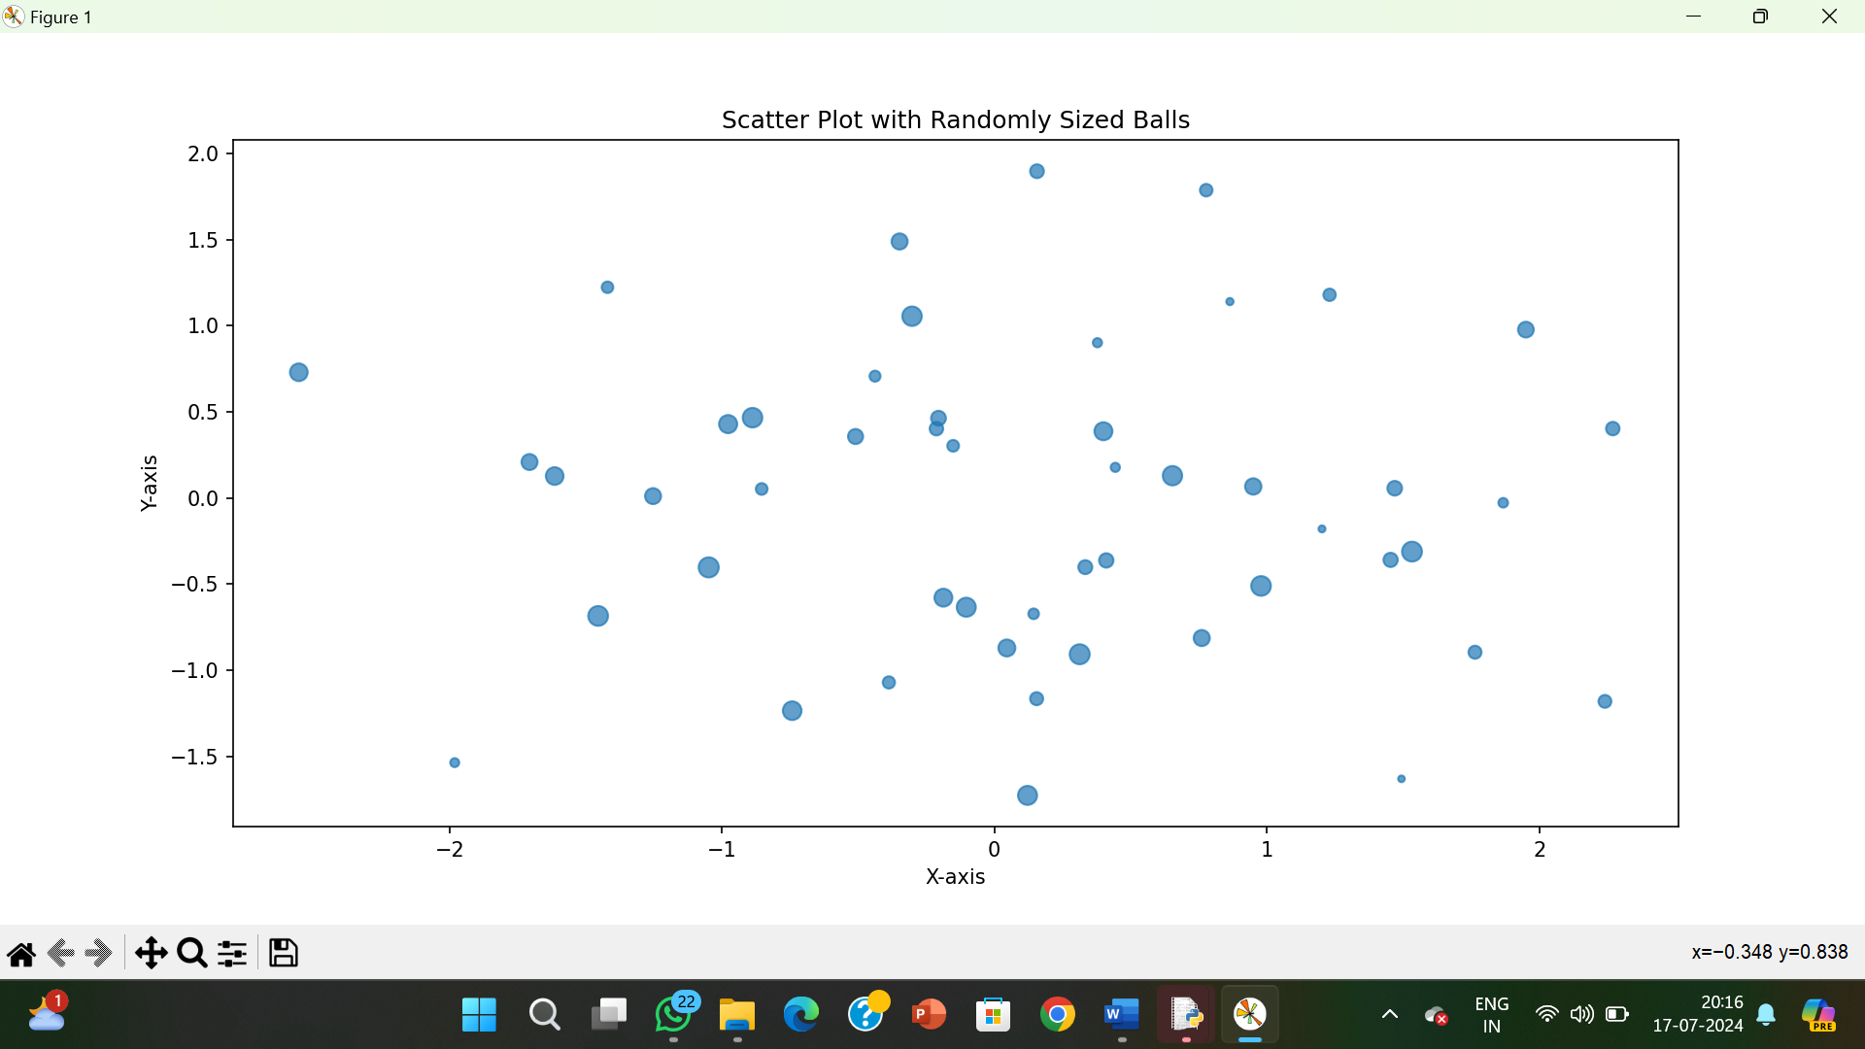

**RESULT:**

The pythonprogram to draw a scatter plot using random distributions to generate balls of different sizes is executed and verified.