**EXPERIMENT-35**

**AIM:**

To computea program to draw a scatter plot comparing two subject marks of Mathematics and Science.

**PROGRAM:**

import matplotlib.pyplot as plt

math_marks = [88, 92, 80, 89, 100, 80, 60, 100, 80, 34]

science_marks = [35, 79, 79, 48, 100, 88, 32, 45, 20, 30]

marks_range = [10, 20, 30, 40, 50, 60, 70, 80, 90, 100]

plt.figure(figsize=(10, 6))

plt.scatter(marks_range, math_marks, color='red', label='Math marks')

plt.scatter(marks_range, science_marks, color='green', label='Science marks')

plt.xlabel('Marks Range')

plt.ylabel('Marks Scored')

plt.title('Scatter Plot')

plt.legend()

plt.xlim(0, 110)

plt.ylim(0, 110)

plt.grid(True)

plt.show()

**OUTPUT:**

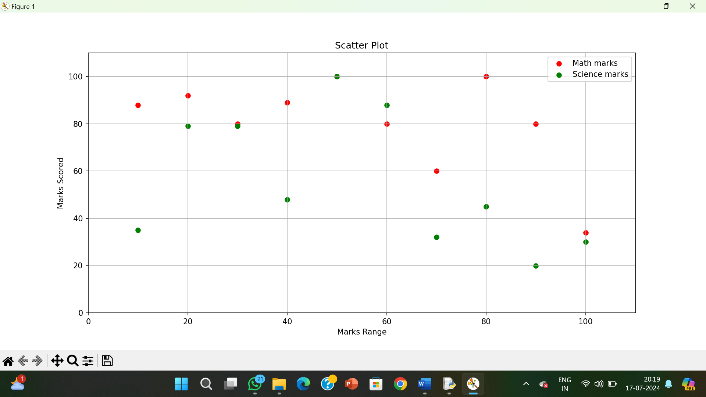

**RESULT:**

The pythonprogram to draw a scatter plot comparing two subject marks of Mathematics and Science is executed and verified.