**EXPERIMENT-36**

**AIM:**

To computea program to draw a scatter plot for three different groups comparing weights and heights.

**PROGRAM:**

import matplotlib.pyplot as plt

import numpy as np

np.random.seed(0)

weights1 = np.random.uniform(55, 65, 10)

heights1 = np.random.uniform(120, 180, 10)

weights2 = np.random.uniform(60, 70, 10)

heights2 = np.random.uniform(140, 200, 10)

weights3 = np.random.uniform(65, 75, 10)

heights3 = np.random.uniform(160, 220, 10)

plt.figure(figsize=(10, 6))

plt.scatter(weights1, heights1, color='blue', marker='*', label='Group 1')

plt.scatter(weights2, heights2, color='red', marker='*', label='Group 2')

plt.scatter(weights3, heights3, color='green', marker='*', label='Group 3')

plt.xlabel('Weight')

plt.ylabel('Height')

plt.title('Group wise Weight vs Height scatter plot')

plt.xlim(55, 75)

plt.ylim(100, 240)

plt.legend()

plt.grid(True)

plt.show()

**OUTPUT:**

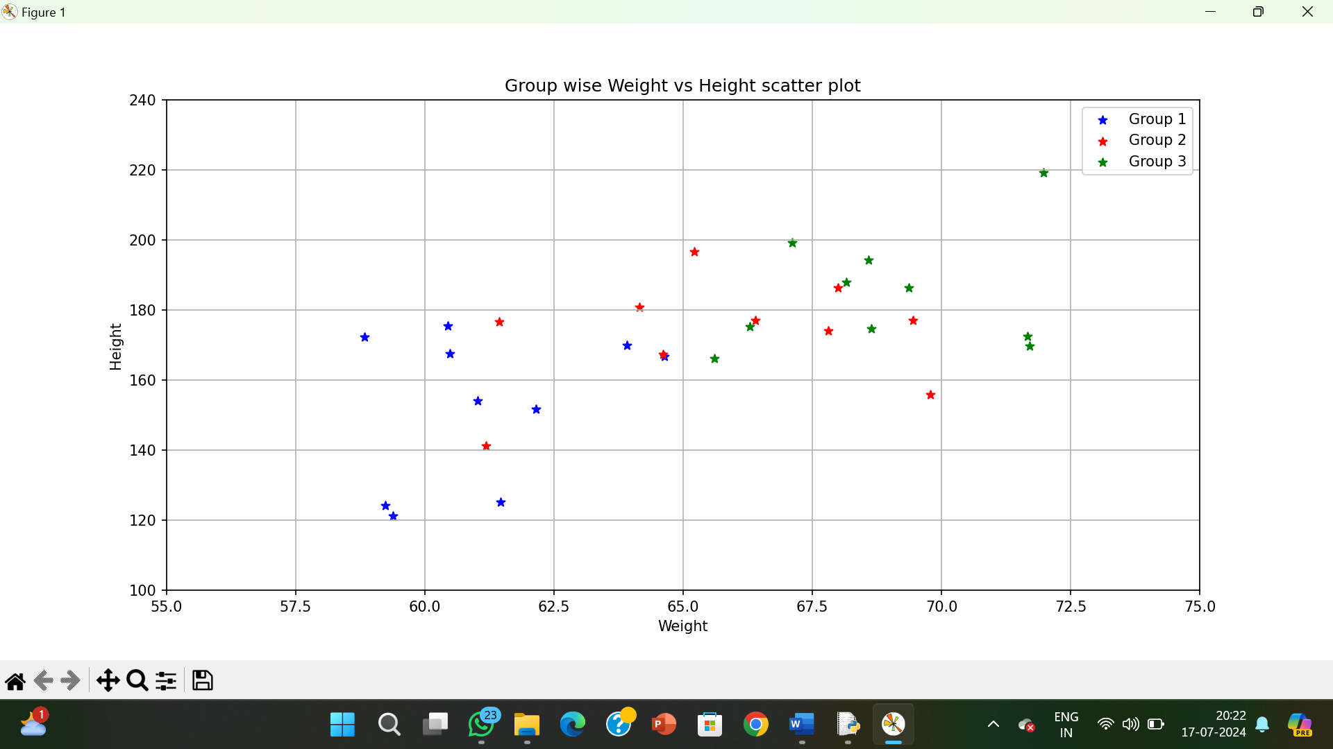

**RESULT:**

The pythonprogram to draw a scatter plot for three different groups comparing weights and heights is executed and verified.