**EXPERIMENT-5**

**AIM:**

To computea Pandas program to create a bar plot of the trading volume of Alphabet Inc. stock between two specific dates.

**PROGRAM:**

import pandas as pd

import matplotlib.pyplot as plt

import yfinance as yf

ticker = 'GOOGL'

start_date = '2023-01-01'

end_date = '2023-12-31'

stock_data = yf.download(ticker, start=start_date, end=end_date)

print(stock_data.head())

plt.figure(figsize=(12, 6))

plt.bar(stock_data.index, stock_data['Volume'], color='b')

plt.title('Alphabet Inc. (GOOGL) Trading Volume')

plt.xlabel('Date')

plt.ylabel('Volume')

plt.grid(True)

plt.show()

**OUTPUT:**

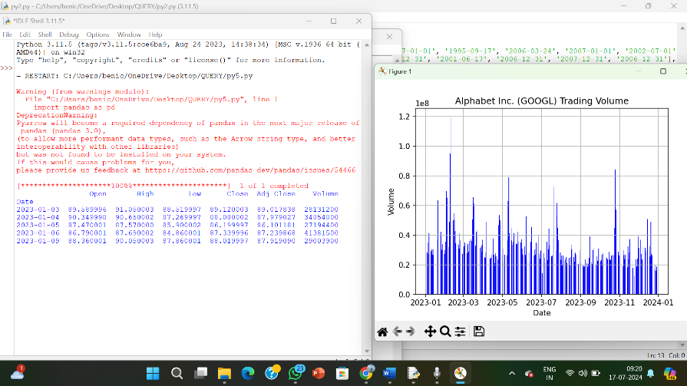

**RESULT:**

The pythonprogram to create a bar plot of the trading volume of Alphabet Inc. stock between two specific dates is executed and verified.