**EXPERIMENT-6**

**AIM:**

To computea Pandas program to create a scatter plot of the trading volume/stock prices of Alphabet Inc. stock between two specific dates.

**PROGRAM:**

import pandas as pd

import matplotlib.pyplot as plt

from io import StringIO

data = """

Date,Open,High,Low,Close,Adj Close,Volume

01-04-2020,1122,1129.69,1097.45,1105.62,1105.62,2343100

02-04-2020,1098.26,1126.86,1096.4,1120.84,1120.84,1964900

03-04-2020,1119.015,1129.5,1079.81,1097.82,1097.82,2314000

06-04-2020,1138,1194.66,1130.94,1186.92,1186.92,2664700

07-04-2020,1122,1123,1113.38,1118.51,1118.51,2383700

08-04-2020,1206.5,1219.07,1188.16,1210.28,1210.28,1971500

09-04-2020,1224.05,1225.57,1196.735,1211.45,1211.45,2175400

13-04-2020,1209.18,1220.17,1187.598,1217.56,1217.56,1739800

14-04-2020,1242.09,1243.59,1236.93,1269.23,1269.23,2442800

15-04-2020,1245.61,1280.1,1240.4,1262.47,1262.47,1671700

16-04-2020,1274.99,1275.53,1241.62,1242.62,1242.62,1511800

17-04-2020,1284.85,1294.3,1271.23,1283.25,1283.25,1949000

20-04-2020,1271,1281.6,1261.45,1274.39,1274.39,1695300

21-04-2020,1247,1254.27,1209.71,1216.34,1216.34,2153000

22-04-2020,1221.15,1228.4,1215.6,1220.81,1220.81,1534000

23-04-2020,1247.5,1250.04,1265.67,1276.31,1276.31,1566200

24-04-2020,1251.3,1280.34,1249.45,1279.31,1279.31,1600400

27-04-2020,1271.14,1296.15,1269.57,1278.88,1278.88,1600600

28-04-2020,1287.93,1291.6,1232.82,1233.47,1233.47,1791000

29-04-2020,1341.46,1359.99,1325.34,1348.66,1348.66,3796400

30-04-2020,1344.88,1352.82,1323.49,1348.66,1348.66,2665400

01-05-2020,1328.15,1352.07,1311,1320.61,1320.61,2072500

"""

df = pd.read_csv(StringIO(data), parse_dates=['Date'], dayfirst=True)

print(df.head())

plt.figure(figsize=(12, 6))

plt.scatter(df['Date'], df['Volume'], color='blue', label='Trading Volume')

plt.scatter(df['Date'], df['Close'], color='red', label='Close Price')

plt.title('Alphabet Inc. (GOOGL) Trading Volume and Close Price')

plt.xlabel('Date')

plt.ylabel('Volume / Close Price')

plt.legend()

plt.grid(True)

plt.show()

**OUTPUT:**

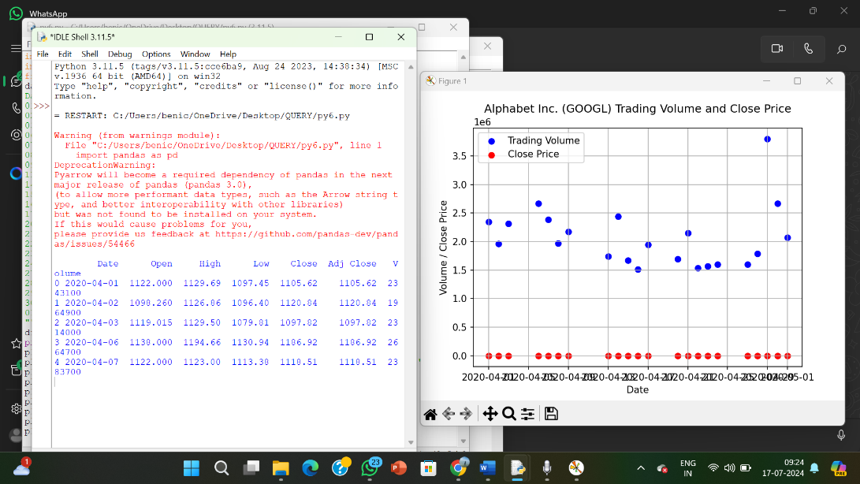

**RESULT:**

The pythonprogram to create a scatter plot of the trading volume/stock prices of Alphabet Inc. stock between two specific dates.is executed and verified.